**Overview of Statistical Analysis**

Before we understand Statistical Analysis, its relation to Data Analysis, and specifically data mining, let’s first examine what Statistics is. Statistics is a branch of mathematics dealing with the collection, analysis, interpretation, and presentation of numerical or quantitative data. It’s all around us in our day to day lives. Whether we’re talking about average income, average age, or highest-paid professions—it’s all statistics. Today, statistics is being applied across industries for decision-making based on data. For example, researchers using statistics to analyze data from the production of vaccines to ensure safety and efficacy, or companies using statistics to reduce customer churn by gaining greater insight into customer requirements. Now let’s look at what Statistical Analysis is. Statistical Analysis is the application of statistical methods to a sample of data in order to develop an understanding of what that data represents. It includes collecting and scrutinizing every data sample in a set of items from which samples can be drawn. A sample, in Statistics, is a representative selection drawn from a total population, where population is a discrete group of people or things that can be identified by at least one common characteristic for purposes of data collection and analysis. For example, in a certain use case, population may be all people in a state that have a driving license, and a sample of this population that is a part, or subset, of the population could be men drivers over the age of 50. Statistical methods are mainly useful to ensure that data is interpreted correctly, and apparent relationships are meaningful and not just happening by chance. Whenever we collect data from a sample, there are two different types of statistics we can run. Descriptive statistics to summarize information about the sample; and Inferential statistics to make inferences or generalizations about the broader population. Descriptive Statistics enables you to present data in a meaningful way allowing simpler interpretation of the data. Data is described using summary charts, tables, and graphs without any attempts to draw conclusions about the population from which the sample is taken. The objective is to make it easier to understand and visualize raw data without making conclusions regarding any hypotheses that were made. For example, we want to describe the English test scores in a specific class of 25 students. We record the test scores of all students, calculate the summary statistics, and produce a graph. Some of the common measures of Descriptive Statistical Analysis include Central Tendency, Dispersion, and Skewness: Central Tendency, or locating the center of a data sample. Some of the common measures of central tendency include mean, median, and mode. These measures tell you where most values in your dataset fall. So, in the earlier example, the mean score, or the mathematical average, of the class of 25 students would be the sum total of the scores of all 25 students, divided by 25, that is, the number of students. If you order the above dataset from the smallest score value to the highest score value of the 25 students and pick the middle value— that is the value with 12 values to the left and 12 values to the right of a score value, that score value would be the median for this dataset. If 12 students have scored less than 75%, and 12 students have scored greater than 75%, then the median is 75. Median is unique for each dataset and is not affected by outliers. Mode is the value that occurs most frequently in a set of observations. For example, if the most common score in this group of 25 students is 72%, then that is the mode for this dataset. So, you can see how looking at your dataset through these values can help you get a clearer understanding of your dataset. Dispersion is the measure of variability in a dataset. Common measures of statistical dispersion are Variance, Standard Deviation, and Range. Variance defines how far away the data points fall from the center, that is, the distribution of values. When a distribution has lower variability, the values in a dataset are more consistent. However, when the variability is higher, the data points are more dissimilar, and extreme values become more likely. Understanding variability can help you grasp the likelihood of an event happening. Standard deviation tells you how tightly your data is clustered around the mean. And Range gives you the distance between the smallest and largest values in your datasets. Skewness is the measure of whether the distribution of values is symmetrical around a central value or skewed left or right. Skewed data can affect which types of analyses are valid to perform. These are some of the basic and most commonly used descriptive statistics tools, but there are other tools as well, for example, using correlation and scatterplots to assess the relationships of paired data. The second type of statistical analysis is Inferential Statistics. Inferential statistics takes data from a sample to make inferences about the larger population from which the sample was drawn. Using methods of inferential statistics you can draw generalizations that apply the results of the sample to the population as a whole. Some common methodologies of Inferential Statistics include Hypothesis Testing, Confidence Intervals, and Regression Analysis: Hypothesis Testing—For example, for studying the effectiveness of a vaccine by comparing outcomes in a control group, hypothesis tests can tell you whether the efficacy of a vaccine observed in a control group is likely to exist in the population as well. Confidence Intervals incorporate the uncertainty and sample error to create a range of values the actual population value is like to fall within. Regression Analysis incorporates hypothesis tests that help determine whether the relationships observed in the sample data actually exist in the population rather than just the sample. There are various software packages to perform statistical data analysis, such as Statistical Analysis System (or SAS), Statistical Package for the Social Sciences (or SPSS), and Stat Soft. Statistics form the core of data mining by: Providing measures and methodologies necessary for data mining; and Identifying patterns that help identify differences between random noise and significant findings. Both data mining, which we will learn more about in this course, and Statistics, as techniques of data analysis, help in better decision-making.

**What is Data Mining?**

Data mining or the process of extracting knowledge from data, is the heart of the data analysis process. It is an interdisciplinary field that involves the use of pattern recognition technologies, statistical analysis and mathematical techniques. Its goal is to identify correlations in data, find patterns and variations. Understand trends and predict probabilities. You'll hear about patterns and trends frequently in the context of data analysis, so let's first understand these concepts. Pattern recognition is the discovery of regularity's or commonality's in data.

Consider the log data for logins to an application in an organization. It contains information such as the username, login timestamp, time spent in each login session, and activities performed. When we analyze this data to gain insights into the habits or behaviors of users, for example, the time of the day when maximum users tend to login or user roles that typically spend the maximum hours logged into the application or modules in the workflow application that are being used where examining the data manually or through tools to uncover patterns hidden in the data. A trend, on the other hand, is the general tendency of a set of data to change overtime. For example, global warming in the short term, like a year on year basis temperatures may remain the same or go up or down by a few degrees, but the overall global temperatures continue to increase overtime, making global warming a trend.

Data mining has applications across industries and disciplines. For example, profiling customer behaviors needs and disposable income in order to offer targeted campaigns, financial institutions, tracking customer transactions for unusual behaviors, and flagging fraudulent transactions using data mining models. The use of statistical models to predict a patients likelihood for specific health conditions and prioritizing treatment.

Accessing performance data of students to predict achievement levels and make a focused effort to provide support where required. Helping investigation agencies deploy police force where the likelihood of crime is higher and aligning supply and logistics with demand forecasts. There are several techniques you can use to detect patterns and build accurate models for discovery, be it descriptive, diagnostic, predictive, or prescriptive modeling. Let's understand some of the most commonly used techniques. Classification is a technique that classifies attributes into target categories, for example, classifying customers into low, medium, or high spenders based on how much they earn.

Clustering is similar to classification, but involves grouping data into clusters so they can be treated as groups. For example, clustering customers based on geographic regions anomaly or outlier detection is a technique that helps find patterns and data that are not normal or unexpected. For example, spikes in the usage of a credit card that can flag possible misuse.

Association rule mining is a technique that helps establish our relationship between two data events. For example, the purchase of a laptop being frequently accompanied by the purchase of a cooling pad. Sequential patterns is the technique that traces a series of events that take place in a sequence. For example, tracing a customer shopping trail from the time they log into an online store to the time they log out.

Affinity grouping is a technique used to discover Co occurrence in relationships. This technique is widely used in on line stores for cross selling and up selling their products by recommending products to people based on the purchase history of other people who purchased the same item.

Decision trees help build classification models in the form of a tree structure with multiple branches, where each branch represents a probable occurrence. This technique helps to build a clear understanding of the relationship between input and output.

Regression is a technique that helps identify the nature of the relationship between two variables, which could be causal or correlational. For example, based on factors such as location and covered area, a regression model could be used to predict the value of a house.

Data mining essentially helps separate the noise from the real information and helps businesses focus their energies on only what is relevant.

Tools for Data Mining

In this video, we will learn about some of the commonly used software and tools for data mining, such as: Spreadsheets, R-Language, Python, IBM SPSS Statistics, IBM Watson Studio; and SAS. Spreadsheets, such as Microsoft Excel and Google Sheets, are commonly used for performing basic data mining tasks. Spreadsheets can be used to host data that has been exported from other systems in an easily accessible and easy-to-read format. You can pivot tables to showcase specific aspects of your data, which is vital when you have huge amounts of data to sort through and analyze. They also make it relatively easier to make comparisons between different sets of data. Add-ins available for Excel, such as the Data Mining Client for Excel, XLMiner, and KnowledgeMiner for Excel, allow you to perform common mining tasks, such as classification, regression, association rules, clustering, and model building. GoogleSheets also has an array of add-ons that can be used for analysis and mining, such as Text Analysis, Text Mining, Google Analytics.

Play video starting at :1:27 and follow transcript1:27

R is one of the most widely used languages for performing statistical modeling and computations by statisticians and data miners. R is packaged with hundreds of libraries explicitly built for data mining operations such as regression, classification, data clustering, association rule mining, text mining, outlier detection, and social network analysis. Some of the popular R packages include tm and twitteR. tm, a framework for text mining applications within R, provides functions for text mining. twitteR provides a framework for mining tweets. R Studio is a popularly used open-source Integrated Development Envionrment (or IDE) for working with the R programming language. Python libraries like Pandas and NumPy are commonly used for Data Mining. Pandas is an open-source module for working with data structures and analysis. It is possibly one of the most popular libraries for data analysis in Python. It allows you to upload data in any format and provides a simple platform to organize, sort, and manipulate that data. Using Pandas, you can: perform basic numerical computations such as mean, median, mode, and range; calculate statistics and answer questions regarding correlation between data and distribution of data; explore data visually and quantitatively; visualize data with help from other Python libraries. NumPy is a tool for mathematical computing and data preparation in Python. NumPy offers a host of built-in functions and capabilities for data mining. Jupyter Notebooks have become the tool of choice for Data Scientists and Data Analysts when working with Python to perform data mining and statistical analysis. SPSS stands for Statistical Process for Social Sciences. While the name suggests its original usage in the field of Social Sciences, it is popularly used for advanced analytics, text analytics, trend analysis, validation of assumptions, and translation of business problems into data science solutions. SPSS is closed source and requires a license for use. SPSS has an easy to use interface that requires minimal coding for complex tasks. It comprises of efficient data management tools and is popular because of its in-depth analysis capabilities and accurate data results. IBM Watson Studio, included in the IBM Cloud Pak for Data, leverages a collection of open source tools such as Jupyter notebooks, and extends them with closed source IBM tools that make it a powerful environment for data analysis and data science. It is available through a web browser on the public cloud, private cloud, and as a desktop app. Watson Studio enables team members to collaborate on projects, that can range from simple exploratory analysis to building machine learning and AI models. It also includes SPSS Modeller flows that enable you to quickly develop predictive models for your business data. SAS Enterprise Miner is a comprehensive, graphical workbench for data mining. It provides powerful capabilities for interactive data exploration, which enables users to identify relationships within data. SAS can manage information from various sources, mine and transform data, and analyze statistics. It offers a graphical user interface for non-technical users. With SAS, you can: identify patterns in the data using a range of available modeling techniques; explore relationships and anomalies in data; analyze big data; validate the reliability of findings from the data analysis process. SAS is very easy to use because of its syntax and is also easy to debug. It has the ability to handle large databases and offers high security to its users. In this video, we have learned about just a few of the data mining tools available today. Your decision regarding the best tool for your needs will be driven by the data size and structures the tool supports, the features it offers, its data visualization capabilities, infrastructure needs, ease of use, and learnability. It’s fairly common to use a combination of data mining tools to meet all your needs.

**Introduction to Data Visualization**

Data visualization is the discipline of communicating information through the use of visual elements such as graphs, charts, and maps. Its goal is to make information easy to comprehend, interpret, and retain. Imagine having to look through thousands of rows of data to draw interpretations and compare that to a visual representation of that same data summarizing the findings. Using data visualization, you can provide a summary of the relationships, trends, and patterns hidden in the data, which, if not impossible, would be very hard to decipher from a data dump. For data visualization to be of value, you have to choose the visualization that most effectively delivers your findings to your audience. And for that, you need to begin by asking yourself some questions. What is the relationship that I am trying to establish? Do I want to compare the relative proportion of the sub-parts of a whole, for example, the contribution of different product lines in the total revenue of the company? Do I want to compare multiple values, such as the number of products sold, and revenues generated over the last three years? Or, do I want to analyze a single value over time, which in this example could mean how the sale of one specific product has changed over the last three years. Do I need my audience to see the correlation between two variables? The correlation between weather conditions and bookings in a ski resort, for example. Do I want to detect anomalies in data—for example, finding values in data that could potentially skew the findings? What is the question I’m trying to answer is not just an overarching question in the data visualization design and process—you need to be able to answer this question for your audience with every dataset and information that you visualize. You also need to consider whether the visualization needs to be static or interactive. An interactive visualization, for example, can allow you to change values and see the effects on a related variable in real-time. So, think about the key takeaway for your audience, anticipate their information needs and the questions they may have, and then plan the visualization that delivers your message clearly and impactfully. Let’s look at some basic examples of the types of graphs you can create for visualizing your data. Bar Charts are great for comparing related data sets or parts of a whole. For example, in this bar chart, you can see the population numbers of 10 different countries and how they compare to one another. Column Charts compare values side-by-side. You can use them quite effectively to show change over time. For example, showing how page views and user sessions time on your website is changing on a month-to-month basis. Although alike, except for the orientation, bar charts and column charts cannot always be used interchangeably. For example, a column chart may be better suited for showing negative and positive values. Pie Charts show the breakdown of an entity into its sub-parts and the proportion of the sub-parts in relation to one another. Each portion of the pie represents a static value or category, and the sum of all categories is equal to hundred percent. In this example, in a marketing campaign with four marketing channels—social sites, native advertising, paid influencers, and live events—you can see the total number of leads generated per channel. Line Charts display trends. They’re great for showing how a data value is changing in relation to a continuous variable. For example, how has the sale of your product, or multiple products, changed over time, where time is the continuous variable. Line charts can be used for understanding trends, patterns, and variations in data; also, for comparing different but related data sets with multiple series. Data visualization can also be used to build dashboards. Dashboards organize and display reports and visualizations coming from multiple data sources into a single graphical interface. You can use dashboards to monitor daily progress or the overall health of a business function or even a specific process. Dashboards can present both operational and analytical data. For example, you could have a marketing dashboard using which you monitor your current marketing campaign for reach-outs, queries generated, and sales conversions, in real-time. As part of the same dashboard, you could also be seeing how the conversion rate of this campaign compares to the conversion rate of some of the successfully run campaigns in the past. Dashboards are a great tool to present a bird’s eye view of the complete picture while also allowing you to drill down into the next level of information for each parameter. Dashboards: are easy to comprehend by an average user make collaboration easy between teams; and allow you to generate reports on the go. Using dashboards, you can see the result of variations in data and metrics almost instantly—and this can help you evaluate a situation from multiple perspectives, on the go, without having to go back to the drawing board

**Introduction to Visualization and Dashboarding Software**

In this video, we will look at some of the most commonly used data visualization software and tools. These include: Spreadsheets, Jupyter Notebook and Python libraries, R-Studio and R-Shiny, IBM Cognos Analytics, Tableau and Microsoft Power BI. Some of these are end-to-end data analytics solutions, while others are specifically for data visualization—ranging from free, open-source tools to commercially available solutions. Spreadsheets, such as Microsoft Excel and Google Sheets, are possibly the most commonly used software to make graphical representations of data sets. Spreadsheets are easy to learn and have a ton of documentation and video tutorials available online for ready reference. Excel provides several chart types ranging from the basic bar, line, pie, and pivot charts, to the more advanced options such as scatter charts, trendlines, Gantt charts, waterfall charts, and combination charts (using which you can combine more than one type of charts). Excel also provides recommendations on the best visual representation for your data set. To make the charts more presentable, you can add a chart title, change colors of the elements, and add labels to data. Google Sheets also offers similar chart types for visualization, though Excel does have more inbuilt formula-based options than Google Sheets. Like Excel, Google Sheets can help you choose the right visualization. All you have to do is highlight the data you wish to visualize and click the chart button—and you get a list of suggested charts best suited for your data. Charts and reports automatically update, in Excel as well as in Google Sheets, as the underlying data is changed. Google Sheets is preferred over Excel, where multiple users need to collaborate. Jupyter Notebook is an open-source web application that provides a great way to explore data and create visualizations. You don’t have to be a Python expert to use Jupyter Notebook. Python provides a host of libraries that are used for data visualization. Let’s look at a few of those libraries. Matplotlib is a widely used Python data visualization library. It provides different kinds of 2D and 3D plots and the flexibility to create plots in several different ways. Using Matplotlib, you can create high-quality interactive graphs and plots with just a few lines of code. It has large community support and cross-platform support as it is an open-source tool. Bokeh provides interactive charts and plots and is known for delivering high-performance interactivity over large or streaming datasets. Bokeh offers flexibility for applying interaction, layouts, and different styling options to visualization. It can also transform visualizations written in some of the other Python libraries, such as Matplotlib, Seaborn, and Ggplot. Dash is a Python framework for creating interactive web-based visualizations. Using Dash, you can build highly interactive web applications using Python code. While knowledge of HTML and javascript is useful, but it is not a requirement. Dash is easily maintainable, cross-platform, and mobile-ready. Using R-Studio, you can create basic visualizations such as histograms, bar charts, line charts, box plots, and scatter plots; and advanced visualizations such as heat maps, mosaic maps, 3D graphs, and correlograms. Shiny is an R package that helps build interactive web apps that you can host as standalone apps on a webpage. These web apps seamlessly display R objects, such as plots and tables, and can be made live to allow access to anyone. You can also build dashboards using Shiny. The ease of working with Shiny is what popularized it among data professionals. IBM Cognos Analytics is an end-to-end analytics solution. Some of the visualization features provided by Cognos include: Importing custom visualizations; A forecasting feature that provides time-series data modeling and forecasts based on data presented in corresponding visualizations; Recommendation for visualizations based on your data; Conditional formatting which allows you to see the distribution of your data and highlight exceptional data points, for example, highlighting high and low sales numbers over a certain threshold; Cognos is known for its superior visualizations and overlaying data on the physical world using its geospatial capabilities. Tableau is a software company that produces interactive data visualization products. Using tableau products, you can create interactive graphs and charts in the form of dashboards and worksheets, with drag and drop gestures. Tableau also offers the option to publish results in the form of stories. You can import R and Python scripts in Tableau and take advantage of its visualization features that are far more superior to that of other languages. Tableau’s visualization capabilities are easy and intuitive to use. Tableau is compatible with excel files, text files, relational databases, and cloud database sources such as Google Analytics and Amazon Redshift. Power BI is a cloud-based business analytics service from Microsoft that enables you to create reports and dashboards. It is a powerful and flexible tool known for its speed and efficiency, and an easy to use drag and drop interface. Power BI is compatible with multiple sources, including Excel, SQL Server, and cloud-based data repositories, which makes it an excellent choice for data professionals. Power BI provides the ability to collaborate and share customized dashboards and interactive reports securely, even on mobiles. Power BI’s dashboard consists of many visualizations on a single page that help you tell your story. These visualizations, called tiles, are pinned to the dashboard. The dashboard is interactive, which means a change in one tile affects the other. When deciding which tools to use, you need to consider the ease-of-use and purpose of the visualization. In terms of the tools that are available and the visualization capabilities they offer —if you can visualize it, you can create it.

**Career Opportunities in Data Analysis**

Data analyst job openings exist across industry, government and academia. Every industry, be it banking and finance, insurance, healthcare, retail or information technology has space for skilled data analysts. These roles are a sought after in large businesses as they are in startup San new ventures. According to Forbes, the global big data analytics market that stood at 37.34 billion US dollars in 2018 is expected to grow at a compound annual growth rate of 12.3% from 2019 to 2027 to reach 105.08 billion US dollars by the year 2027. Currently, the demand for skilled data analysts far outweighs the supply, which means companies are willing to pay a premium to hire skilled data analysts.

Play video starting at :1:6 and follow transcript1:06

There's a wide variety of job roles available for data analysts to understand. The career path is open to you, we will broadly classify the rolls into data analyst, specialist roles and domain specialist roles. Data analyst specialist roles are for data analysts who want to stay focused and grow in the technical and functional aspects of their role. On this path. You could be starting your career as an associate or junior data analyst and work your way up through analyst, senior analyst, lead analyst and principle analyst roles. The boundaries between these roles, the years of experience that qualify you for the next level and the nature of experience you need to gain to move up could vary depending on the industry, the size of the organization, and how big your team is. In smaller teams, for example, you could be gaining experience in all facets of data analysis from gathering data all the way through to visualizing and presenting your findings to stakeholders, and this may happen within a short span of time in larger teams and organizations, roles may typically be bifurcate it based on activity, which means you could be gaining experience in one specific phase of the process before you move to the next. This helps you hone your skills in one part of the process before you move to the next. On your journey from an associate data analyst to a lead or principle data analyst, you will be continually advancing your technical, statistical and analytical skills from a foundational level to an expert level. You will be demonstrating your ability to work with a wide ranging set of tools and platforms. Different aspects of the data analysis process and a wide variety of use cases in terms of technical skills, you may start off knowing just one querying tool and programming language. Anyone type of data repository or a limited set of visualization tools. As you gather more experience, you're expected to learn and demonstrate your ability to work with more and more tools, languages, data, repository's and newer technologies, your communication skills, presentation skills, stakeholder management skills and project management skills all need to be honed and taken up A notch progressively. As a lead or principle analyst, you may also be responsible for establishing processes in your team, making recommendations for software and tools. The team should work on upskilling the team and expanding the team to include more profiles. In some organizations, these responsibilities could be aligned with the manager level person who has risen through the ranks to manage a team of data analysts. Domain specialists, also known as functional analysts, are analysts who require specialization in a specific domain and are seen as an authority in their domain such as our healthcare, sales, finance, social media or digital marketing. They may not be the most technically skilled people. These roles carry titles such as our analyst, marketing analyst, sales analyst, Healthcare analyst or social media analyst.

Play video starting at :4:31 and follow transcript4:31

And then there are the analytics enabled job roles. These include roles such as project managers, marketing managers and HR managers. These are jobs where analytics skills lead to greater efficiency and effectiveness. Affair amount of the data analyst job openings are analytics enabled. As more and more organizations rely on data for decision making.

Play video starting at :4:56 and follow transcript4:56

As a data analyst you also have options for exploring and learning new skills to gain entry into other data professions such as data engineering or data science. For example, if you're starting off as a junior data analyst and really like working with data lakes and big data repository's, you can acquire further expertise in these technologies and evolve your career into becoming a big data engineer. If the business side of things excite you more, you could similarly explore the skills required for making. A lateral move into business analytics or business intelligence Analytics.

Play video starting at :5:35 and follow transcript5:35

While the data analyst career landscape is very vast, the good thing is that you have a plethora of resources available to help you grow to be successful in your journey as a data analyst, all you need to do is grab the opportunities you want to pursue, or the ones that present themselves to you and learn along the way.

**The Many Paths to Data Analysis**

There are various paths you can take for gaining entry into the data analyst field. While some employers may ask for an academic degree as a pre-requisite, even if you don’t have a degree, you still have several options available to you that can help you gain an entry, or even make a lateral move, into the field of data analysis. Let’s start with the most obvious path. An academic degree in Data Analytics, Statistics, Computer Science, Management Information Systems, or Information Technology Management can start you off with a strong advantage. You could alternately enroll in online training programs that can equip you with the required knowledge. Comprehensive online programs for data analysis are multi-course specializations offered by learning platforms such as Coursera, edX, and Udacity. These courses are designed and delivered by some of the world’s best domain experts. Since you have a fair idea, by now, of the technical, functional, and soft skills you need in order to be a data analyst, choosing the right learning path should be fairly straightforward. As you gather more work experience, you can keep advancing your knowledge and skills in specific areas, for example, Statistics, Spreadsheets, SQL, Python, Data Visualization, Problem-Solving, Storytelling, or making impactful presentations. These courses also give you hands-on assignments and projects which give you a feel for the real-world application of your knowledge and skills. You can even add these projects to your portfolio. So, if you don’t have an academic qualification, these courses can help you gain opportunities at an entry-level and work your way up as your experience grows. Now let’s look at a scenario where you have a couple of years of experience in a different line of work and want to make a switch into the data analysis field. There’s a very good chance that you can do that successfully if you plan well. Since data analysis is a vast field, it would be useful for you to first research the knowledge and skills you need, the various job opportunities that are available, and the growth opportunities available on the path you may be considering. You can tap into online resources, forums, and your network of friends and colleagues to connect with people in this field and gain insights into real-world scenarios. If you’re currently working in a non-technical role, you may consider exploring the Domain Specialist, or Functional Analyst path. If you’re in Sales, you could consider starting your journey by positioning and skilling yourself for a Sales Analyst position. You begin with the advantage of industry experience and skill yourself in other areas such as Statistics and programming, for example. If you’re currently working in a technical role, you have the ability to quickly pick up the tools and software you need for the data analyst role. You’re also probably stepping in with the advantage of having a good understanding of the domain or industry you’re from. For some of the other skills, such as problem-solving, project management, communication, and storytelling—you may already be using these in some capacity in your existing job. You can always enhance these skills through trainings, online courses, communities of practice, and forums. Data Analysis is a fast-moving field. If you’re curious, open to learning new things, and excited about the field, you will be able to forge a path forward, regardless of the formal qualifications you think you may be missing.

Reading: Excel Keyboard Shortcuts

**Estimated time needed:** n/a

The table below lists keyboard shortcuts for some of the most common Excel tasks.

| **Task** | **Shortcut** |
| --- | --- |
| Close a workbook | Ctrl+W |
| Open a workbook | Ctrl+O |
| Save a workbook | Ctrl+S |
| Copy | Ctrl+C |
| Cut | Ctrl+X |
| Paste | Ctrl+V |
| Undo | Ctrl+Z |
| Remove cell contents | Delete |
| Bold | Ctrl+B |
| Open context menu | Shift+F10 |
| Expand or collapse the ribbon | Ctrl+F1 |
| Move up one cell in the worksheet | Up arrow key |
| Move down one cell in the worksheet | Down arrow key |
| Move one cell left in the worksheet | Left arrow key |
| Move one cell right in the worksheet | Right arrow key |
| Move to the edge of the current data region in the worksheet (e.g. end of column) | Ctrl+Arrow key (e.g. Ctrl+Down arrow) |
| Move to the last cell on a worksheet | Ctrl+End |
| Move to the beginning of a worksheet | Ctrl+Home |
| Extend the selection of cells to the last used cell on a worksheet (lower right corner) | Ctrl+Shift+End |
| Move to the cell in the upper-left corner of the window (when Scroll Lock is On) | Home+Scroll Lock |
| Move one screen down in a worksheet | Page Down |
| Move one screen up in a worksheet | Page Up |
| Move one screen to the right in a worksheet | Alt+Page Down |
| Move one screen to the left in a worksheet | Alt+Page Up |
| Move to the next sheet in a workbook | Ctrl+Page Down |
| Move to the previous sheet in a workbook | Ctrl+Page Up |
| Edit the active cell and put the cursor at the end of the cell's contents | F2 |
| Enter the current time | Ctrl+Shift+colon (:) |
| Enter the current date | Ctrl+semi-colon (;) |

## **Task A: Viewing Data**

1. Download the file [**indian_startup_funding_Lab3.xlsx**](https://cf-courses-data.s3.us.cloud-object-storage.appdomain.cloud/IBMDeveloperSkillsNetwork-DA0130EN-SkillsNetwork/Hands-on%20Labs/Lab%203%20-%20Entering%20and%20Formatting%20Data/indian_startup_funding_Lab3.xlsx). Upload and open it using Excel for the web.
2. Select **F20:H26** (if required, use the vertical and horizontal scroll bars to bring the selected cell range area to the center of the screen). Hold **CTRL and +** to zoom in closer to the specific area of the data. Then hold **CTRL and -** to zoom the worksheet back out to its original size. (**Note:** **Zoom to Selection** which is found under the **View** tab of Excel Desktop, is not available for Excel for the web)
3. On the ribbon, click **View, Freeze Panes, Freeze Top Row**. Now you have headings in your columns like a header row, which will remain static on screen while you move down the worksheet. Next, click **Unfreeze Panes**, and click **Freeze First Column**. The Sr No column will remain static on the screen while you move right across the worksheet. Lastly, click **Unfreeze Panes** to end this step.

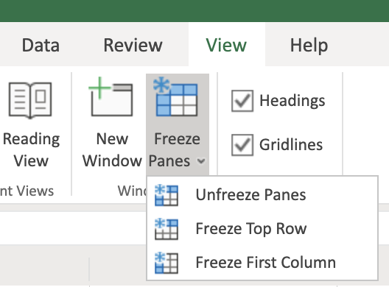

1. To freeze both the top row and the first column at the same time, select cell **B2** and click **View, Freeze Panes, Freeze Panes**.



1. You can open multiple workbooks in multiple browser tabs in Excel for the web, and to switch between them, you just click each browser tab. (In Excel Desktop you have to click the **View** tab, then click **Switch Windows**)

## **Task B: Entering Data**

1. Download the file [**Personal_Monthly_Expenditure_Lab3.xlsx**](https://cf-courses-data.s3.us.cloud-object-storage.appdomain.cloud/IBMDeveloperSkillsNetwork-DA0130EN-SkillsNetwork/Hands-on%20Labs/Lab%203%20-%20Entering%20and%20Formatting%20Data/Personal_Monthly_Expenditure_Lab3.xlsx). Upload and open it using Excel for the web. Go to the **Expense - 2018** worksheet.
2. In cell **A1**, type **Month** and press **Tab**. Then type **Housing** and press **Tab**, type **Food & Dining**, and press **Tab**, type **Personal**, and press **Tab**, type **Auto & Transport**, then press **Tab**, type **Health & Fitness**, then press **Tab**. You are now done with the header row.
3. To enter some data as rows in column **A**, in **A2**, type **Jan** and press **Enter**. Then type **Feb**, and press **Enter**, type **Mar**, and press **Enter**, type **Apr**, and press **Enter**.
4. To add another column between the **Housing** and **Food & Dining**, select column **C**, then right-click column **C**, and choose **Insert Columns**. In the top row header cell **C1**, type **Bills & Utilities**.

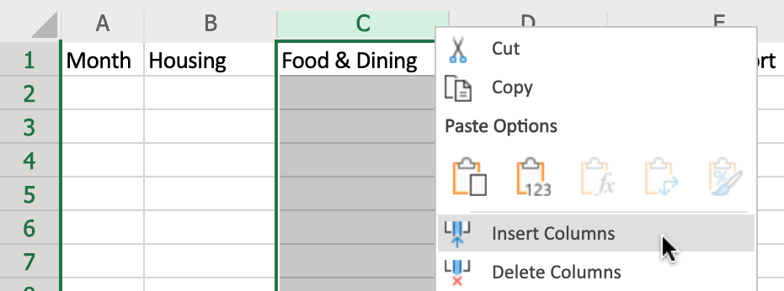

1. Select columns **A to G**, then double-click the divider between **A** and **B** to adjust the column widths.



## **Task C: Editing Data**

1. Select cell **C1** and press **Backspace** to clear the contents. Then type **Bills**.
2. Click **Undo** to undo the change.

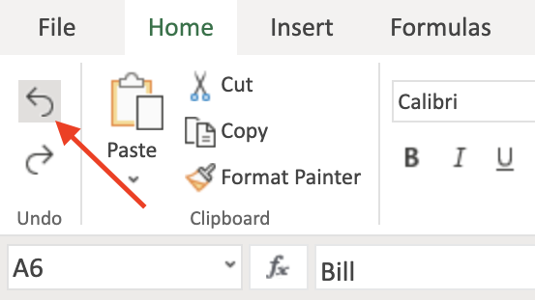

# Exercise 2: Copying, Filling, and Formatting Cells and Data

In this exercise, you will learn how to move, copy, paste, and fill data, and how to format cells and cell data in a worksheet.

## **Task A: Copying and Filling Data**

1. Select **A2:A5**. Hover over the edge of the selected cells to get the **Move** pointer and then drag the selection to move the selected cells to **B6**. Click **Undo**.

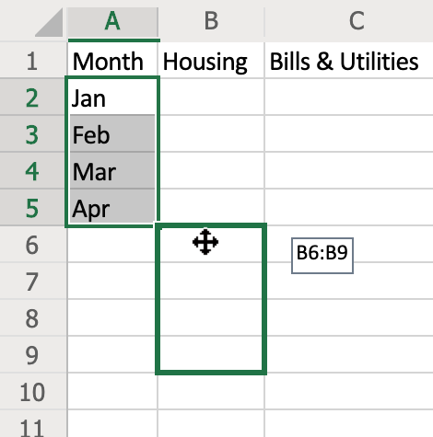

1. Select cell **A5**. Hover over the bottom right corner of cell **A5** to get the **+ (Fill Handle)** symbol, then drag to **A13**.



1. On the **Expense - 2018** sheet, select **A1:G13** and press **CTRL+C**. Then on the **Expense - 2019** sheet, select cell **A1** and press **CTRL+V**.
2. Select cell **A1** and press **CTRL+A** to select the whole datasheet. On the **Home** tab, in the **Cells** group, click the drop-down arrow under **Format**, and click **Auto-Fit Column Width**.

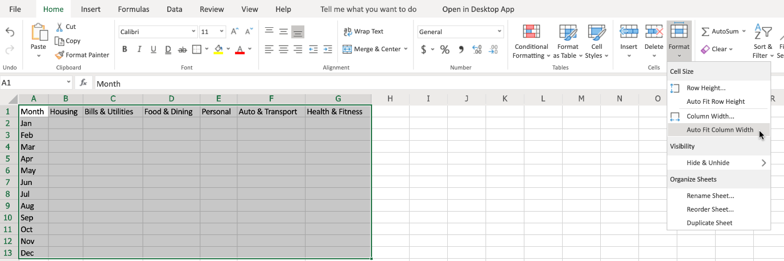

## **Task B: Formatting Cells and Data**

1. Formatting Cells:
   * a. Select **A1:G13**. On the **Home**, in the **Tables** group, click **Format as Table**, and choose a table style from the list. In the pop-up dialog box, ensure that the option **My table has headers**, is checked and then click **OK**.

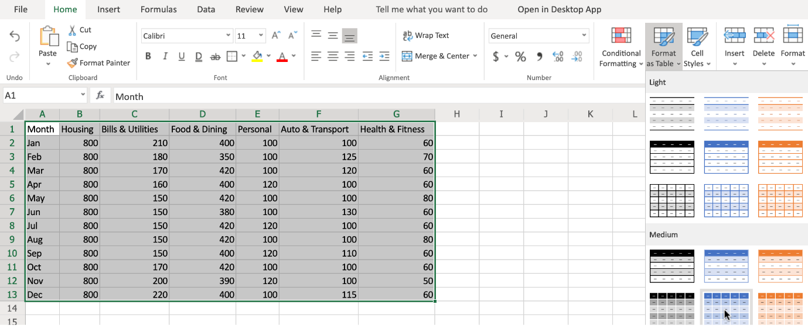

* + b. Select **A2:A13**. In the **Font** group click **Italic**. In the font size box, select **10**. In the font style drop-down box, select **Arial**.

1. Formatting Cell Data:
   * a. Select column **B**, and use **SHIFT+right arrow** to select across to include column **G**. On the **Home** tab, in the **Number** group, click the **Number Format** drop-down list and choose **Currency**.
   * b. Select columns **B** to **G** again. On the **Home** tab, in the **Number** group, click **Decrease Decimal** once.
   * c. Select columns **B** to **G** again. On the **Home** tab, in the **Number** group, click the **Accounting Number Format ($)** drop-down list, and select **£ English (United Kingdom)**.

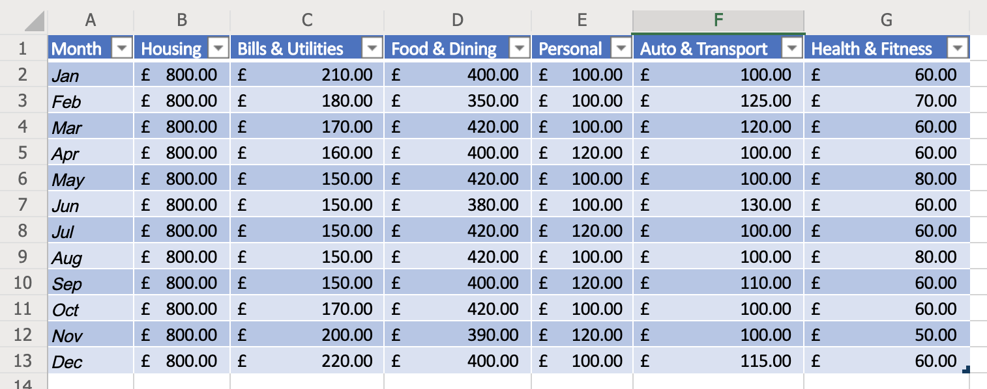

### **Congratulations! You have completed Lab 3, and you are ready for the next topic.**

# The Basics of Formulas

Now that we have learned how to move, copy, and fill data, and how to format cells and data, next we will take a look at the basics of formulas, including some basic calculations, selecting ranges in formulas, and how to copy formulas. A typical formula is made of several key components. The equal sign starts the formula off and lets Excel know you are creating a formula in this cell. The next part is the function, which performs the calculation. For example, the SUM function adds up the values in referenced cells or cell ranges. Then comes the reference, which is the cell or range of cells you want to include in your calculation, and these need to be enclosed in parentheses. You also have operators, which specify what type of calculation to perform. Common arithmetic operators include: addition, subtraction, multiplication and division. And these are represented by symbols. The plus symbol for addition, the minus symbol for subtraction, the asterisk for multiplication, and the forward slash for division. There are other types of operators too. Namely comparison, text concatenation, and reference. You may also use constants in your formulas, which as the name suggests are numbers or values which you can enter directly into a formula, and which don’t change. This might be a whole number such as 5, it might be a percentage such as 10%, or it might even be a date. So, a typical formula might be =SUM(B5*20), which would take the value in cell B5 and multiply it by 20. Let’s start with a few basic calculations. Suppose you want to add up January and February sales of accessories. You would start by typing an equal sign, which lets Excel know you are entering a formula. Then you type in the function you wish to use, in this case the SUM function. Note the description. Next you type an open parenthesis, then you select your cell range, which in this case would be E2 to E3, so you could enter that as ‘E2,E3’ then a close paranthesis and press Enter. And if you wanted to add March sales as well, then you would have to extend the cell range to include E4. So you could type E2,E3,E4 as your range and it will work. Remember, to edit a cell, you select the cell, and either edit it directly in the formula bar, or press F2, or double-click the cell. However, it’s very cumbersome and not very flexible to do it this way, because if you wanted to add up the entire column then you’d have to type every cell reference, one after the other. So thankfully, there’s a better way. Instead of typing each cell to include in the reference, you just put a colon between the first and last values in our range, so E2:E4, in this case. And if you wanted the whole column, then you would enter E2:E13 in your formula. But there’s another way of doing it, and that’s by using your mouse to select the range, so you still type =sum then open parenthesis, but select the range with your mouse (or SHIFT + arrow keys) and just press Enter. Excel will add the close parenthesis for you. To total these columns up, and add some tax, you’d add some headings first for Subtotals, and Tax at 20%. Then your formula will need to multiply the value in Subtotals by 20%. If you want to add up all the column subtotals and calculate the taxes, then you could repeat the previous process for each column, but that’s very time consuming, and you don’t need to, because Excel has some neat tricks to do this for you. Just select the fill handle in the bottom right corner of the cell, and drag across to the other cells to copy the formula; this is called AutoFill. Notice how the formula is copied, but the row references change in relation to the cells’ position on the worksheet. So what was E2:E13 has become B2:B13. These are known as relative references, but more on that later in the course. And you can do the same thing for the tax values in row 16. Now, you need a row for showing the totals. The calculation here is simply the subtotal value in cell B15, added to the tax in B16. And again, you can use the fill handle to copy the formula across. If you want to total the sales of all products by month, you’d add a column heading; notice how the cell style is copied to the new heading automatically. Remember, to widen a column, either drag the divider manually, or double-click the divider. Then enter the formula in cell F2 as you’ve done before. However, Excel has another trick up its sleeve. It’s called AutoSum and is found on the Home tab, in the Editing group. This is a great little shortcut for some simple common functions like Sum, Average, Count, Max, and Min, but you can choose other functions too. You want ‘Sum’ for this particular calculation. Notice that it also has a keyboard shortcut of ‘Alt plus equals’, and then press Enter, and it’s done. Now you can use the fill handle to copy down the remaining values. But hold on, there is one more Excel trick to show and it’s a good one! Suppose your column of data was very long; you might have to drag the fill handle down over several pages, which isn’t easy to do and can easily lead to errors when selecting large lists of data values. Rather than needing to drag down to the rest of the column, you can just double-click the fill handle, and it will automatically copy the formula to all the remaining cells in that column. This one is a real time-saver. Finally, let’s format all these values to use the US dollar currency format. In this video, we learned about the basics of formulas, how to perform simple calculations, how to select ranges in formulas, and how to copy formulas. In the next video, we will look at how to use some of the common functions used by Data Analysts and discover some more advanced functions.

# Intro to Functions

Now that you have learned about the basics of formulas, learned how to perform some basic calculations, and how to select ranges and copy formulas, next we will have an introduction to functions, including using some common statistical functions. And then we will learn about some more advanced functions that a Data Analyst might also use. First, let’s look at some common functions used for statistical calculations. So, we’ll add some row headings for average, minimum, maximum, count, and median. Then in cell B20, let’s work out the average of the car sales for the year, from the table above. On the Home tab, in the Editing group, we click the AutoSum drop-down list and choose Average. Now, because AutoSum tries to add up the values directly above it in the column, we need to modify the cell range here to B2 to B13. Then we can use the Fill Handle as we’ve seen before to copy the formula across to column E. For the minimum calculation in B21, we select Min from the AutoSum list. And again, we need to modify the cell range. So this calculates the lowest value in our range. And fill across to column E. And for the maximum calculation, we select Max from the list. And then modify the range. And once again, copy the formula across. This calculates the highest value in our range. In B23 we will calculate the Count, which basically just means the number of values that exist in the selected range. So, we select Count Numbers from the list. Then modify the range. For the median calculation, we can select ‘More Functions’ from the AutoSum list,then select ‘Statistical’ as the category, and scroll down to find the MEDIAN function. The ‘median’ returns the exact middle of a range of selected values. Note that if you’re selecting an odd number of values it will return the figure that is the middle value in your selected range, but if you have selected an even number of values in your range, it will return the middle figure between the two middle values in your range. Once again, we need to change the cell range to B2 to B13. And we can then copy this formula across to column E. You’ve seen AutoSum and some of the common statistical functions in Excel, but there are another 400-plus other functions available, so let’s explore just a few of those now. On the Formulas tab, in the Function Library group, there are drop-down lists for several function categories. The first is a list of ‘Recently Used’ functions, which updates automatically as you use them. Then you have functions related to ‘Financial’ calculations. If you hover over the name of a function, you see a short description for each one; so here we have the accrued interest function, and here is the interest rate function. The ‘Logical’ list has BOOLEAN operator functions such as AND, IF, and OR. There are several functions related to Text, such as CONCAT, which is an updated version of a previous function called CONCATENATE (which is still supported by the way for backwards compatibility), FIND, and SEARCH. There are also several functions related to dates and times, such as NETWORKDAYS, WEEKDAY, and WEEKNUM. In the ‘Lookup & Reference’ list there are functions such as AREAS, HLOOKUP, SORTBY, and VLOOKUP. In the ‘Math & Trig’ list you’ll find lots of useful mathematical functions, such as POWER, SUMIF, and SUMPRODUCT, alongside many functions for trigonometric purposes, such as cosine, sine and tangent. There is also a ‘More Functions’ list which provides several more function categories, such as Statistical, Engineering, and Information. In the ‘Statistical’ list you’ll find functions such as Average, Count, Max, Median, and Min; we saw some of these used earlier in this video. If you’re struggling to find the function you want in these lists, you can also search for a function; just click the ‘Insert Function’ button on the Formulas tab, and then either browse the category lists available, or choose ‘All’ and look down the alphabetical list for the function you want. Alternatively, type the name of a function you want to find, and click ‘Go’ to search for it, then select the one you want from the returned search. In this video, we learned about the basics of functions, how to use some of the more common functions that a Data Analyst might employ, and looked at some of the more advanced functions available in Excel. In the next video, we will look at referencing data in formulas; specifically differentiating between relative and absolute references, and error handling in formulas.

# Referencing Data in Formulas

Now that you've had an introduction to functions, seeing the use of some common statistical functions and learned about some of the more advanced functions that a data analyst might use, in this video will look at the difference between relative, absolute, and mixed references in formulas as well as how to use them. And we'll learn about formula errors in Excel. It's important to understand the difference between relative and absolute references when creating your formulas. By default, in Excel, cell references are always relative references. The term relative is the key here, because it means that when you reference a cell, you are in fact referencing the cells position in relation to the cell that the formula is in. That is why when we have been copying formulas from one cell to another so far in this course, using either copy and paste or the fill handle, we haven't needed to modify the cell references because Excel assumes you are using relative references. When the formulas are copied, the cell references are changed to match the relative positions of the cells that are being copied to. So now we know that relative references are the default in Excel, but how do we make it so that the cell references don't change when we copy them? For that you need to use absolute references in contrast to relative references. Absolute references to cells stayed the same. When you copy a formula containing such references. Lastly, there may also be some instances where you only want one of the cell reference identifiers to be absolute and the other one to be relative. For example, you might want the row identifier to be absolute, but the column Identifier to be relative, or vice versa. These are called mixed references and. An example of this would be equal sign a dollar sign one plus A3 where a dollar one. Has a relative column and an absolute row or dollar 8. Three has an absolute column. Ando relative RO. In contrast to relative and absolute references, when you copy a formula containing mixed cell references, any relative cell references will change, whereas any absolute cell references will stay the same in the copied formula. First, let's look at an example of using relative references in a formula. For example, if we enter the formula equals A1 plus a 3IN cell, four note the blue an red highlighted cells in a one, and a three. These denote the cells being relatively referenced in the formula. If we copy the formula to the cell directly below using the fill handle, we can see that the result changes, and if we look at the copied formula. You can see that the blue and red cell references have changed relative to their position on the worksheet. The formula has been changed to equals A2 plus a four in the copied formula. That is, each cell reference has moved one cell down and if we copy and paste the formula to see seven, you can see that the results also changes and again we can see that the blue and red cell references in the copied formula have changed now. Let's look at an example of how to use absolute references in a formula. All you need to do to make a cell reference absolute is put a dollar sign in front of the column and or row identifiers in the formula. For example, if we enter the formula equals dollar sign a one plus sign a dollar 3IN cell E4. Note the blue and red highlighted cells in a one and a three. These denote the cells being. Absolutely referenced in the formula. When we copy the formula using the fill handle, you can see that the result stays the same this time and if we look at the copied formula you can see that the blue and red cell references haven't changed. The formula is still equal sign dollar a dollar one plus a dollar three in the copied formula. That is, the cell references haven't changed. Similarly, if we then copy and paste the formula to E7, you can again see that the result stays the same this time and we can see that the blue and red cell references haven't changed. The formula is still equal sign dollar a dollar one plus dollar a dollar three in the copied formula. That is, the cell references haven't changed. Lastly, will look at an example of how to use mixed references in a formula so. If we enter the formula equals a dollar one plus dollar 8, three in cell G4. Note the blue and red highlighted cells in A1A three. These denote the cells being referenced in the formula. If we copy the formula to the cell below using the fill handle, you can see that the result changes, but it's a different result from the previous examples. And if we look at the copied formula, you can see that the first blue cell reference has stayed the same. But the second red cell reference has changed. If we copy and paste the formula to G7, you can see that the same thing happens. The result changes and again we can see that the first blue cell reference has stayed the same in the copied formula, while only the red cell reference has changed. Now we'll have a quick introduction to dealing with formula errors in Excel. Because of the complexity of writing formulas, especially the more complicated ones, there are bound to be occasions when you make a mistake in the syntax or in the data selection which will lead to a formula error. Errors are typically denoted by displaying in the cell that is supposed to be displaying the result. One of the error codes in this list when you see multiple hash symbols in a cell, it's not really an error, it just means the column either isn't wide enough to display the whole word or value. Or it contains a negative date or time value? So if we type control plus semi colon, then space then control plus shift plus semi colon, it enters today's date and the current time. But the cell is too narrow to display it. So what we see is multiple hash symbols. If we adjust the column width we can now see the cell contents. So as I said, this really shouldn't be considered as an error. However if we enter the formula seen in Cell I7. When we press enter, we see a hash name error. This error was caused by trying to use an X as a multiplication operator when in fact it should be an asterisk. Note the small green triangle in the top left corner of the cell. Also note that when you select the cell and exclamation mark appears, providing you with a hint about what caused the error. In this case it says the formula contains unrecognized text. When you click the dropdown error next to the exclamation mark for an error, you see several options. The first line also gives you a clue on the nature of the error. This one says invalid name error, so it was probably a mistyped cell reference value or function name. If you click help on this error, uh, help pane opens with specific information related to this error. If you click show calculation steps, a dialog box opens displaying the current syntax with the error underlined. And you can try to evaluate the error if you are certain the error is incorrect, you can choose ignore error, and if you want to edit the formula, click edit in Formula Bar and the cursor will be focused in the formula bar so that you can try and correct the formula error.

Play video starting at :8:34 and follow transcript8:34

If you click error checking options, the Excel Options Dialog Box is opened at the section related to error checking rules and you can modify these options to suit your needs. Each of the errors you make which generate one of the error codes listed at the start of this video will have a different reason and a different solution For more information on each of these errors and typical solutions visit the link provided. In this video we learned about referencing data in formulas, specifically differentiating between relative, absolute, and mixed references, and how to use them. And we learned about formula errors in Excel.

# Hands-on Lab 4: Simple Use of Functions

**Estimated time needed:** 30 minutes

In this lab, first you will learn the basics of formulas, how to perform simple calculations, how to select ranges in formulas, and how to copy formulas. Next, you will learn the basics of functions, how to use some of the more common functions that a Data Analyst might employ, and look at some of the more advanced functions available in Excel. Finally, you will learn about referencing data in formulas; specifically how to differentiate between relative and absolute references, and you will also learn about error handling in formulas.

# Software Used in this Lab

The instruction videos in this course use the full Excel Desktop version as this has all the available product features, but for the hands-on labs we will be using the free 'Excel for the web' version as this is available to everyone.

Although you can use the Excel Desktop software if you have access to this version, it is recommended that you use Excel for the web for the hands-on labs as the lab instructions specifically refer to this version, and there are some small differences in the interface and available features.

# Dataset Used in this Lab

The dataset used in this lab is an internal dataset.

# Objectives

After completing this lab, you will be able to:

* Understand the basics of formulas
* Perform simple calculations
* Select ranges in formulas and copy formulas
* Understand the basics of functions
* Use common functions
* Understand the more advanced functions available
* Reference data in formulas
* Differentiate between relative and absolute references
* Understand how to handle formula errors

# Exercise 1: Basics of Formulas

In this exercise, you will learn the basics of formulas, how to perform simple calculations, how to select ranges in formulas, and how to copy formulas.

1. Download the file [**Personal_Monthly_Expenditure_Lab4.xlsx**](https://cf-courses-data.s3.us.cloud-object-storage.appdomain.cloud/IBMDeveloperSkillsNetwork-DA0130EN-SkillsNetwork/Hands-on%20Labs/Lab%204%20-%20Simple%20use%20of%20functions/Personal_Monthly_Expenditure_Lab4.xlsx). Upload and open it using Excel for the web. Go to the **Expense - 2018** worksheet.



1. In **A14**, type **Totals** and in **B14**, type **=SUM(** then select cells **B2 to B13** with the mouse, and press **Enter**.
2. Select the **fill handle** on cell **B14** and drag to **G14** to copy the formula.



1. In cell **H1**, type **Monthly Total** and double-click the divider between **H and I**.
2. In **H2**, type **=SUM(** then select cells **B2 to G2** with the mouse, and press **Enter**. If necessary, select the **fill handle** on cell **H2** and drag to **H14** to copy the formula.
3. Select columns **B to H**. On the **Home** tab, in the **Number** group, click the **Accounting Number Format ($)** drop-down list, and select **$ English (United States)**.

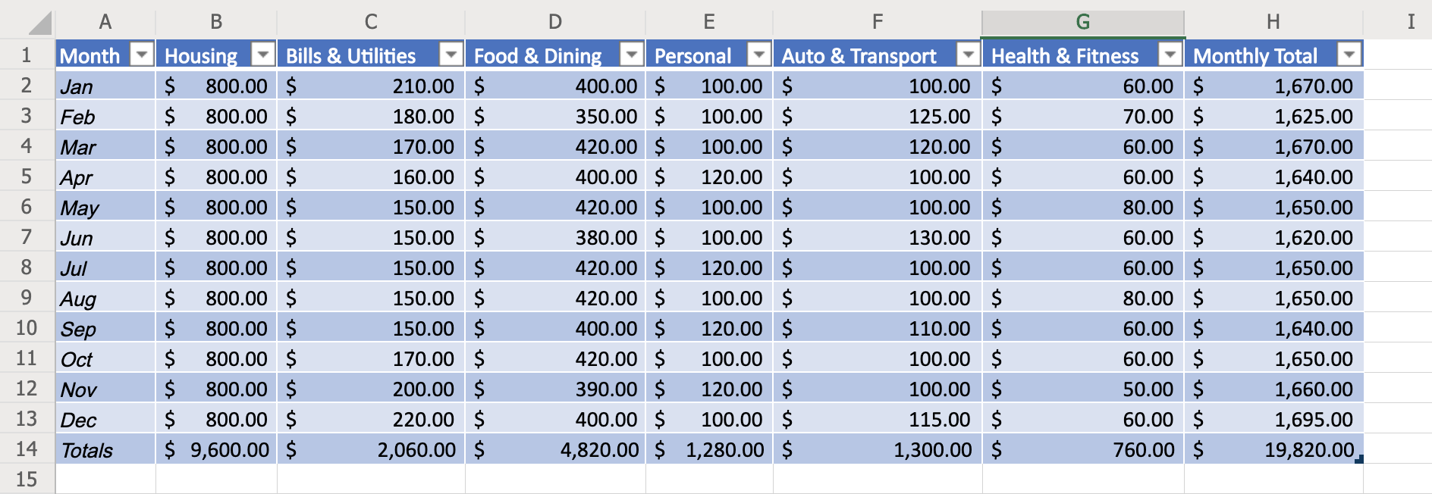

# Exercise 2: Basics of Functions

In this exercise, you will have an introduction to functions, including using some common statistical functions, and then you will learn about some more advanced functions that a Data Analyst might also use.

1. In cells **A16-A20**, type the following:
   * **Avg**
   * **Min**
   * **Max**
   * **Count**
   * **Median**
2. In **B16**, type **=AVERAGE(** then select cells **B2 to B13** with the mouse, and press **Enter**. Select the **fill handle** on cell **B16** and drag to **G16** to copy the formula.
3. In **B17**, type **=MIN(** then select cells **B2 to B13** with the mouse, and press **Enter**. Select the **fill handle** on cell **B17** and drag to **G17** to copy the formula.
4. In **B18**, type **=MAX(** then select cells **B2 to B13** with the mouse, and press **Enter**. Select the **fill handle** on cell **B18** and drag to **G18** to copy the formula.
5. In **B19**, type **=COUNT(** then select cells **B2 to B13** with the mouse, and press **Enter**. Select the **fill handle** on cell **B19** and drag to **G19** to copy the formula. Select row **19**. On the **Home** tab, click the **Number Format** drop-down list, and select **Number**.
6. In **B20**, type **=MEDIAN(** then select cells **B2 to B13** with the mouse, and press **Enter**. Select the **fill handle** on cell **B20** and drag to **G20** to copy the formula.

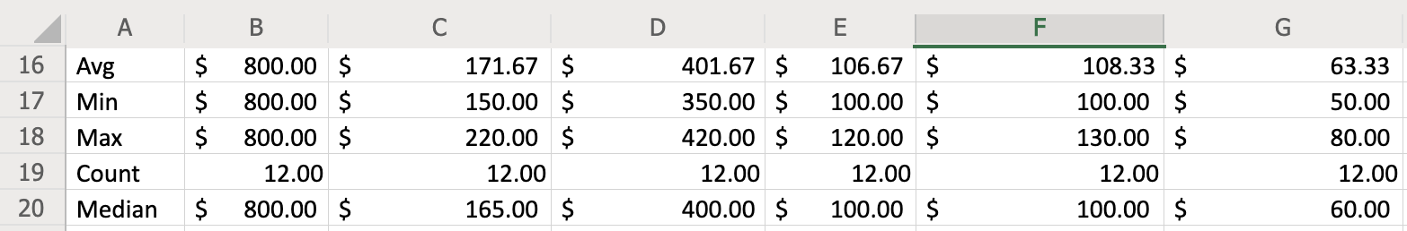

1. Explore some more commonly used functions of a data analyst by clicking the arrow under **AutoSum**, then select **More Functions** and look at some of the functions in various categories to see what actions they perform:
   * Financial : **ACCRINT, INTRATE**
   * Logical : **AND, IF, OR, NOT**
   * Text : **CONCAT, FIND, SEARCH**
   * Date & Time : **NETWORKDAYS, WEEKDAY**
   * Lookup & Reference : **AREAS, SORTBY, VLOOKUP, HLOOKUP**
   * Math & Trig : **POWER, SUMIF, SUMPRODUCT**
   * Statistical : **AVERAGE, COUNTIF, MAX, MEDIAN, MIN**

# Exercise 3: Referencing Data in Formulas (relative vs absolute) & Formula Errors

In this exercise, you will learn how to reference data in formulas; specifically differentiating between relative and absolute references, and you will also learn about error handling in formulas.

1. In cells **A31-A40**, type **1-10**. Select row **31 to 40**. On the **Home** tab, click the **Number Format** drop-down list, and select **General**.
2. Relative References : In cell **B33**, type **=A31+A32** and press **Enter**. Select the **fill handle** on cell **B33** and drag to **B40** to copy the formula. Here, both first and second cell reference will move 1 cell down. For example, on cell **B34** formula will be changed to **=A32+A33**, on cell **B35** formula will be changed to **=A33+A34** and so on.
3. Absolute References : In cell **C33**, type **=$A$31+$A$32** and press **Enter**. Select the **fill handle** on cell **C33** and drag to **C40** to copy the formula. Here, both first and second cell references will not change. For example, on cell **C34** formula will remain **=$A$31+$A$32**, on cell **C35** formula will remain **=$A$31+$A$32** and so on.
4. Mixed References : In cell **D33**, type **=$A$31+$A32** and press **Enter**. Select the **fill handle** on cell **D33** and drag to **D40** to copy the formula. Here, first cell reference will stay the same, but the second reference will change. For example, on cell **D34** formula will be changed to **=$A$31+$A33**, on cell **D35** formula will be changed to **=$A$31+$A34** and so on.

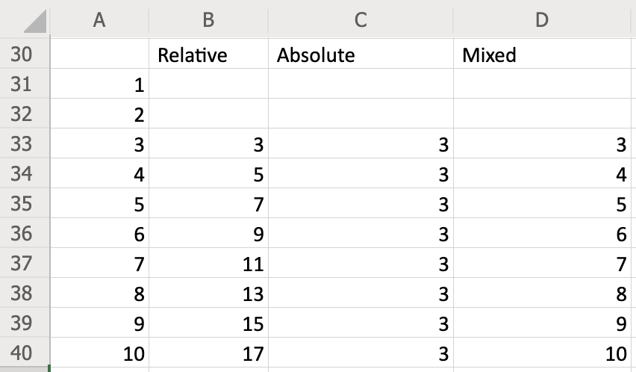

1. In cell **B31**, type **=A16+A17**. Now this will lead to a formula error **#VALUE!** since cells **A16** and **A17** do not contain any number.

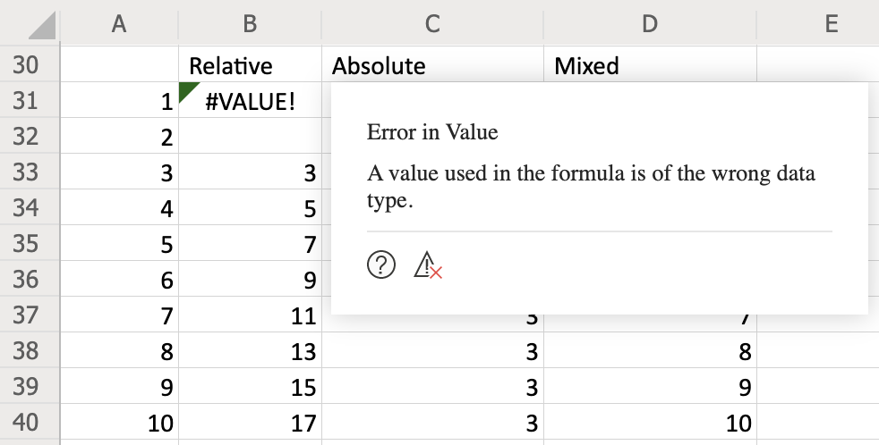

1. Click the **question mark icon** in the error message box. This will open the **Help** for this topic. Read through this help file for more information about **#VALUE!** errors in formulas.

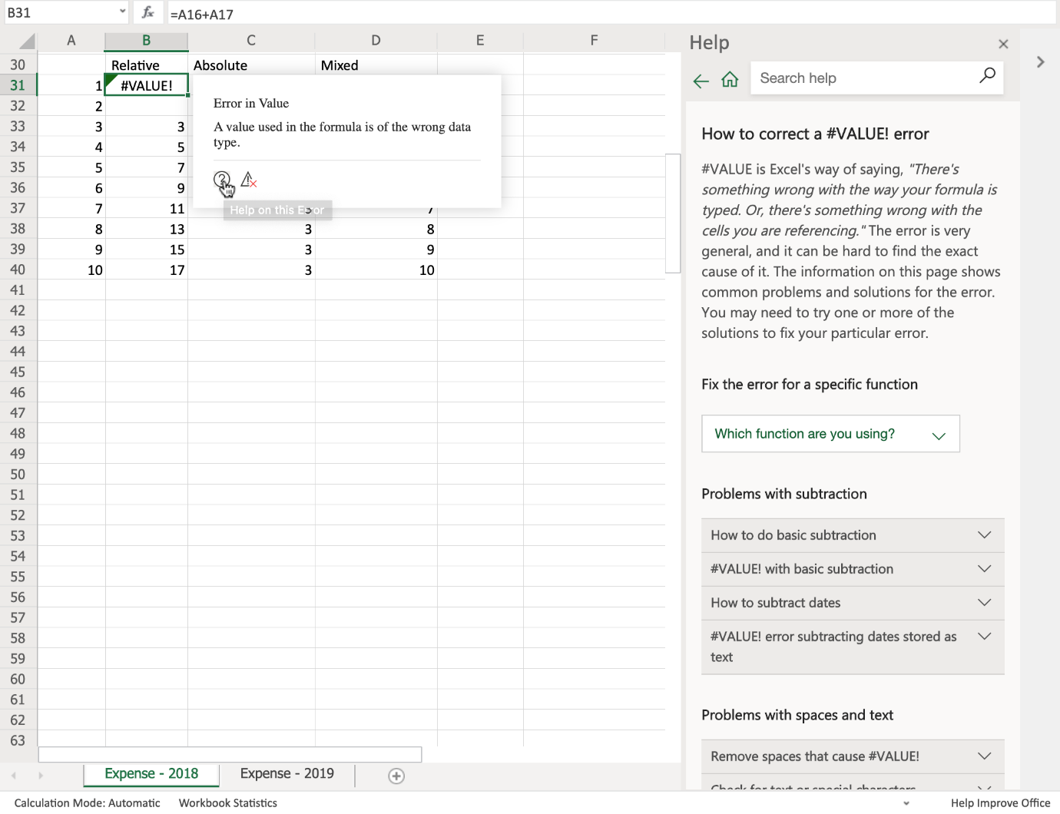

### **Congratulations! You have completed Lab 4, and you are ready for the next topic.**

# Basics of Data Privacy

In this video, we will learn about data privacy and the regulations that govern the collected data. When collecting customer data, specific regulations apply to how that data can used. By understanding data privacy regulations and getting familiar with the following three fundamentals, you can eliminate the risk of financial penalties and keep the trust of your customers. Confidentiality, Collection and Use, and Compliance. Confidentiality is an important element in data privacy and it acknowledges that the customer’s personal information belongs to them. The types of information that can be accessed by a data analyst can range from sales forecasts, to employee information, or even patient records. When accessing these types of records the analyst must be able to recognize the different types of personal data. Personal Information or PI is any type of information that can be traced back to a specific individual. This type of information can include anything from emails to images. Personally Identifiable Information or PII is specific information that could be used to identify an individual. This type of information could include a social security number or a driver’s license number. And lastly , Sensitive Personal Information or SPI, may not necessarily identify a specific individual, but contains private information that needs to be protected because if made public it could possibly be use to harm the individual . The type of information can include data about race, sexual orientation, biometric or genetic information. By understanding personal data and the associated regulations, we can efficiently anonymize our data by removing unnecessary information. This type of action can help build consumer confidence and continue to develop the free flow of information. When searching through data, the analyst must know the location of the company collecting the data and the location of the respondent. Knowing where the data was collected is an essential element of data privacy and what regulations must be applied.The General Data Protection Regulation or GDPR is a regulation specific to the European Union, and only applies to the jurisdiction of the individual. A new law created in Brazil, the LGPD, will take effect in August 2020. These new data policy regulations apply to individuals within Brazil, and ignores the location of the data processor. While the United States does not have one country-wide principle law for data privacy. Because of this individual states began to make their own regulations. For instance, California created the California Consumer Privacy Act (CCPA) to better protect customer data. There are also industry specific regulations that govern the collection and use of sensitive and personal data. For example, in Healthcare, HIPAA privacy rules govern the collection and disclosure of protected health information. In retail, the PCI standards govern credit card data, and failure to safeguard cardholder information can result in hefty fines. With a basic understanding of these policies, we are able to remain compliant when handling any sensitive information. Unfortunately, breeches in customer data is an all too common occurrence and understanding how to remain compliant is essential. Understanding the data privacy regulations of the European Union, the United States, and other countries as well as industries is key to keeping data safe. Companies must comply with these privacy regulations at all times and also make sure policies are readily accessible to employees. For example, let’s say a data analyst downloads a spreadsheet of sensitive information. In order to complete the report by Monday morning, the analyst decided to take their work laptop home for the weekend. After driving home, the analyst accidently left the laptop in their car. The next morning, they found their car had been stolen along with the laptop. Because it is the responsibility of the company to keep customer data safe, this was a breach of privacy when the data left company property. This type of action could not only cost the company large amounts of money in fines and penalties, but could also reduce consumer confidence causing a significant impact to revenue. While data privacy applies to most data that is collected, there are some instances where these regulations do not apply. In order for these laws and regulations not to apply, the particular collection of data must be completely anonymous. To make data anonymous means to exclude all data which ties it back to a particular individual. While this approach might not be practical in all circumstances, collecting data with privacy in mind could remove privacy limitations and make data collections more accessible. In this video we learned about the importance of data privacy and the challenges that a data analyst can face when collecting and sorting through data. In the videos in the next lesson, we will learn about different methods for cleaning data in a spreadsheet.

# Removing Duplicated or Inaccurate Data and Empty Rows

Now that we have learned about the importance of data quality and data privacy, in this video we will learn how to deal with inaccurate data, how to remove empty rows, and how to remove duplicated data. It’s very common when collecting or importing data - whether through manual or automated processes - to get errors and inconsistencies in your data. This can be as simple as spelling mistakes, extra white space, or the wrong case used in text, to empty rows or missing values in your data, to inaccurate or duplicated data. Having these errors and inconsistencies in your data can lead to issues with formulas not working, with unsuccessful sorting and filtering operations and therefore inadequately visualized and presented data findings. These data errors and inconsistencies require you to carry out some form of data-cleaning routine to improve the quality and usability of the data. Let’s start off with one of the easier of those tasks, which is spell checking. In Excel, this works in pretty much the same way as you may have already encountered in applications such as Microsoft Word or other common word processing applications. I have some data here relating to the sales of toy vehicles, and the first thing we need to do is select what data we wish to check for spelling; in this case we will try column K which contains the product line data. Then we click Spelling which is on the Review tab. Well that seems to be OK, so let’s try the Country information in column T. So, we do have an error here, where a country name has been misspelt, or more likely, mistyped. We just click Change if we are happy with the spelling suggestion, or we could choose another suggestion from the list, or even ignore this error if we know the data is correct, but in this case we will change it. Here’s another typo for a country name and here’s one more. So, that seems to be all the errors in this column, let’s try the final column now which is the deal size in column X. Here is a misspelling of the word small and another for medium. And that seems to be all for this column. The next inconsistency we will look for is empty rows. Empty rows in your data can cause lots of issues relating to moving around your data, working with formulas, and sorting and filtering. Therefore, it’s very important to remove them from your data. If you remember from an earlier lesson, when we click CTRL+DOWN ARROW, it should take us to the end of that column of data, but notice if we do that in this dataset, the cursor keeps stopping when it gets to an empty row meaning that the dataset if essentially being split into multiple sections, separated by these empty rows. That’s not good, so let’s resolve that now. We have a couple of options; one option is to just manually scroll down the sheet looking for empty rows and deleting each one, which is easy enough, and fine to do if you only have a small amount of data, but imagine if you were dealing with hundreds, or thousands, or even tens of thousands of rows? That would be a very laborious and time-consuming process. There is a much better way - which involves selecting all our data first, either using the mouse, or the CTRL+SHIFT+END keyboard shortcut. Then we select the Filter icon on the Data tab. We can now see that each column has a filter icon next to the column header. If we then select the Customer Name column-filter in column M then uncheck Select All then scroll down to the bottom of the list, we can check the item called Blanks, and then click OK. This will now show only the empty rows at the top of our sheet; this can be quite hard to see, but if you look in the row numbers, you can see that rows 28,29,65,73,74,75 and 117 are listed at the top and are highlighted in blue text. We can now select these rows, either using the mouse or going to the first cell in the first data row, which is A28, and then using the CTRL+SHIFT+END keyboard shortcut then delete the offending empty rows. We then need to clear the filter and turn it off, so we can view our data again. Now, if we go back to the first row in the top of the datasheet and try the CTRL+DOWN shortcut again, to go to the end of the data column, it will work. The next inconsistency we’ll look for is duplicated rows of data; it’s quite common for duplicate data rows to exist in your imported data, caused either by human input error, or an error in the import process. There are two ways of doing this in Excel; the first way includes reviewing the data you plan to remove first, before deleting it, to ensure you are deleting the right data. This is our preferred method as it provides an additional level of data security. The second method, which we will also show you, is simpler, as you don’t review the data to be removed first, but it lacks the security of the first method. It’s important to select a column of data that you would NOT expect to have duplicate values in. For example, if we consider the Price Each column, which is C, we would expect lots of these values to be repeated, because the unit price of some products is the same, so this is a bad example of a column to use to find duplicates. Instead, let’s use the Sales column in column E, because it is far less likely that these values will be duplicated in the normal process of things, as they are the total sales for each order. So, we select the column…and choose Conditional Formatting, then Highlight Cells Rules, and then Duplicate Values. When we click OK, and scroll down the sheet, we can see that only a few values have been identified as being duplicates. There seem to be duplicate values in rows 36 to 40 and in rows 74 to 78 Let’s zoom out so we can see both duplicate sections together. It seems like these are in fact exact duplicate entries, and are likely to be an input error. Let’s delete the second section of duplicate rows as they are out of sequence; as they relate to Motorcycles sales and are in the Ships section of the sheet. So that was the first, and recommended method of removing duplicate rows of data, which previews the data to be removed first. Now, let’s try the second, simpler, but less secure method. Let’s go back to 100% zoom, and go back to the top of the worksheet. This time, we select the whole datasheet, and on the Data tab, we use the Remove Duplicates button. We then unselect all the columns, then only select the Sales column. And the duplicate rows are deleted. The last cleaning process we’ll look at in this video is using the Find & Replace feature to repair some misspelt surnames in the customer contacts column. Find and Replace tools are under Find & Select on the Home tab in Excel, and if you have used other Office products such as Word, it should be familiar to you already. We’ve had an email from a Swedish customer, informing us that we have his surname spelt incorrectly on his order sheets. So, we type the misspelt surname in to the ‘Find what’ box and click Find Next, then click it again to see there are multiple incorrect entries. If we click Find All, all instances are listed, and we can open the Replace tab to enter a name to replace the incorrect spellings. His surname should be Larsson with a double ‘s’, so we’ll replace all instances with that corrected spelling. That looks better, and we are finished. In this video, we learned how to deal with inaccurate data, how to remove empty rows, and how to remove duplicated data. In the next video, we will look at changing the case of text, fixing date formatting errors, and trimming whitespace from data.

# Dealing with Inconsistencies in Data

Now that we’ve learned how to deal with inaccurate data, how to remove empty rows, and how to remove duplicated data, in this video we’ll look at changing the case of text, fixing date formatting errors, and trimming whitespace from data. When you collect or receive data from varying sources, it’s quite common to find that your data contains text in mixed case; that is, some in uppercase, some in lowercase and some in capitalized proper case (also known as sentence case). Some of this may be intentional; but often it’s not. Excel doesn’t have a Change Case button like there is in Microsoft Word, so you need to use other methods to perform this data cleaning task. Those methods are functions; namely the UPPER, LOWER, and PROPER functions. You can use these functions to help you change the case of text in your data. You can see that the header row here is using all uppercase characters, so if you want to change that to use proper case then you need to add another row to put the function in; this is referred to as a ‘helper’ row. The PROPER function is simple to use; just type equals, then PROPER, then open parenthesis, then the cell reference - In this case A1 - then close parenthesis, and press Enter. Here you can see that the result in A2 is in proper case. Now you can try and drag the formula right across to column X by using the Fill Handle on A2... but this can be very tricky when you have a lot of columns, so let’s try another way. Instead of dragging, you can use SHIFT+RIGHT ARROW to select the columns across to X first then press F2 to bring the cursor into focus in cell A2 then you hold down the CTRL key while you press Enter, and it fills across for you. You might think that you could now remove the original row; but look what happens when you do; you get a REF error because the formula is referencing an invalid reference, and the header row cells now contain just the failed formula rather than the actual header text. So, you need to undo that, and instead, you copy the contents of the helper row to row 1 but when you paste you need to choose the Paste Values option. Now the header row cells just contain header text, and you can remove the helper row in row 2. Let’s now use the UPPER function to change text from proper case to upper case. Insert a column to the right of the column you want to change. This will be a ‘helper’ column. Then you type the formula containing the UPPER function in the first data cell in this new helper column. Again, it’s a simple formula; you type equals, then UPPER, then open parenthesis, then the cell reference – in this case T2 – and then close parenthesis and press Enter You can see the result is the country name in upper case, and you can then copy that formula down the rest of the column by double-clicking the Fill Handle cross symbol. As before, you then copy and paste the contents of the helper column to the original column, but use the Paste Values option. Now you can delete the helper column Next, we’ll use the LOWER function to change text from proper case to lower case. As before, you insert a column to the right of the column you want to change. This will be another ‘helper’ column. Then you type the formula containing the LOWER function in the first data cell in the helper column. Once again, it’s a very simple formula; you type equals, then LOWER, then open parenthesis, then the cell reference – in this case K2 – and then close parenthesis, and press Enter You can see the result is the product line data in lower case, and you can now copy the formula down to the rest of the column by double-clicking the Fill Handle once more. As before, you then copy and paste the contents of the helper column to the original column, but ensuring you use the Paste Values option. Now you can delete the helper column It’s quite common to receive data that has a mixture of date formats, or that uses a date format that isn’t suitable to your region. Now let’s look at how to change the format of some dates. You can see that this date format is currently using a 2-digit day, a 2-digit month, and a 4-digit year value. When you open the Number format dialog box, you can see in the Locale box, that this is an English (United Kingdom) date format. You want to use a US date format, so you first change the locale to English (United States). In this list, you can see there are several date options to choose from; let’s choose one which uses the full month name, then a 2-digit day, and a 4-digit year value. You could then copy this format to the rest of the date cells. However, if you want to format these dates using your own custom format, you can do that too. In the Number format list, you select Custom, and then choose an existing format that is similar to what you want and simply modify it to create a new custom format; here we’ll have the day, then 3-letter month, then 4-digit year. To apply that new custom date format to the rest of the column you could either use the Format Painter tool, or you can select the rest of the column and choose the new custom format from the Custom list in the Number Format dialog box. You might find that your data has some whitespace; that is, unwanted spaces in your data. Here you can see that we have some spaces at the start some spaces at the end and some unwanted double spaces in the middle of our data. We’ll first have a look at what you can do to clean up these unwanted spaces in your data by using the Find & Replace feature in Excel. So you first select all the data then on the Home tab, you click Find & Select, then Replace. To get rid of double spaces, you enter a double space in the ‘Find what’ box, and a single space in the ‘Replace with’ box. Then you click Find Next. And choose Replace for each item you want to change. You could click Replace All to do all the fixes in one go but unless you are absolutely sure of the changes, it’s better practice to check and replace each one in sequence in case there are some valid reasons for these extra spaces. If you have a very large dataset you might also choose Replace All to save you a lot of time. So using the Find & Replace feature got rid of most of those unwanted whitespaces, but not all of them; we removed double spaces using that feature, but we also have some single spaces left at the start and end of some of the cells. You can’t use Find & Replace to remove single spaces otherwise you would lose ALL spaces in your data - including standard spaces between words - which you don’t want to remove. But, there is another tool you can use to clear spaces from cells, and that’s the TRIM function. To use the TRIM function, you once again insert a helper column. The TRIM function is simple to use; just type equals, then TRIM, then open parenthesis, then the cell reference – in this case M2 – then close parenthesis, and press Enter. You can then double-click the Fill Handle symbol to copy this formula down to the remainder of the column. Now you need to copy the contents of the new column N to column M, and remember once again to paste using the Paste Values option. You can now see that those erroneous spaces have been removed, or more accurately speaking, have been trimmed. And lastly, you can remove the helper column. In this video, we learned how to change the case of text, how to change date formatting, and how to trim whitespace from data. In the next video, we will discuss how to use the Flash Fill and Text to Columns features in Excel to help clean data.

More Excel Features for Cleaning Data

Now that we’ve learned how to change the case of text, how to change date formatting, and how to trim whitespace from data, in this video we’ll discuss how to use the Flash Fill and Text to Columns features in Excel to help clean data. We used Flash Fill briefly earlier in the course as a quick method of entering data that fits a specific pattern, such as the names of months or days of the week, but it can also be useful as a data cleaning tool. It can split a column of full names into two separate columns for the forename and surname, and it can also help to modify the naming convention used in a column of names. For example, in the vehicle toy sales worksheet there is a column containing the last names of contacts, and another containing their first names. If you want to use the Flash Fill feature to combine these names into one name column, you first insert a helper column; let’s call it ‘Contactname’. Then, in the first row in the new column you enter the full name of the first contact in the format of your choice; for example you might want surname, then a comma, then the forename, or you might want surname, and just an initial, and so on; in this case let’s just enter the name in the standard format of forename then surname with a space between them, and then we press Enter. Next you start typing the second contact’s name in, and you’ll see that Flash Fill displays a preview of the remaining names for you. If you’re happy with what’s in the preview, all you have to do is press Enter, and it fills in the remaining names for you right down the column. It even works when there are two names in one of the columns such as Wing C here … and Da Cunha here. Now you can remove the original columns if you no longer need them. So, in the previous task we saw how to combine two columns of data into one column using Flash Fill; now let’s see how to use it to modify the naming convention in a column. Let’s switch to the customer contacts worksheet. Then in the first data row of the next column, that is B2, we type the name of the first contact using whatever naming convention we want. We’ll use surname, then comma, then a space, then the forename, and press Enter. Again, when we start typing the second contact’s name in the next row down, that is B3, Flash Fill detects the pattern and fills in the remaining names in column B when we press Enter. You could then copy and paste the column header, and delete the original column A. What we couldn’t do with Flash Fill was take a single column with two names in and split that into two separate columns. We need to use the ‘Text to Columns’ feature to do that. So, we’ll close this worksheet and we won’t save the changes. Now, let’s see how the ‘Text to Columns’ feature can help with data cleaning too. As the name suggests, and unlike Flash Fill, the ‘Text to Columns’ feature can take a column containing multi-part text and split that text into one or more other columns. This can be useful for splitting any multi-part text, such as names or addresses, into separate component parts. Let’s open the customer contacts worksheet again. Then we’ll add column headings for the next two columns, and copy the cell format used in the first column header. Then we’ll widen the columns. If we then select the data in column A from A2 to A23, and on the Data tab, click Text to Columns, a wizard is launched. On the first page of the wizard, ensure that ‘Delimited’ is selected. On the second page, ensure that only ‘Space’ is selected as the delimiter. On the third page of the wizard, click the little arrow next to ‘Destination’… and select cell B2 on the worksheet, then click the little arrow again to return to the wizard. We’re now finished with this wizard. You can see that the full customer contact names in column A have now been successfully split into two new columns in B and C, and you could now remove column A if you no longer need it. We’ll close this worksheet, and again we won’t save the changes. You can also achieve the same result using functions. This would be required if you were using ‘Excel for the web’, the online version of Excel, as this doesn’t have the ‘Text to Columns’ feature. There’s also a bit more flexibility with functions, which can be especially useful if you have names that are complex and mixed, such as having hyphenated names or some names with a middle initial, some with two middle initials, and some with no middle initial. So, we open the customer contacts worksheet again. Then we’ll add column headings for the next two columns, and copy the cell format used in the first column header. Then we’ll widen the columns. Next, we enter the formula in B2 to extract the forename part of the name. This formula extracts five characters from cell A2, starting from the left and including the space. Then, in cell C2 we enter the formula to extract the surname part of the name. This formula extracts seven characters from cell A2, starting from the right. Then we double-click the Fill Handle in cell B2 to use AutoFill to complete the column. And we do the same to the Fill Handle in cell C2 to use AutoFill to complete that column also. In this video, we learned how to use the Flash Fill and Text to Columns features in Excel to help clean data.

# Hands-on Lab 5: Cleaning Data

**Estimated time needed:** 45 minutes

In this lab, first you will learn how to deal with inaccurate data, how to remove empty rows, and how to remove duplicated data. Next, you will learn how to change the case of text, how to change date formatting, and how to trim whitespace from data. Finally, you will learn how to use the Flash Fill feature and functions in Excel to help clean data.

# Software Used in this Lab

The instruction videos in this course use the full Excel Desktop version as this has all the available product features, but for the hands-on labs we will be using the free 'Excel for the web' version as this is available to everyone.

Although you can use the Excel Desktop software if you have access to this version, it is recommended that you use Excel for the web for the hands-on labs as the lab instructions specifically refer to this version, and there are some small differences in the interface and available features.

# Dataset Used in this Lab

The dataset used in this lab comes from the following source: [https://dataplatform.cloud.ibm.com/exchange/public/entry/view/f8ccaf607372882403a37d9019b3abf4](https://dataplatform.cloud.ibm.com/exchange/public/entry/view/f8ccaf607372882403a37d9019b3abf4?utm_medium=Exinfluencer&utm_source=Exinfluencer&utm_content=000026UJ&utm_term=10006555&utm_id=NA-SkillsNetwork-Channel-SkillsNetworkCoursesIBMDeveloperSkillsNetworkDA0130ENSkillsNetwork20531059-2022-01-01). This dataset is published by **IBM**, and includes fictitious customer demographics and sales data.

We are using a modified subset of that dataset for the lab, so to follow the lab instructions successfully please use the dataset provided with the lab, rather than the dataset from the original source.

# Objectives

After completing this lab, you will be able to:

* Understand how to deal with irrelevant or inaccurate data
* Remove empty rows and duplicated data
* Change text case and date formatting
* Trim whitespaces from data
* Use Flash Fill and functions to clean data

# Exercise 1: Removing Duplicated, Irrelevant or Inaccurate Data

In this exercise, you will learn how to deal with inaccurate data, how to remove empty rows, and how to remove duplicated data.

## **Task A: Check spelling**

1. Download the file [**Customer_demographics_and_sales_Lab5.xlsx**](https://cf-courses-data.s3.us.cloud-object-storage.appdomain.cloud/IBMDeveloperSkillsNetwork-DA0130EN-SkillsNetwork/Hands-on%20Labs/Lab%205%20-%20Cleaning%20Data/Customer_demographics_and_sales_Lab5.xlsx). Upload and open it using Excel for the web.
2. Select column **L (CREDITCARD_TYPE)**, then click **Review** tab, and select **Spelling**.
3. Click the correct suggestion to change the spelling.
   * **Note:** Don’t change ‘jcb’ spelling when doing the spell check. We will need 'jcb' for the Exercise 1 Task D.
4. Close the **Spelling** pane.

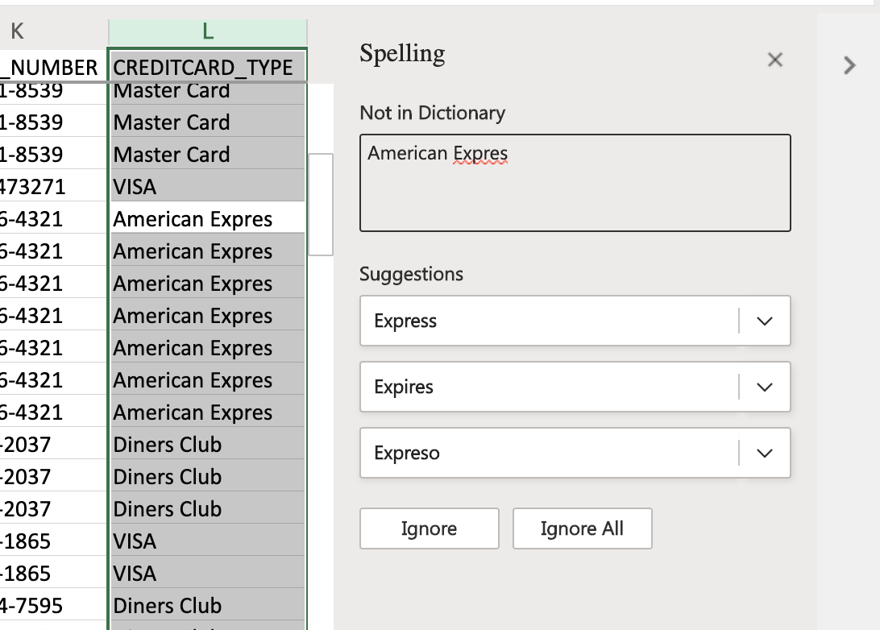

## **Task B: Remove empty rows**

1. Press **CTRL+HOME**, then press **CTRL+SHIFT+END** to select the whole datasheet.
2. On the **Data** tab, click **Filter**.
3. Press **CTRL+HOME**, click the **filter arrow** in the **CUST_NAME** column, and then click **Filter**.
4. Click the **Select All** checkbox to deselect all of them. Then select just **Blanks**, then **OK**.
5. Select **first row**, then press **CTRL+SHIFT+END** to select all rows.
6. Right-click the selected rows and then click **Delete Rows**.
7. Finally, on the **Data** tab, click **Clear**, then click **Filter**.

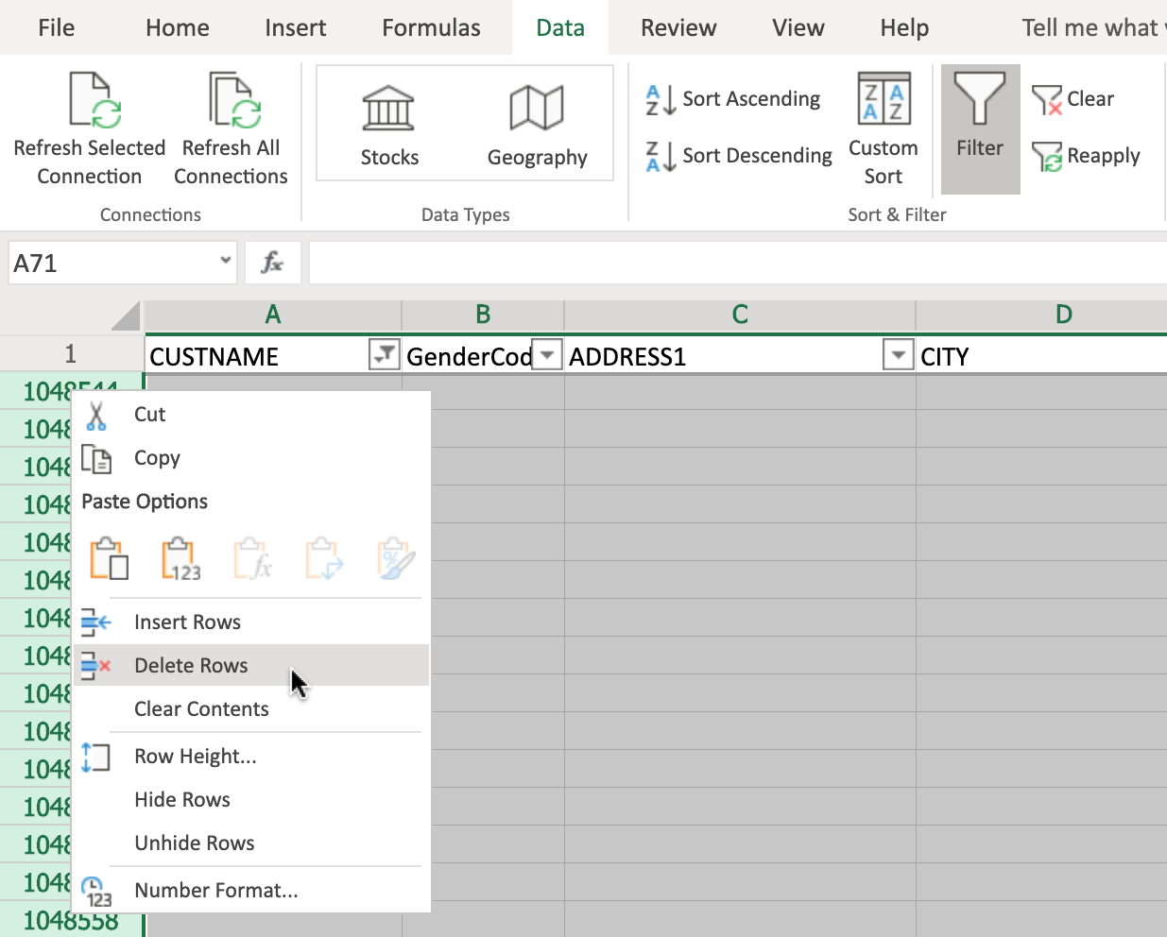

## **Task C: Remove duplicate rows**

1. Select Column **T (ORDER_ID)** since ORDER_ID values are unique.
2. On the **Home** tab, click **Conditional Formatting> Highlight Cells Rules> Duplicate Values**, and then click **OK**.
3. Select the whole datasheet **(CTRL+SHIFT+END)**
4. On the **Data** tab, click **Remove Duplicates**.
5. In the Remove Duplicates dialog box, ensure that **Select all columns** is checked and that **My data has headers** is also checked, then click **OK**.
6. In the pop-up box informing you how many duplicate values were found and removed, click **OK**.

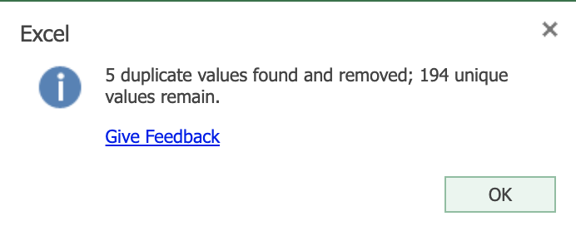

## **Task D: Use Find & Replace to correct misspelling**

1. On the **Home** tab, click **Find & Select**.
2. Click **Find**. In Find what, type **jcb**, and click **Find All**.
3. Click **Replace**.
4. In Replace with, type **JCB**, click **Replace All**, and then click the **Close** icon.
5. On the **Home** tab, click **Conditional Formatting> Clear Rules> Clear Rules from Entire Sheet**.

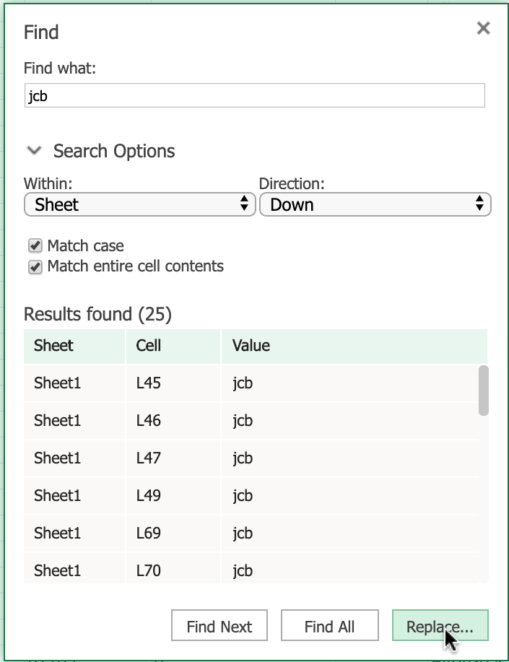

# Exercise 2: Dealing with Inconsistencies in Data

In this exercise, you will learn how to change the case of text, how to change date formatting, and how to trim whitespace from data.

## **Task A: Use the PROPER function to change text from upper case to proper case**

1. Select row **2**, then right-click it and choose **Insert Rows**.
2. In cell **A2**, type **=PROPER(A1)** and press **Enter**.
3. Hover over the bottom-right corner of cell **A2**, and drag the **Fill Handle** across to the last column.
   * If dragging across is too difficult with the mouse, then select the cells in the row 2 using **SHIFT+RIGHT ARROW**, then press **F2** to put the cursor focus back in cell **A2**, then hold **CTRL** while you press **Enter**.
4. Select row **2**, then press **CTRL+C**.
5. Select row **1**, Right-click and choose **Paste Options>Values**.
6. Select row **2**, right-click it and choose **Delete Rows**.

## **Task B: Use the UPPER function to change text from proper case to upper case**

1. Select column **AG (Generation)**. Then right-click and choose **Insert Columns**. In cell **AG1**, type **Generation**.
2. In cell **AG2**, type **=UPPER(AH2)** and press **Enter**.
3. Hover over the bottom-right corner of cell **AG2** and double-click the **Fill Handle**.
4. Select column **AG**, then press **CTRL+C**.
5. Select column **AH**, right-click and choose **Paste Options>Values**.
6. Select column **AG**, right-click it and choose **Delete Columns**.

## **Task C: Use the LOWER function to change text from proper case to lower case**

1. Select column **AC (T_Type)**. Then right-click and choose **Insert Columns**. In cell **AC1**, type **T_Type**.
2. In cell **AC2**, type **=LOWER(AD2)** and press **Enter**.
3. Hover over the bottom-right corner of cell **AC2** and double-click the **Fill Handle**.
4. Select column **AC**, then press **CTRL+C**.
5. Select column **AD**, right-click and choose **Paste Options>Values**.
6. Select column **AC**, right-click it and choose **Delete Columns**.

## **Task D: Change date formatting**

1. Select column **Z (Order_Ship_Date)**.
2. On the **Home** tab, in the **Number** group click **Number Format> More Number Formats**.
3. In the Category list, select **Date**.
4. In the **Format Cells** box, under **Locale**, select **English (United States)**.
5. Under **Type**, select **Wednesday, March 14, 2012** and click **OK**.

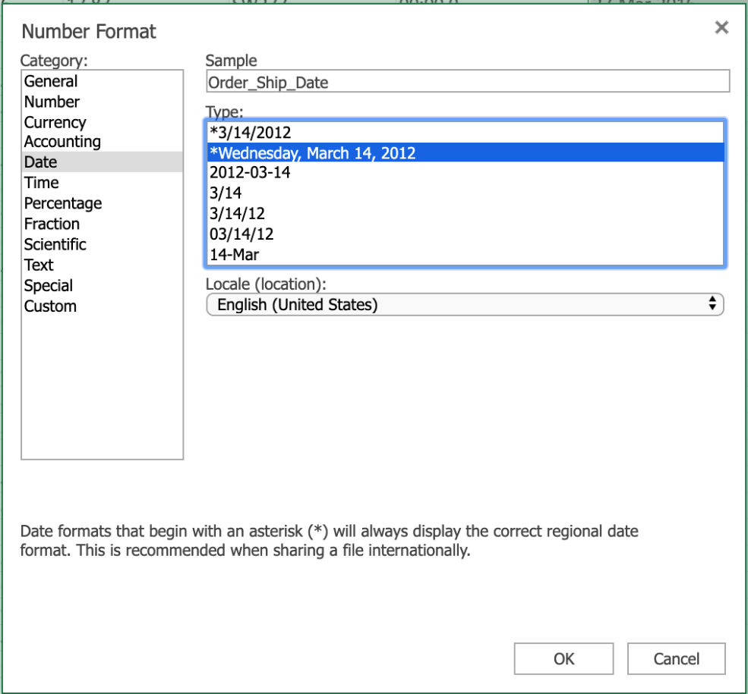

## **Task E: Use Find & Replace to trim whitespace**

1. Click **CTRL+HOME**.
2. Select all the data using **CTRL+SHIFT+END**.
3. On the **Home** tab, click **Find & Select**, then **Replace**.
4. In Find what, type **2 spaces**. In Replace with, type **1 space**.
5. Click **Find All**, then click **Replace All**.
6. Click the **Close** icon.

# Exercise 3: More Excel Features for Cleaning Data

In this exercise, you will learn how to use the Flash Fill feature and functions in Excel to help clean data.

## **Task A: Use the Flash Fill feature to clean data:**

1. Select column **A (Cust_Name)**, right-click and choose **Insert Columns**.
2. In cell **A1** type **Customer_Name** and press **Enter**.
3. In cell **A2**, type **Mr. Allen Perl** and press **Enter**.
4. Select column **A (Customer_Name)**, on the **Data** tab, click **Flash Fill**.
5. Click **Undo** to undo this step.

**If you are using the desktop version of Excel, you could use the 'Text to Columns' feature to perform this next task (see the corresponding topic video for instructions).**

**If you are using ‘Excel for the web’ (the online version of Excel), the ‘Text to Columns’ feature is not available, but you can achieve the same results using functions, as shown in the steps below.**

## **Task B: Use LEFT, RIGHT, LEN, and SEARCH functions to clean data:**

1. Select column **A (Cust_Name)**, right-click and choose **Insert Columns**.
2. Select column **A** again, right-click and choose **Insert Columns**.
3. In cell **A1**, type **Customer_Firstname** and in cell **B1**, type **Customer_Lastname**.
4. Click **C1**, then on the **Home** tab, click **Format Painter**, then drag **across to A1 and B1**.
5. Double-click the **divider between columns A and B**.
6. In cell **A2** type **=LEFT(C2, SEARCH(" ",C2,1))** and press **Enter**.
7. In cell **B2** type **=RIGHT(C2,LEN(C2)-SEARCH(" ",C2,1))** and press **Enter**.
8. Double-click the **Fill Handle** on cell **A2**.
9. Double-click the **Fill Handle** on cell **B2**.

Intro to Analyzing Data Using Spreadsheets

Now that we have learned how to collect and clean our data, it is time to decide the best method for analysis. In this video, we will discuss the importance of filtering, sorting, performing calculations, and shaping our data to provide meaningful information. Deciding how to manipulate our data can sometimes be difficult. Before we make any changes or adjustments, we will need to visualize the final output. Below are some questions to ask before beginning the task. How big is the dataset? What type of filtering is required to find the necessary information? How should the data be sorted? What type of calculations are needed? Now that we have visualized the final output, we must decide the best approach to shape our data. The most basic step would be to filter and sort the data. By sorting the data, we are able to organize it based on conditions such as alphabetically or numerically. For example, if we wanted to check for duplicate order numbers, we could sort the data and quickly see any duplicates. After sorting and removing the duplicate row, we find that the view needs to be more specific to meet our requirements. We now decide that we only want to see the data for the month of November. By adding a filter, we can now choose to only see items with a ‘MONTH_ID” that is equal to “11”. By filtering our data, we are now able to only see the rows that meet the filter criteria and it allows us to better analyze our information. Becoming familiar with all of the tools to analyze data can seem daunting, but one key benefit of using a spreadsheet is the ability to use functions. Functions in Excel are organized by several categories, including mathematical, statistical, logical, financial, and date and time-based. Let’s say we wanted to get an average of company revenue for the month of June. We realize there are over 100 items that would need to be calculated. In normal circumstances, to get an average, we would have to create a formula to add each row and divide by the total number of rows. This type of calculation would not only be very long, but can expose the analyst to possibly making a mistake. =B1+B2+B3…../160 With the use of a function, we would be able to simplify our calculation in one easy step. =AVERAGE(B1:B160) While sorting and filtering data on our spreadsheet can be useful on its own, first converting your data to a table has many benefits. When we convert our data into a table, we are able to filter and calculate the data more efficiently. One example is the ability to easily calculate columns. For the column ‘MSRP’, we choose ‘Sum’ and we’re able to quickly calculate the sum of the column. If we then look at the data, and only want to calculate the ‘MSRP’ total based on Japan, we would filter the ‘Country’ column to only display Japan, and the column would then only add the values in the rows that were associated with Japan. While all data may not work in a table, there are quite a few advantages to formatting your data as a table: Automatic calculations even when filtering Column headings never disappear Banded rows to make reading easier Tables will automatically expand when adding new rows Sometimes data needs to be more organized then what a basic tabular format can give us, and creating pivot tables with charts can be a better way to analyze and display the required information. In Excel we have the option of creating a pivot table to display and analyze our data, and optionally, an associated pivot chart. For example, let’s say we want to know what company ordered products in the month of October. From the original table of data, we create a pivot table to organize and analyze the required data, along with a pivot chart to display the information. By then adding the month filter to the newly created pivot table, we can see the results for the month of October not only in the table, but the changes are automatically updated in the pivot chart. When trying to single out specific information in a large dataset, a pivot table is a nice way to show only the information that is required. This allows us to quickly and easily scan the essential information. Pivot charts are a nice accessory to pivot tables, as they allow us to visually process data, and in most cases, will let the audience grasp the information quicker. The advantages of selecting a pivot table and chart are: Manipulate data without using formulas Quickly summarize large data sets Ability to display engaging charts and graphs In this video, we learned about the importance of filtering, sorting, performing calculations, and shaping our data to provide meaningful information, and we learned about some of the tools to begin analyzing our data. In the next video, we will learn more about filtering and sorting our data.

: Added to Selection. Press [CTRL + S] to save as a note

Filtering and Sorting Data in Excel

In the previous video we learned how to use the Flash Fill and Text to Columns features in Excel to help clean data. In this video we will discuss how to filter and sort our data to enable us to control what information is displayed, and how it’s displayed in our worksheets. Filtering your data enables you to gain more control over which parts of your data are displayed at any given time in Excel. This can help with the visibility of data by narrowing down the data to within specified criteria and parameters, and it can also help when searching for specific pieces of data. To filter your data, the first thing you need to do is turn filtering on, which is very simple. On the Data tab, click Filter, and that’s it. You will now see a small filter icon next to each of the column headers. As a sidenote; if you want to only filter on one or more columns, select those columns first, then click Filter. As another sidenote; if you format your data as a table, the columns automatically have filter controls added to them. So now, each column has a filter that can be applied to the data in that column. In the Orderdate column you can filter on the years, in Productline you can filter on the different product types, and in Customername you can filter on each customer by name. Let’s first filter on the year. We’ll select orders from 2004 only, by deselecting the other year. And if we wanted to, we could expand the year and filter by months also, but we won’t do that for now. If you look in the status bar at the bottom of the worksheet, you can see that there are only 50 out of 114 records now displayed. If you want to clear a filter, you can either click the ‘Clear Filter From…’ option, or click the Select All item in the filter list. Now let’s filter on the productline column, to display only the rows that hold data for sales of classic cars. And again, we’ll clear the filter. Lastly, we’ll filter on the customername column, and only display sales to Mini Gifts Distributors Ltd. And then clear that filter. So far, we’ve only applied one filter at a time, but suppose you want to filter down to a greater degree? We can do that too by just enabling all those filters together and now we are only displaying sales of classic cars, to Mini Gifts Distributors Ltd, in 2004. Remember, if you only want to clear one filter, then click its filter button in the column header, and click the ‘Clear filter from’ option but if you want to quickly clear ALL filters, you can use the Clear button in the Sort & Filter group on the Data tab. So far, we’ve used what are commonly referred to as AutoFilters, but you can also use custom filters to specify other criteria, to apply a filter to text or numbers. For example, if you wanted to see sales orders that are over or under a certain value, you can do that with custom filters. For the sales column, let’s add a number filter that only displays sales that are over $2,000. If you look in the status bar, you can see that we are now showing 111 out of 114 records. Then let’s clear that filter and filter it the other way to display the sales orders that are BELOW $2000. We can see that there are only 3 orders that are below $2000. It’s important to note that the data rows that we don’t see have not been removed they are still there they have just been hidden from view by the filters. And this is indicated by the row numbers you see on the left in blue. The row numbers start at 69, and jump in large increments, indicating that there are many more rows of data in our dataset, than are currently being displayed. Let’s clear those filters. If we look at a column filter for a column that contains text, you will see that the menu item changes to ‘Text Filters’ instead of ‘Number Filters’, and you can see there are several text filter options. (And if you want to turn off filtering altogether for a worksheet, just click the Filter button on the Data tab. Now, let’s take a look at the basic sorting capabilities in Excel. Sorting is a very important part of the role of a typical Data Analyst. You might need to organize your text-based data alphabetically, your number-based data numerically, or your date-based data chronologically. When you sort data using these logical parameters, it makes it easier for you to conceptualize and visualize your data in a more meaningful way. When sorting data, the first thing you need to do is select which data to sort. For example, if you want to sort your customers alphabetically, select a cell in the Customername column first and then either sort by A to Z or by Z to A. And if you want to sort your sales figures numerically, select a cell in the Sales column first… and then either sort from smallest to largest or from largest to smallest. And lastly, if you want to sort your customer’s order dates chronologically, select a cell in the Orderdate column first… then sort from oldest to newest or from newest to oldest. But you can also sort your data by more than one column at a time. Simply select a cell in your data, then on the Data tab, click Sort. Then either use the Sort by column suggested, or use the drop-down list to select a different column; in this case we’ll choose the ‘Orderdate’ column as our first sorting criteria, and we’ll choose ‘Oldest to Newest’ in the Order drop-down list. To add a further sorting level, you click ‘Add Level’. Then you choose another sort column in the ‘Then by’ drop-down list, in our case we’ll choose Sales, and for this sort level we’ll choose ‘Largest to Smallest’ in the Order list. If you have a header row in your data – as we do here – then ensure you select the ‘My data has headers’ checkbox, then click OK to sort. So, the data is now sorted to list the oldest orders by order date first, then within each order date, if there are multiple instances with the same order date… then the next sorting level lists data by the largest order values first, down to the smallest order values. In this video, we learned how to use the Filter and Sort tools in Excel to filter and sort our data to enable us to control what information is displayed, and how it is displayed in our worksheets.

# Useful Functions for Data Analysis

Now that we’ve learned how to use the Filter and Sort tools in Excel to filter and sort our data to enable us to control what information is displayed, and how it is displayed in our worksheets, in this video we’ll discuss how to use some of the most common functions a Data Analyst might use; namely IF, IFS, COUNTIF, and SUMIF. First up, let’s look at how to use the IF function. The IF function is one of the most used logical functions in Excel. The IF function enables you to logically compare a value against criteria you set in the function, and then return a result based on whether the result of the logical comparison is true or false. And these values can be text values or numeric values. An IF function essentially says; “if something is true, then return a value or do something, but if it’s not true, then return a different value or do something else”. For example, in our vehicle toy sales worksheet, if we wanted to have a column that recorded whether the order had been shipped or not, you could add a new column to the right of the existing column – let’s call it shipped? and then enter the formula seen in cell H2 This formula is saying – if the text in G2 says ‘shipped’ then return ‘Yes’, and if it doesn’t then return ‘No’. You can then use the Fill Handle to copy this formula down the column. You can see that most of the cells do say ‘Yes’, but some don’t, as the order hasn’t been shipped for one reason or another. We could also use the IF function to emphasize the size of an order. So, if we add a new column to the right of ‘Sales’, and name it ‘3K plus or minus’ Then enter the formula seen in cell F2 This formula is saying – if the order is over three thousand, then return the text “Over 3k”, but if it isn’t, then return the text “Under 3k”. And we can copy the formula down the column. In an ideal world, you would only use the IF function to apply one or two conditions, but there may be scenarios where you want to apply multiple conditions. In these cases, you can use the ‘nesting’ capabilities of functions to bring together several IF statements in one formula; these are called ‘nested IF functions’. For example, if we add another column here for the order size. And then enter the formula seen in cell F2. You can see that this formula, contains multiple IF functions; one is needed for each condition one for Large, one for Medium, and one for Small and it requires three sets of parentheses. So, it’s a relatively long and complex formula, but it does work. Again, we can copy the formula down the column. Even though Excel technically supports the nesting of up to 64 different IF functions in a formula, it is not a recommended best practice. Having multiple IF functions in a single formula can become extremely challenging to manage. For example, suppose you come across a formula like this that you haven’t used for some time, or even worse, was created by someone else; it could be quite difficult to work out how and why it is being used. Also, if your conditions increase, then you need to add more conditions to an already quite complex and long formula, which will only complicate matters more. To resolve this issue, a new function was developed called IFS. The IFS function is only supported on Excel 2019, Excel for Microsoft 365, and Excel for the web. As the name suggests, this function can replace multiple nested IF functions being used in a single formula, to simplify matters. (So, if we add a further column for order size but this time we’ll use the IFS function instead. As you can see in cell G2, this formula only has one set of parentheses instead of three, and only uses one function instead of three. Let’s copy that formula down the column too. Now let’s have a look at another example of using the IF function, but we’ll combine it with Conditional Formatting too. If we switch to the car sales worksheet… and add a new column to the right of the Year Resale Value column and call it ‘Retention %’. Then, we enter the formula seen in cell G2, which will divide the ‘Year Resale Value’, by the original ‘Retail Price’. We need to format this as a percentage. And then we can copy it down the column. Next, we’ll add a column to highlight the retention value for each car. The formula we add here in cell H2 uses the IF function to state that if the percentage in the previous column is greater than 69%, then mark it as ‘Good’, but if it isn’t, then mark it as ‘Poor’. Once again, we’ll copy the formula down the column. We could also use Conditional Formatting to highlight the retention value percentages even more. We select H2, and on the Home tab, click Conditional Formatting, and make a new rule. The condition in our rule will only format cells that contain a specific text value… and that value is the word ‘GOOD’. And if it does match that condition, then format it with a dark green font and fill the cell in pale green. Let’s copy that conditional formatting down the rest of the column. You can see that the cells that contain the word ’good’ are now formatted as we defined, but the cells containing the word ‘poor’ are not. Let’s add another conditional format rule. This time, we’ll select Manage Rules, because we are going to add another rule to our existing rule. he new rule will be the same as the previous one, with the exception of looking for a match with the word ‘poor’ instead, and formatting those matching cells with red text and a pink background fill. And once again, we copy that down the column. Now all the cells that contain the word ‘poor’ are formatted as red text with a pink cell fill. Let’s now have a quick look at how to use the COUNTIF function. COUNTIF is one of the statistical functions provided in Excel. You can use it to count the number of cells that meet a certain criterion; such as the number of instances where an employee’s name appears in a list of sales invoices, or the number of occasions a particular part number appears in a list of purchase orders. Let’s switch to the vehicle toy sales worksheet. Suppose you want to find out how many of the sales orders in the list went to customers based in the United Kingdom. We enter the formula you see in cell AD7. Note that when we are using text as a criterion, we have to enclose the text in quotation marks. So there were 6 sales orders in the UK. And if you wanted to discover the same thing for French customers, then you would just edit the existing formula, or copy it and then edit it. You can see there were 14 orders for French customers. Notice that this time the text entered was in lowercase, and it still works; so names in this function are not case-sensitive. And let’s do the same for United States customers; there are 41 orders to customers based in the states. There is also a newer function called COUNTIFS which applies criteria to cells across multiple ranges to count the number of occasions where all criteria have been met. This removes the need to use multiple COUNTIF functions in a long and complex single formula. The COUNTIFS function is only supported on Excel 2019, Excel for Microsoft 365, and Excel for the web. Now let’s take a quick look at how to use the SUMIF function, which is a very commonly used mathematical function in Excel. You use the SUMIF function to sum the values within a specified range that meet specified criteria. For example, you might want to add up only the salaries that are over a specified salary level, or you might want to find the total of all sales of a particular product category. We’ll enter the formula seen in cell AD10 This formula will add up each of the sales orders that have a total of more than 3,000 dollars. Again, notice that because we have used an arithmetic operator, that is the ‘greater than’ operator, we must enclose the criterion in quotes. If we specify a criterion that is only a number, we don’t enclose it in quotes. So, the total sum of all orders that were over 3,000 dollars is almost 470,000 dollars. You can also use wildcards such as ‘question mark’ (?) and ‘asterisk’ (*) when searching for partial matches, and you can also specify to extract values from a different column than the column where you have specified the criteria. For example, if we enter the formula you can see in cell AD13, it will sum all the car sales in column E, for only those products in the ‘productline’ column that end in ‘cars’. There is also a newer function called SUMIFS that you can use to sum cells based on multiple criteria. This removes the need to use multiple SUMIF functions in a long and complex single formula. The SUMIFS function is only supported on Excel 2019, Excel for Microsoft 365, and Excel for the web. In this video, we learned how to use the IF, IFS, COUNTIF, and SUMIF functions. In the next video we’ll look at how to use the VLOOKUP and HLOOKUP reference functions.

# Using VLOOKUP and HLOOKUP Functions

Now that we’ve learned how to use the IF, IFS, COUNTIF, and SUMIF functions, in this video we’ll look at how to use the VLOOKUP and HLOOKUP reference functions. VLOOKUP is one of the most commonly used reference-type functions in Excel, and it enables you to find data referenced in a lookup table. It stands for Vertical Lookup and therefore is a useful tool to use when you want to find something in a table or a range by row. Shortly, we will look at HLOOKUP, which stands for Horizontal Lookup, which looks for data by column instead. VLOOKUP works by using a common shared key between the source data and the lookup data in the lookup table. A typical VLOOKUP formula would look like: =VLOOKUP(B3,A2:B12,2,FALSE) Where B3 is the lookup value, that is, the value or word you are looking for A2:B12 is the lookup table or range, that is, the table array or range of cells that contains the lookup value. In a formula, Excel references this as ‘table_array’. The lookup table can be on the same worksheet or in another separate worksheet. 2 is the lookup column number, that is, the number of the column in the lookup table that contains the value you are looking for. In a formula, Excel references this as ‘col_index_num’. FALSE is an optional parameter that determines whether the match found has to be exact (denoted by FALSE), or can be approximate (denoted by TRUE). In a formula, Excel references this as ‘[range_lookup]’. The square brackets round this argument in the formula, signifies that it is an optional argument, whereas the others are required arguments of a VLOOKUP formula. If you don’t specify the optional FALSE or TRUE parameter in your formula, it will default to FALSE; that is, an exact match is required. You can also use the number 0 instead of FALSE, and the number 1 instead of TRUE. OK, now let’s see the VLOOKUP function in action. In the car sales worksheet, suppose we wanted a quick price list of our favorite cars. The first thing we need to do, is put the column containing the value we want to search for, in the leftmost column, as VLOOKUP requires this. Then we can delete the original column. We then enter the formula seen in cell V16… … which is looking for the word ‘Corvette’ in the table array from cell A2 to G156, and then looks for the value in the fifth column – in this case, the ‘Price’ column – that matches the row containing ‘Corvette’ and returns an exact value of 45,705 dollars. Note that in this example, we are using a part of our existing data table as the lookup table, or table array. Let’s format that as US currency. Then we’ll format it to zero decimal places. In fact, rather than use the reference A25 in the formula, it will be easier to use the reference to the word Corvette in the mini table in this worksheet, where our list of favorite cars is. So that is V5, and the formula still works. Now, let’s copy that formula up to the favorite car table, above it in the worksheet. But there’s a problem, because when we copied the formula, the cell references changed. This happened because as we learned earlier in this course, the default state of cell references is relative, and we want them to be absolute in this case. So, let’s undo that copy operation. To make the cell references absolute, we need to add dollar symbols to all the cell references in the formula. This can either be done manually, or you can put the cursor in each cell reference in turn in the formula and press F4 each time, to automatically add the dollar symbols. Let’s try and copy the formula again and this time it works. If we use the Fill Handle on cell W5 to copy it down to the rest of the cars, it doesn’t work; in fact, we end up with the same result in every cell. Why? Because each one is referencing the same cells in the lookup value, because we used an absolute reference. All we need to do now, is modify the formula to remove the absolute reference for just the row parameter, in the lookup value part of the formula, by removing the dollar symbol. So in cell W5 we change $V$5 to $V5, then when we drag the Fill Handle down it will copy the formula correctly, and all the prices will be changed to reflect their correct retail price. Lastly, to show that the two tables are now connected by this VLOOKUP function, if we change the retail price for the Chevrolet Corvette in the main data table in cell E25… the price will also change in the favorite cars price list. Let’s now take a quick look at the HLOOKUP function, which as we mentioned earlier, does the same thing, and works in virtually the same way, as the VLOOKUP function, but it looks for data in columns, rather than rows. So, HLOOKUP looks for a word or value in the top row of a table, and then returns a value in the same column from a row specified in the table array. Therefore, you would use HLOOKUP if your comparison values were situated in a row along the top of a data table. In contrast, you would use VLOOKUP if your comparison values were located in a column to the left of the data you want to find; as they were in the previous task. Of the two functions, VLOOKUP is used far more than frequently than HLOOKUP, because of the nature of most data tables. The syntax for HLOOKUP is identical to that of VLOOKUP except that you specify a row index number, referenced in a formula by Excel as ‘row_index_num’. This indicates the number of the row in the lookup table that contains the value you are looking for. Let’s create a small lookup table on the right hand-side of our main data table; a few columns have been hidden in this worksheet to make viewing a little easier. So we’ve now got Low HP, Medium HP, and High HP in the top row of the lookup table. Next, we’ll add Wingdings symbols as ratings for the 3 horsepower levels... … 1 sad face for the low horsepower rating … … 2 neutral faces for the medium rating … … and 3 happy faces for the high horsepower rating. Now, let’s add a new column to the right of the HP Level column, and call it HP Rating. Then in cell L2 we’ll enter the HLOOKUP function. This function will look for the value in cell K2, which in this case is ‘Medium HP’, and it will look for it in the cell range from Y21 to AA22, which is our little lookup table, and it will return the answer it finds in row 2 of the table under Medium HP, and use an exact value. Note that we’ve used some absolute references in this formula too. Notice that what is returned is the text ‘KK’, so we need to format the cell using the Wingdings font. Now, when we double-click the Fill Handle, the whole column shows the HP Rating symbols relevant to each row’s HP Level value. And we’re done. Although VLOOKUP and HLOOKUP are regularly still used as the de facto functions for lookup references in Excel, there is a newer function called XLOOKUP. This version is only supported on Excel desktop versions from Excel for Microsoft 365, and on Excel for the web, as well as on Excel for iPad and iPhone, and Excel for Android tablets and phones. XLOOKUP is an improved and combined version of VLOOKUP and HLOOKUP together. It can work in any direction; vertically or horizontally. It also uses separate lookup array and return array values, instead of a single table array and a column or row index number. In this video, we learned how to use the VLOOKUP and HLOOKUP functions in Excel to find and connect to data referenced in both vertical and horizontal lookup tables. In the videos coming up in the next lesson, we’ll start to look at using Pivot Tables in Excel.

# Hands-on Lab 6: Filtering and Sorting Data using Functions for Data Analysis

**Estimated time needed:** 30 minutes

In this lab, first you will learn how to use the Filter and Sort tools in Excel to filter and sort our data to enable us to control what information is displayed, and how it is displayed in our worksheets. Next, you will learn how to use some of the most common functions a Data Analyst might use; namely IF, IFS, COUNTIF, and SUMIF. Finally, you will learn how to use the VLOOKUP and HLOOKUP functions in Excel to reference data contained in both vertical and horizontal lookup tables.

# Software Used in this Lab

The instruction videos in this course use the full Excel Desktop version as this has all the available product features, but for the hands-on labs we will be using the free 'Excel for the web' version as this is available to everyone.

Although you can use the Excel Desktop software if you have access to this version, it is recommended that you use Excel for the web for the hands-on labs as the lab instructions specifically refer to this version, and there are some small differences in the interface and available features.

# Datasets Used in this Lab

The first dataset used in this lab comes from the following source: [https://dataplatform.cloud.ibm.com/exchange/public/entry/view/f8ccaf607372882403a37d9019b3abf4](https://dataplatform.cloud.ibm.com/exchange/public/entry/view/f8ccaf607372882403a37d9019b3abf4?utm_medium=Exinfluencer&utm_source=Exinfluencer&utm_content=000026UJ&utm_term=10006555&utm_id=NA-SkillsNetwork-Channel-SkillsNetworkCoursesIBMDeveloperSkillsNetworkDA0130ENSkillsNetwork20531059-2022-01-01). This dataset is published by **IBM**, and includes fictitious customer demographics and sales data.

The second dataset used in this lab comes from the following source: [https://www.kaggle.com/sudalairajkumar/indian-startup-funding](https://www.kaggle.com/sudalairajkumar/indian-startup-funding?utm_medium=Exinfluencer&utm_source=Exinfluencer&utm_content=000026UJ&utm_term=10006555&utm_id=NA-SkillsNetwork-Channel-SkillsNetworkCoursesIBMDeveloperSkillsNetworkDA0130ENSkillsNetwork20531059-2022-01-01) under a [**CC0: Public Domain license**](https://creativecommons.org/publicdomain/zero/1.0/?utm_medium=Exinfluencer&utm_source=Exinfluencer&utm_content=000026UJ&utm_term=10006555&utm_id=NA-SkillsNetwork-Channel-SkillsNetworkCoursesIBMDeveloperSkillsNetworkDA0130ENSkillsNetwork20531059-2022-01-01). Acknowledgement and thanks also goes to [https://trak.in](https://trak.in/?utm_medium=Exinfluencer&utm_source=Exinfluencer&utm_content=000026UJ&utm_term=10006555&utm_id=NA-SkillsNetwork-Channel-SkillsNetworkCoursesIBMDeveloperSkillsNetworkDA0130ENSkillsNetwork20531059-2022-01-01) who were generous enough to share the data publicly for free.

We are using modified subsets of these datasets for the lab, so to follow the lab instructions successfully please use the datasets provided with the lab, rather than the datasets from their original sources.

The third dataset used in this lab is an internal dataset.

# Objectives

After completing this lab, you will be able to:

* Use the Filter and Sort tools
* Use IF, IFS, COUNTIF, and SUMIF functions for data analysis
* Use the VLOOKUP and HLOOKUP reference functions

# Exercise 1: Filtering and Sorting Data

In this exercise, you will learn how to use the Filter and Sort tools in Excel to filter and sort our data to enable us to control what information is displayed, and how it is displayed in our worksheets.

## **Task A: Filtering data**

To use Auto Filters to filter data:

1. Download the file [**Customer_demographics_and_sales_Lab6.xlsx**](https://cf-courses-data.s3.us.cloud-object-storage.appdomain.cloud/IBMDeveloperSkillsNetwork-DA0130EN-SkillsNetwork/Hands-on%20Labs/Lab%206%20-%20Filtering%20and%20Sorting%20Data%20using%20Functions%20for%20Data%20Analysis/Customer_demographics_and_sales_Lab6.xlsx). Upload and open it using Excel for the web.
2. Select **any cell** in the data, and click the **Data** tab, then click **Filter**.
3. Click the **filter drop-down** in column **AG (Purchase_Status)**, and select **Filter...**.
4. In the list, only select **Frequent** and click **OK**.

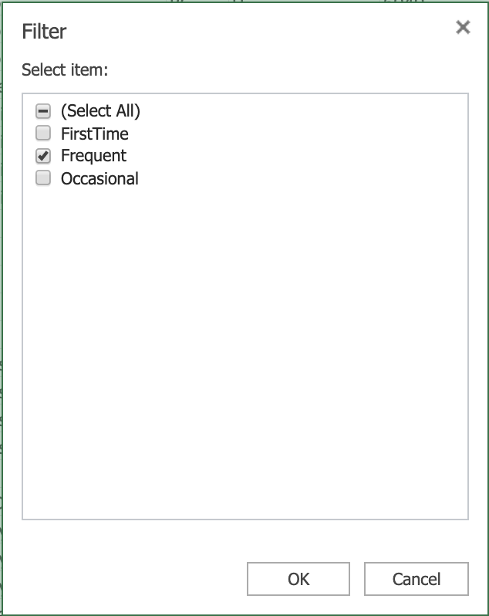

1. Click the **filter drop-down** in the column **AG**, and click **Clear Filter From “Purchase_Status”**.

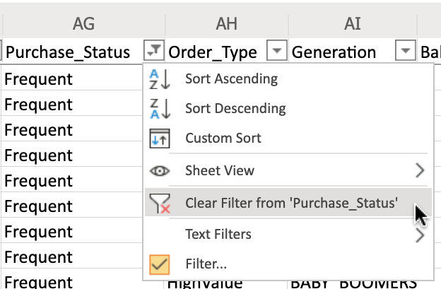

1. Click the **filter drop-down** in column **AE (T_Type)**, and select **Filter...**.
2. In the list, only select **Cancelled** and click **OK**.
3. Click the **filter drop-down** in column **AF (Purchase_Touchpoint)**, and select **Filter...**.
4. In the list, only select **Desktop** and click **OK**.
5. On the **Data** tab, click **Clear**.

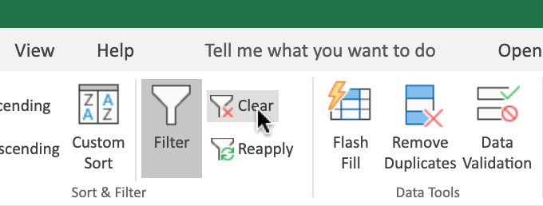

To use Custom Filters to filter data:

1. Click the **filter drop-down** in column **AD (Order_Value)**, then **Number Filters>Top 10...**.
2. Change the value from **10 to 50** and Click **OK**.
3. Click the **filter drop-down** in the column **AD**, and click **Clear Filter From “Order_Value”**.

## **Task B: Sorting data**

1. On the **Data** tab, click Custom Sort to open a dialog box like below.

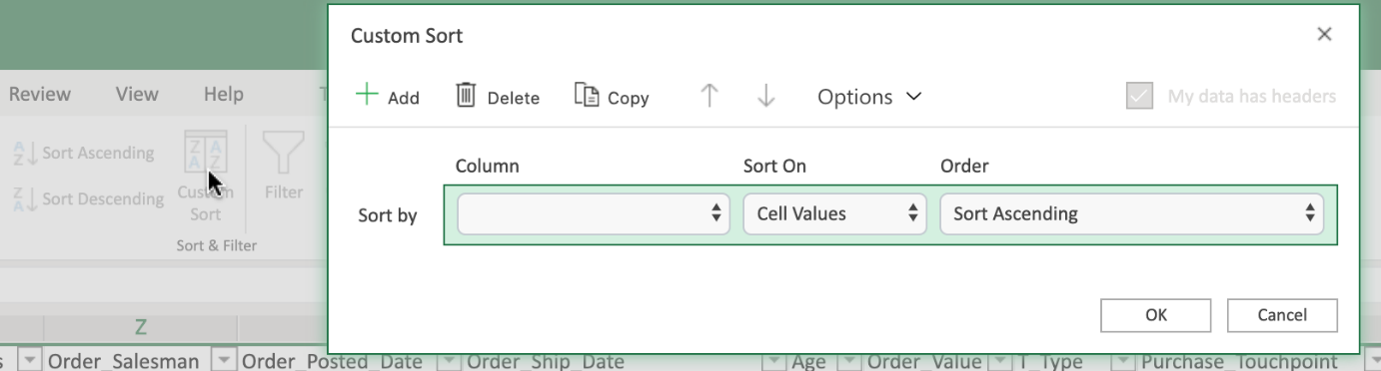

1. Click the **Column drop-down** of row **Sort By**, select **Order_Ship_Date**.
2. Click the **Order drop-down** of row **Sort By**, select **Sort Ascending**.
3. Click **Add**.
4. Click the **Column drop-down** of row **Then By**, select **Order_Value**.
5. Click the **Order drop-down** of row **Then By**, select **Sort Descending**.
6. Click **OK**.

# Exercise 2: Useful Functions for Data Analysis

In this exercise, you will learn how to use some of the most common functions a Data Analyst might use; namely IF, IFS, COUNTIF, and SUMIF.

## **Task A: Use of IF to apply one condition**

1. Select column **AF**, right-click, **Insert**.
2. In cell **AF1**, type **Complete?**.
3. In cell **AF2**, type **=IF(AE2="Complete","Yes","No")** and press Enter.
4. Double-click the **Fill Handle of AF2** to copy down the column.

## **Task B: Use of Nested IF to apply multiple conditions**

1. Select column **AE**, right-click, **Insert**.
2. In cell **AE1**, type **Order Size (IF)**.
3. In cell **AE2**, type **=IF(AD2>300,"Large",IF(AD2>100,"Medium",IF(AD2>0,"Small")))** and press **Enter**.
4. Double-click the **Fill Handle of AE2** to copy down the column.

## **Task C: Use of IFS to apply multiple conditions (alternative of Nested IF)**

1. Select column **AE**, right-click, **Insert**.
2. In cell **AE1**, type **Order Size (IFS)**.
3. In cell **AE2**, type **=IFS(AD2>300,"Large",AD2>100,"Medium",AD2>0,"Small")** and press **Enter**.
4. Double-click the **Fill Handle of AE2** to copy down the column.

## **Task D: Use of COUNTIF to count the number of cells that meet a specified criterion**

1. Select cell **BX2** and type **count VISA card**.
2. Select cell **BY2** and type **=COUNTIF(N2:N195,"VISA")** and press **Enter**.

## **Task E: Use of SUMIF function to sum the values within a specified range that meet a specified criterion**

1. Select cell **BX3** and type **sum Large order**.
2. Select cell **BY3** and type **=SUMIF(AE2:AE195,"Large", AD2:AD195)** and press **Enter**.
   * Formula: **=SUMIF(range, criteria, [sum range])**.

## **Task F: Use of SUMIFS function to sum the values within a specified range that meet multiple specified criteria**

1. Select cell **BX4** and type **sum Large order with Baby Gen**.
2. Select cell **BY4** and type **=SUMIFS(AD2:AD195, AE2:AE195,"Large", AL2:AL195,"*BABY_BOOMERS*")** and press **Enter**.
   * Formula: **=SUMIFS ([sum range], range1, criteria1, range2, criteria2, ...)**.

# Exercise 3: Using the VLOOKUP and HLOOKUP Functions

In this exercise, you will learn how to use the VLOOKUP and HLOOKUP functions in Excel to reference data contained in both vertical and horizontal lookup tables.

## **Task A: Use of VLOOKUP to look up data in a table organized vertically**

1. Download the file [**indian_startup_funding_Lab6.xlsx**](https://cf-courses-data.s3.us.cloud-object-storage.appdomain.cloud/IBMDeveloperSkillsNetwork-DA0130EN-SkillsNetwork/Hands-on%20Labs/Lab%206%20-%20Filtering%20and%20Sorting%20Data%20using%20Functions%20for%20Data%20Analysis/indian_startup_funding_Lab6.xlsx). Upload and open it using Excel for the web.
2. In cell **K2,L2,M2,** type **VLOOKUP, Startup Name, Amount in USD** respectively.
3. Select and copy cells from **C9 to C15** and paste in cell **L3**.
4. In cell **M3**, type **=VLOOKUP(L3, C2:I113, 7, FALSE)** and press **Enter**.
   * Formula: **=VLOOKUP (value, table, col_index, [range_lookup])**.
5. Hover over the bottom-right corner of cell **M3**, and drag the Fill Handle down to the cell **M9**.
6. Select cells from **M3 to M9** and **select Number Format>Currency**.

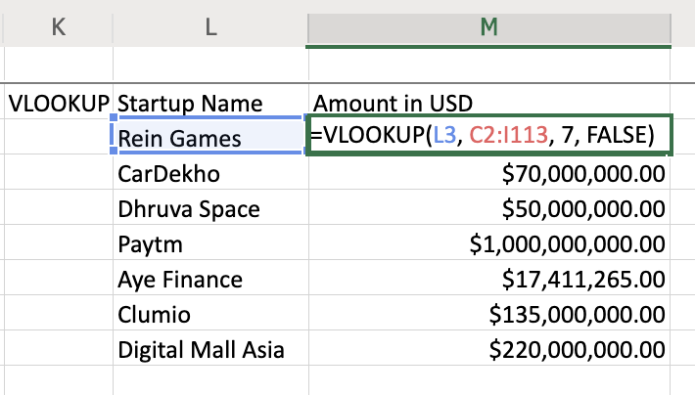

## **Task B: Use of HLOOKUP to look up data in a table organized horizontally**

1. Download the file [**Personal_Monthly_Expenditure_Lab6.xlsx**](https://cf-courses-data.s3.us.cloud-object-storage.appdomain.cloud/IBMDeveloperSkillsNetwork-DA0130EN-SkillsNetwork/Hands-on%20Labs/Lab%206%20-%20Filtering%20and%20Sorting%20Data%20using%20Functions%20for%20Data%20Analysis/Personal_Monthly_Expenditure_Lab6.xlsx). Upload and open it using Excel for the web.
2. In cell **J2,K2,L2,M2,** type **HLOOKUP, Month, Food & Dining, Health & Fitness** respectively.
3. Select and copy cells from **A10 to A12** and paste in cell **K3**.
4. In cell **L3**, type **=HLOOKUP(D1, A1:H14, 10, FALSE)** and press **Enter**.
   * Formula: **=HLOOKUP (value, table, row_index, [range_lookup])**.
5. Hover over the bottom-right corner of cell **L3**, and drag the Fill Handle down to the cell **L5**.
6. Select cells from **L3 to L5** and **select Number Format>Currency**.
7. In cell **M3**, type **=HLOOKUP(G1, A1:H14, 10, FALSE)** and press **Enter**.
8. Hover over the bottom-right corner of cell **M3**, and drag the Fill Handle down to the cell **M5**.
9. Select cells from **M3 to M5** and **select Number Format>Currency**.

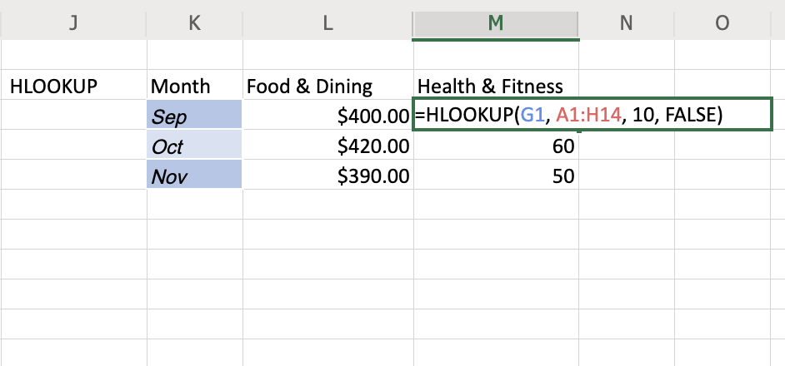

### **Congratulations! You have completed Lab 6, and you are ready for the next topic.**

Introduction to Creating Pivot Tables in Excel

Now that we’ve learned how to use the VLOOKUP and HLOOKUP functions, in this video we’ll look at how to create and use Pivot Tables in Excel. We’ll first look at how to format our data as a table, then how to create Pivot Tables and use fields in a Pivot Table to analyze data, and lastly we’ll see how to perform calculations in a Pivot Table. Having a worksheet full of informational data is all very well, but to really get some use out of it we need to analyze it from different perspectives to find answers to questions related to the data. Now, we’ve already used features such as filters and formulas to draw mathematical and logical conclusions about our data but not all questions can be answered easily using filters and formulas alone. In order to obtain usable and presentable insights into your data you need something else… and that something else is Pivot Tables. Pivot Tables provide a simple and quick way, in spreadsheets, to summarize and analyze data, to observe trends and patterns in your data and to make comparisons of your data. A Pivot Table is dynamic, so as you change and add data to the original dataset on which the Pivot Table is based, so the analysis and summary information changes too. A Data Analyst can use Pivot Tables to draw useful and relevant conclusions about, and create insights into, an organization’s data in order to present those insights to interested parties within the company. Before you start to create a Pivot Table in Excel, it can be very helpful to first format your data as a table. The reason for this is not only to make it more organized and defined and to add table styles to your data, but primarily it makes it a lot easier when adding records to the dataset. In the car sales worksheet, let’s first select any cell within the data, and then on the Home tab, in the Styles group, choose ‘Format as Table’. Then choose a style from the gallery… note that Excel automatically knows the boundaries of our data range, but we can change this if we need to. And ensure you select ‘My table has headers’, if indeed it does. After you click OK and the data has been formatted as a table, note the filter drop-downs at the top of each column – these are automatically added when you format as a table. If we now scroll down to the bottom of the table… and start adding another row of data for another vehicle… when you click Tab or Enter, note that it is automatically formatted and included as part of our table. OK, now let’s see how to create a basic Pivot Table, and how to use fields to arrange data in a Pivot Table. Just before we do that, there are a few things you should use as a checklist to ensure your data is in a fit state to make a Pivot Table from, and these are: Format your data as a table for best results Ensure column headings are correct, and there is only one header row, as these column headings become the field names in a Pivot Table Remove any blank rows and columns, and try to eliminate blank cells also Ensure value fields are formatted as numbers, and not text Ensure date fields are formatted as dates, and not text In the worksheet, we can just select any cell in the table. Then, on the Insert tab, we click PivotTable. Note that in the ‘Select a table or range’ box, the table name – Table1 – is already entered for us. If we hadn’t just formatted this data as a table, we would specify the cell range here instead. Under that, we need to decide whether we want to create the Pivot Table on a separate new blank worksheet, or on this worksheet – a new worksheet is the default – and is the most commonly used option. So, a new blank worksheet opens, displaying some basic Pivot Table instructions in the graphic on the left of the worksheet, and a ‘PivotTable Fields’ pane on the right. You can rename the worksheet for the Pivot Table if you wish. To build the Pivot Table report we need to add some fields from the top of the PivotTable Fields pane, to one or more of the sections in the bottom part of the pane. For example, if we want to find out the total sales for each model of car, let’s drag the Manufacturer field to the Rows section of the report, … and then we’ll drag the Model field there too. But this isn’t really the way we want it to look, so we’ll drag the Manufacturer field to appear at the top of the Rows section above the Model, which makes more sense with our data. Next, we’ll add the Price field to the Columns section, … … but again that really isn’t the way we want to view the data, so we’ll drag Price to the Values section instead, which makes a lot more sense and looks a lot better. Next, we’ll add the Unit Sales field to Values too, so now we can see both the individual price for each model and the number of unit sales of each model. Let’s add the Vehicle-type field to Columns, but that doesn’t seem very useful, so let’s remove that field, … , which we can do in two ways. Either by using the drop-down menu, … ( or, if we undo that, … we can also do it by simply dragging the field out of the Columns section, either to the left over the worksheet, or to the top over the fields list above. Let’s now look at how to perform a simple calculation in a Pivot Table. If we look in the ‘Sum of Price’ column in our Pivot Table, we can see that the figures are formatted as General. So first, let’s change the format for these figures to US currency. This can be done by modifying the value field settings for the field in the relevant section of the PivotTable Fields pane. We’ll format the field as US dollars and show no decimal places. Next, we’ll add a calculated field from the ‘PivotTable Analyze’ tab, using the ‘Fields, Items & Sets’ button. We want this field to calculate the total sales for each model by multiplying the price by the number of unit sales. When we create and add this formula, it gets added to the PivotTable Fields pane, as a field called Total Model Sales. And we can change the format to make it US dollars again. A new column called ‘Sum of Total Model Sales’ has now appeared in the Pivot Table in our worksheet. In row 5 we can see that there have been over 360 million dollars of sales of the Acura Integra model, … and in row 7 we can see that there has been over a billion dollars in sales of the Acura TL model. In this video, we learned how to format data as a table, how to create a Pivot Table and use fields to analyze data in a Pivot Table, and how to perform calculations using Pivot Table data. In the next video, we’ll look at some other features of Pivot Tables.

# Pivot Table Features

Now that we’ve learned how to create and use Pivot Tables in Excel, in this video we’ll look at some other features that we can use with Pivot Tables, including Recommended Pivot Tables, Filters, Slicers, and Timelines. Now that we’ve learned how to create and use Pivot Tables in Excel, in this video we’ll look at some other features that we can use with Pivot Tables, including Recommended Pivot Tables, Filters, Slicers, and Timelines. First, let’s look at Recommended Pivot Tables, which isn’t exactly a feature as such; it’s really more of a list of suggested different combinations of data that could be used when creating a Pivot Table. These recommendations are based on the data we select in the worksheet, and they are a great way to get started creating Pivot Tables if you don’t have much experience with them yet. For example, in the vehicle toy sales worksheet, if we select column B, which contains data about the quantity of items ordered, … when we choose Recommended Pivot Tables from the Insert tab, then we are presented with a list of potential data combinations related to the order quantity information. (3) However, if we select column F, which contains Order Size information, then the recommended pivot table list changes to reflect that data. (6) And if we select column E, which contains sales information, then the pivot tables recommended are related to sales data. Let’s select the third one down, which is the sum of sales by territory; because that sounds like something we could get some useful insight from, by presenting it in a pivot table. Note that a new worksheet is opened containing the recommended pivot table, and a new pane opens on the right, called PivotTable Fields. Let’s rename the worksheet to something more meaningful. In the PivotTable Fields pane, you can see that some fields have already been added to the Rows and Values areas. Although it’s a recommended pivot table, we can still make it our own, by adding more fields for example. So, let’s add the Productline item to the Columns area using drag and drop. Now we have columns for each of the product lines in our pivot table, such as motorcycles, ships, and trains. In the pivot table, we can manually expand any field we want to view its contents. Here we can see that the order dates are located underneath the territory names in our pivot table. Note that this matches the order of the fields in the Rows area of the PivotTable Fields pane. We can manually collapse each of the fields too. But we also have the option of expanding all the fields at once, … and collapsing them all too. The next feature we will delve into is pivot table filtering. Pivot table filters work in much the same way as the standard filters we used earlier in the course. Note that we already have some in-built filtering in this pivot table. For example, the Row Labels header is a filter, and we can filter on any of the listed territories, such as Japan. Just like standard filters, it’s very simple to clear a filter in a pivot table. We also have a Column Labels filter, allowing us to filter on any of the productline items in this pivot table; for example we could show data only for the trains product. (7) We also have the option of adding the Productline field as a standard filter instead of a column heading, by dragging it to the Filters area in the PivotTable Fields pane. And we can then use it as a standard filter, as we have done earlier in this course. The filter also allows us to select multiple filter items. But because it is now being used as a standard filter rather than a column header, we can’t see the split of the information on these two product lines; we just see a combined total. When we had the filter as a column header, the information on each product line was presented separately in each column. Let’s display all the field totals again. And we’ll drag the productline field back to the Columns area where it was previously, so we can see the split of our different product lines in the pivot table. The next pivot table feature we will look at are Slicers. Slicers are essentially on-screen graphical filter objects that enable you to filter your data using buttons. Slicers make it easy to perform quick filtering of your pivot table data, and they also display the current filter state, making it easier for you to know, and see, what data is currently being shown, and which is being hidden, by the filter. For example, if we remove the productline field from the pivot table by dragging it out of the PivotTable Fields pane, ... and then, from the PivotTable Analyze tab, we click Insert Slicer,... and then choose the Territory field as our slicer,… we can see that the slicer can be freely moved around anywhere on the worksheet, and it contains buttons for each of the territory items, such as EMEA, North America, and Japan. We can also select the Multi-Select button to filter on multiple territories if we wish. We can click the Clear Filter button to clear all slicer filters. Let’s add another slicer to our worksheet for the productline field. However, be sure to select a cell in the pivot table first, because if you don’t, then the insert slicer button won’t work. Note that slicers can also be added from the Filters group on the Insert tab as well as from the PivotTable Analyze tab. We’ll select the Productline field this time for our slicer, and drag it near the top of the worksheet. As before, we can select only one slicer item, or we can turn on Multi-Select and choose several items to filter on in the slicer. Then let’s clear the slicer filters, … and now let’s filter using both slicers. Note that when you use multi-select filtering, when you select an item, you are in fact filtering it out; that is, you are defining which items will NOT be displayed in the pivot table. This is the opposite behavior to when you are selecting single items in a slicer. So now we are displaying only ‘classic cars’, ‘trains’, and ‘trucks and buses’ products for the EMEA and North America territories. Now let’s clear those slicer filters, and put the productline field back in the Columns area of the pivot table, so it’s ready for the next feature we will explore. And let’s move these slicers out of the way, further down the worksheet. The last useful feature for pivot tables we are going to look at, is Timelines. A Timeline is another type of filter tool that enables you to filter specifically on date-related data in your pivot table. This is a much quicker and more effective way of dynamically filtering by date, rather than having to create and adjust filters on your date columns. We can add a Timeline for our pivot table either from the PivotTable Analyze tab, or from the Insert tab. Again, ensure you select any cell in the pivot table first. We’ll select the Orderdate field as our Timeline filter. Then we can drag it up the worksheet and enlarge it. The default for this timeline is to display data by month, but you can also filter by days, … or by quarters. You can select a single quarter; or you can select a range of quarters. In this case, we’ll select twelve months between quarter 3 of 2003 and quarter 2 of 2004. You use the Clear Filter button to clear a timeline filter. You can also filter by years. For example, here we have selected 2003 only. And you can combine slicers and timelines as filters in a pivot table. For example, here we can filter the slicers to display only data for trains, in the EMEA and North America territories, and only in the year 2003. And if we filter on the year 2004 instead, you’ll see that there is no data being displayed; meaning that there were no sales of train products in 2004 in either the EMEA or the North America territories. (15) Timelines and Slicers have their own tabs in the ribbon when you select them, and their properties can be modified to change how they look and how they work. For example, let’s change this Timeline to a light green shade, … and let’s change this Slicer to a nice orange color. And lastly, to remove a timeline or slicer, you can either select it and press the Delete key, … or right-click it and choose Cut. In this video, we learned about some of the other features in Excel that we can use with Pivot Tables, namely; Recommended Pivot Tables, Filters, Slicers, and Timelines.

# Exercise 1: Introduction to Creating Pivot Tables in Excel

In this exercise, you will learn how to format data as a table, how to create a Pivot Table and use fields to arrange data in a Pivot Table, and how to perform calculations using Pivot Table data.

## **Task A: Format data as a table**

1. Download the file [**indian_startup_funding_Lab7.xlsx**](https://cf-courses-data.s3.us.cloud-object-storage.appdomain.cloud/IBMDeveloperSkillsNetwork-DA0130EN-SkillsNetwork/Hands-on%20Labs/Lab%207%20-%20Using%20Pivot%20Tables/indian_startup_funding_Lab7.xlsx). Upload and open it using Excel for the web.
2. Select cell **A2**.
3. On the **Home** tab, in the **Tables** group, click **Format as Table**.
4. Select **Light Gray, Table Style Medium 15**.

## **Task B: Create a pivot table and use fields to arrange data in a pivot table**

1. Select cell **D4**
2. On the **Insert** tab, click **PivotTable**.
3. Click **OK**.

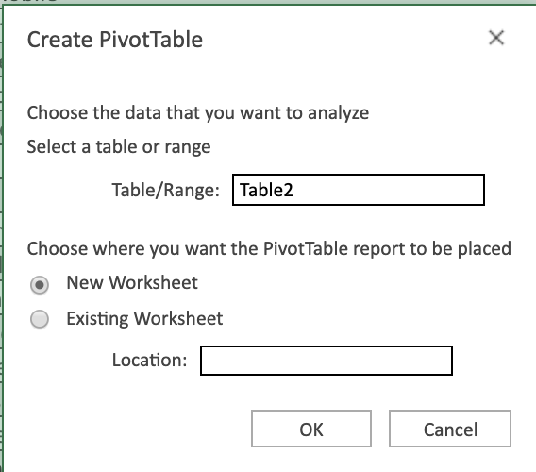

1. Double-click **Sheet1**, type **Pivot1** and click **OK**.
2. In the fields list, drag **Industry Vertical** to **Rows**.
3. In the fields list, drag **City Location** to **Rows** below **Industry Vertical**.
4. In the fields list, drag **Startup Name** to **Rows** below **City Location**.
5. In the fields list, drag **Amount in USD** to **Values**.
6. In the ribbon, select the **PivotTable** tab, click **Settings**, then in the **PivotTable Settings** pane, under **Layout**, select **Single column**.

## **Task C: Perform a simple calculation in a pivot table**

1. In the **PivotTable Fields** pane, in the **Values** section, click the drop-down arrow next to **Count of Amount in USD**, and click **Value Field Settings**.
2. Select **Summarize value field by > Sum**.

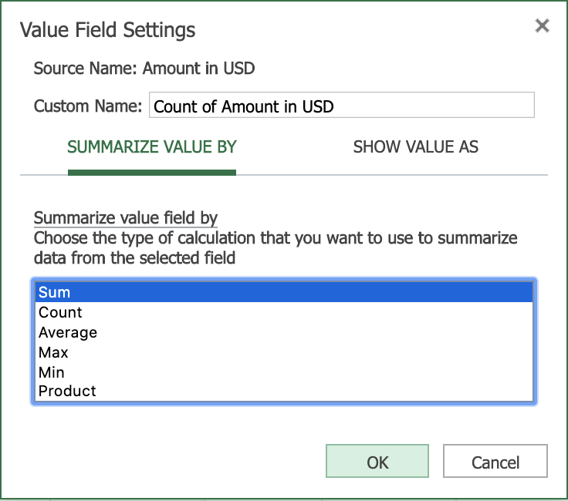

1. Click **OK**.
2. Select the column called **Sum of Amount in USD** and then on the **Home** tab, select **Accounting Number Format > $ English (United States)**.

# Exercise 2: Pivot Table Features

In this exercise, you will learn some other features that we can use with Pivot Tables, including Recommended Charts, Filters, Slicers, and Timelines.

**Note: The 'Recommended Charts' feature only works with 'full' Office for the web plans (those plans that come with an Office 365 subscription). Recommended Charts do not work with the 'basic' plan that comes with a Microsoft Account.**

## **Task A: Use of the Recommended Charts feature (Optional: If you have a full Office for the web plan)**

1. Switch to worksheet **indian-startup-funding**.
2. Select column **F (City Location)**.
3. On the **Insert** tab, select **Recommended Charts**.
4. Click **+ Insert PivotChart**.

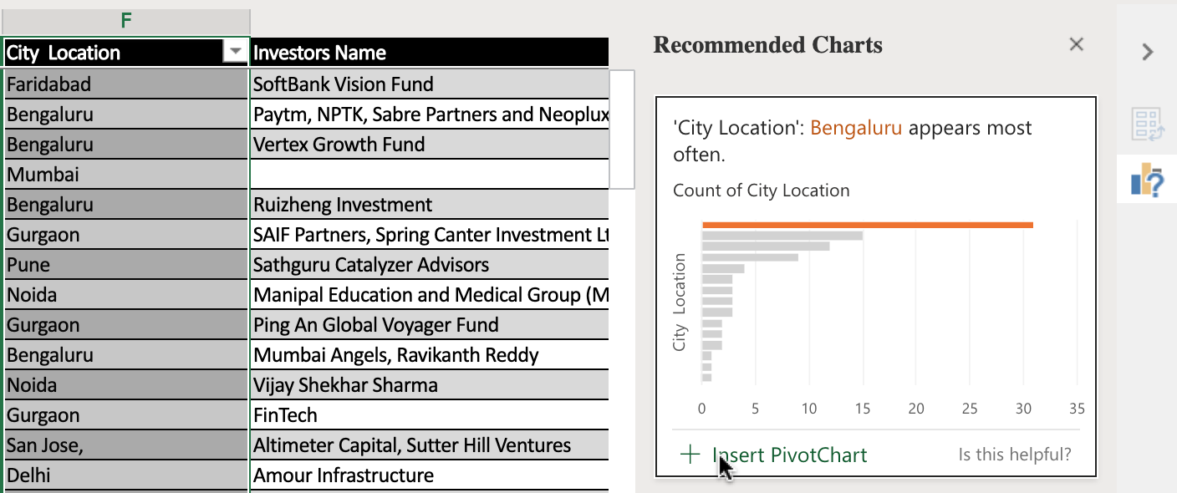

1. Switch to worksheet **indian-startup-funding** again.
2. Select column **C, D, E**.
3. On the **Insert** tab, select **Recommended Charts**.
4. Choose the recommended chart, and click **+ Insert PivotChart**.

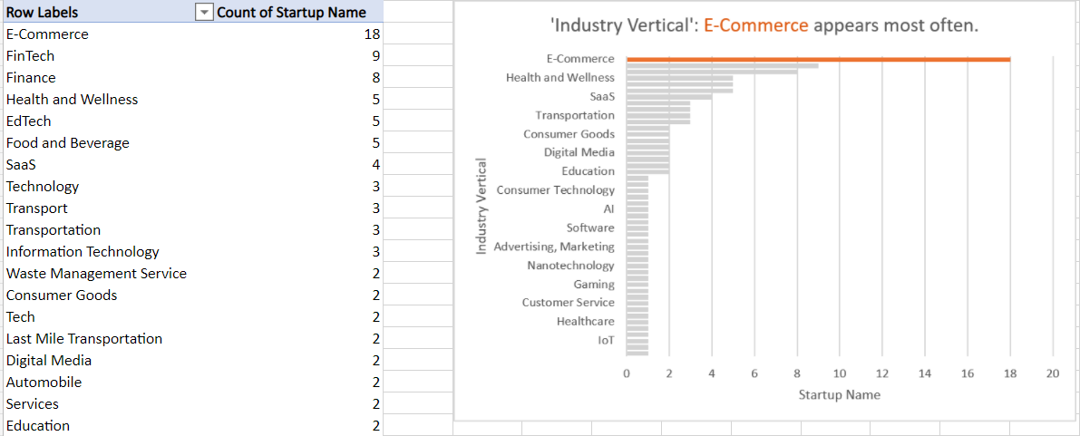

## **Task B: Use of the Filters feature**

1. Switch to worksheet **Pivot1**.
2. In the Pivot Table, click the **Row Labels** arrow.
3. Select **City Location**, then **Filter...**.
4. Just select **Burnsville**, **Delhi**, **New York**, then click **OK** to display the amounts for startups in these three cities only.
5. In the Pivot Table, click the **Row Labels** arrow.
6. Select **City Location**, then click **Clear Filter From 'City Location'** to display the startups in all cities again.

## **Task C: Use of the Slicers feature**

1. Download the file [**indian_startup_funding_Lab7_with_slicers_timelines.xlsx**](https://cf-courses-data.s3.us.cloud-object-storage.appdomain.cloud/IBMDeveloperSkillsNetwork-DA0130EN-SkillsNetwork/Hands-on%20Labs/Lab%207%20-%20Using%20Pivot%20Tables/indian_startup_funding_Lab7_with_slicers_timelines.xlsx). Upload and open it using Excel for the web.
2. Switch to worksheet **Pivot1** if you are not there.
3. In the **City Location** slicer, select **Burnsville**, then **Delhi**, then **New York**.
4. To filter by multiple selection in the **City Location** slicer, with **New York** still selected, press **CTRL** and select **Burnsville**, and then **Delhi**.
5. To filter using more than one slicer, in the **Investors Name** slicer, select **Amour Infrastructure**, then press **CTRL** and select **Westbridge Capital**, and then **Breakthrough Energy Ventures**.
6. In the **City Location** slicer, click the **Clear Filter** button, then in the **Investors Name** slicer, click the **Clear Filter** button.

## **Task D: Use of the Timelines feature**

1. In the Date timeline, click **top right drop-down** and select **DAYS**, then scroll **left and right**.

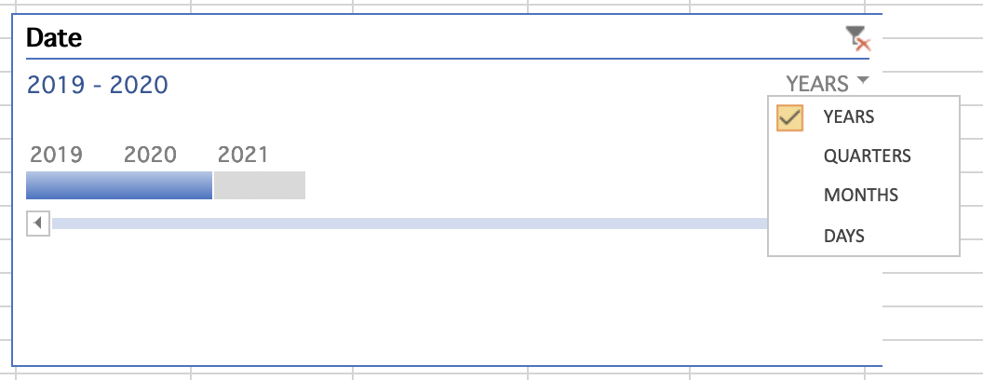

1. In the Date timeline, click **top right drop-down** and select **QUARTERS**.
2. In the Date Timeline, select **2019 Q1**, then drag **2019 Q1 to 2019 Q3**.
3. In the Date timeline, click the **Clear Filter** icon.
4. In the Date timeline, click **top right drop-down** and select **YEARS**, then select **2020** only.

### **Congratulations! You have completed Lab 7, and you are ready for the next topic.**

# Exercise 1: Sign-up for a Microsoft Account to Use Excel for the web

In this exercise, you will sign up for a Microsoft Account to use Excel for the web.

* If you already have a Microsoft account, you can skip Exercise 1 and proceed to Exercise 2 directly.

1. Go to [www.office.com](https://www.office.com/?utm_medium=Exinfluencer&utm_source=Exinfluencer&utm_content=000026UJ&utm_term=10006555&utm_id=NA-SkillsNetwork-Channel-SkillsNetworkCoursesIBMDeveloperSkillsNetworkDA0130ENSkillsNetwork20531059-2022-01-01). Click **Sign in**



1. Click **Create one!**

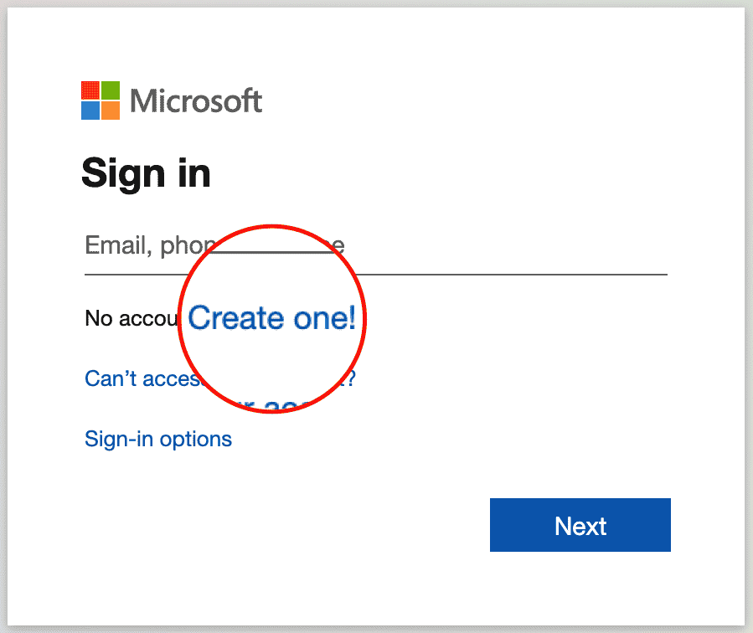

1. Enter your existing email id with which you want to create a Microsoft account. Click **Next**.

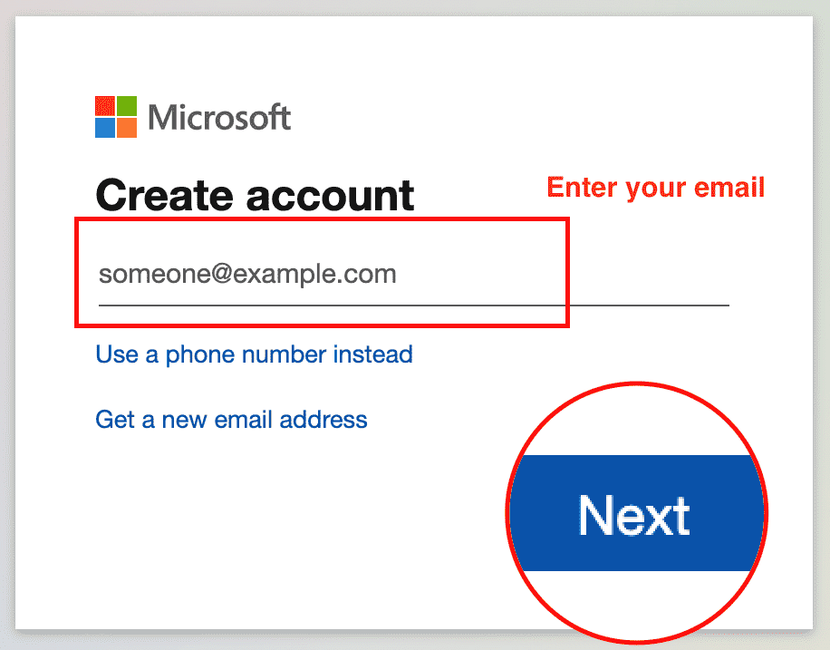

1. Enter your password and click **Next**.

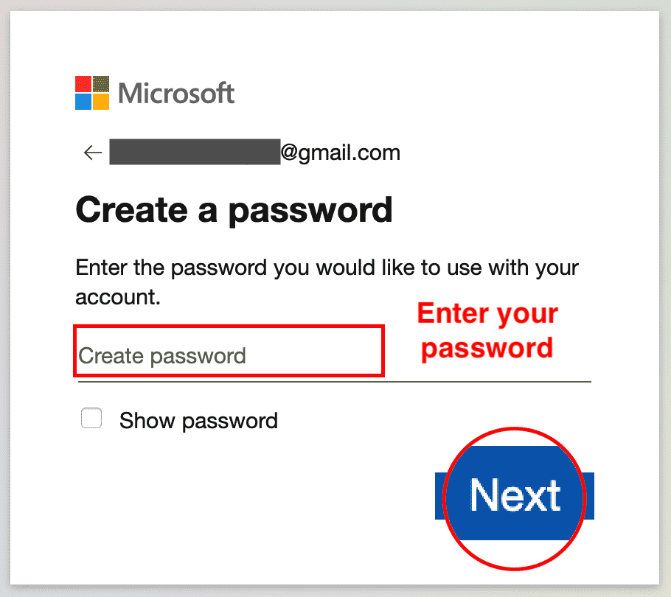

1. Enter the code you received by email. Click **Next**.

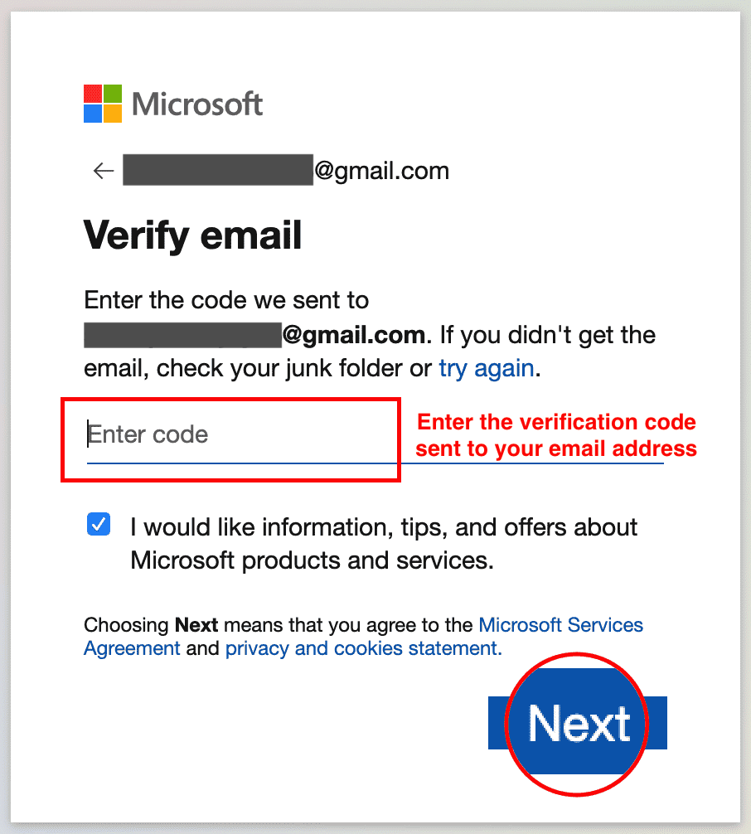

1. Enter your phone number and click **Send Code**.

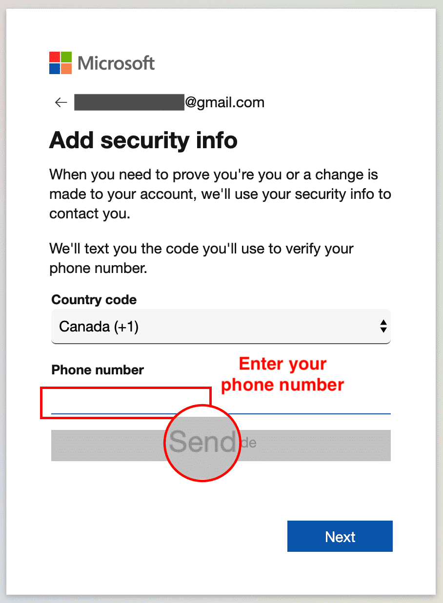

1. Enter the access code you received as a text on your phone, then click **Next**.

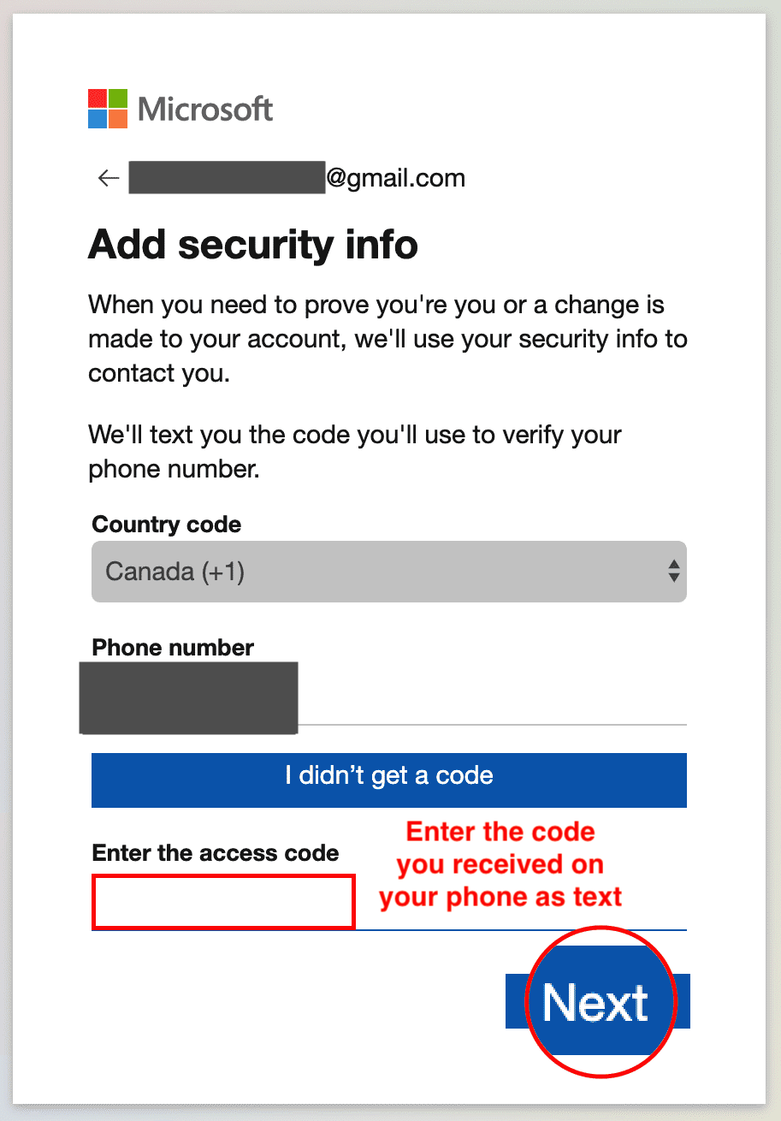

1. You are now done with the sign up procedure. Now since you are signed in after sign up at this stage, you can proceed directly to **Task B** of **Exercise 2**.

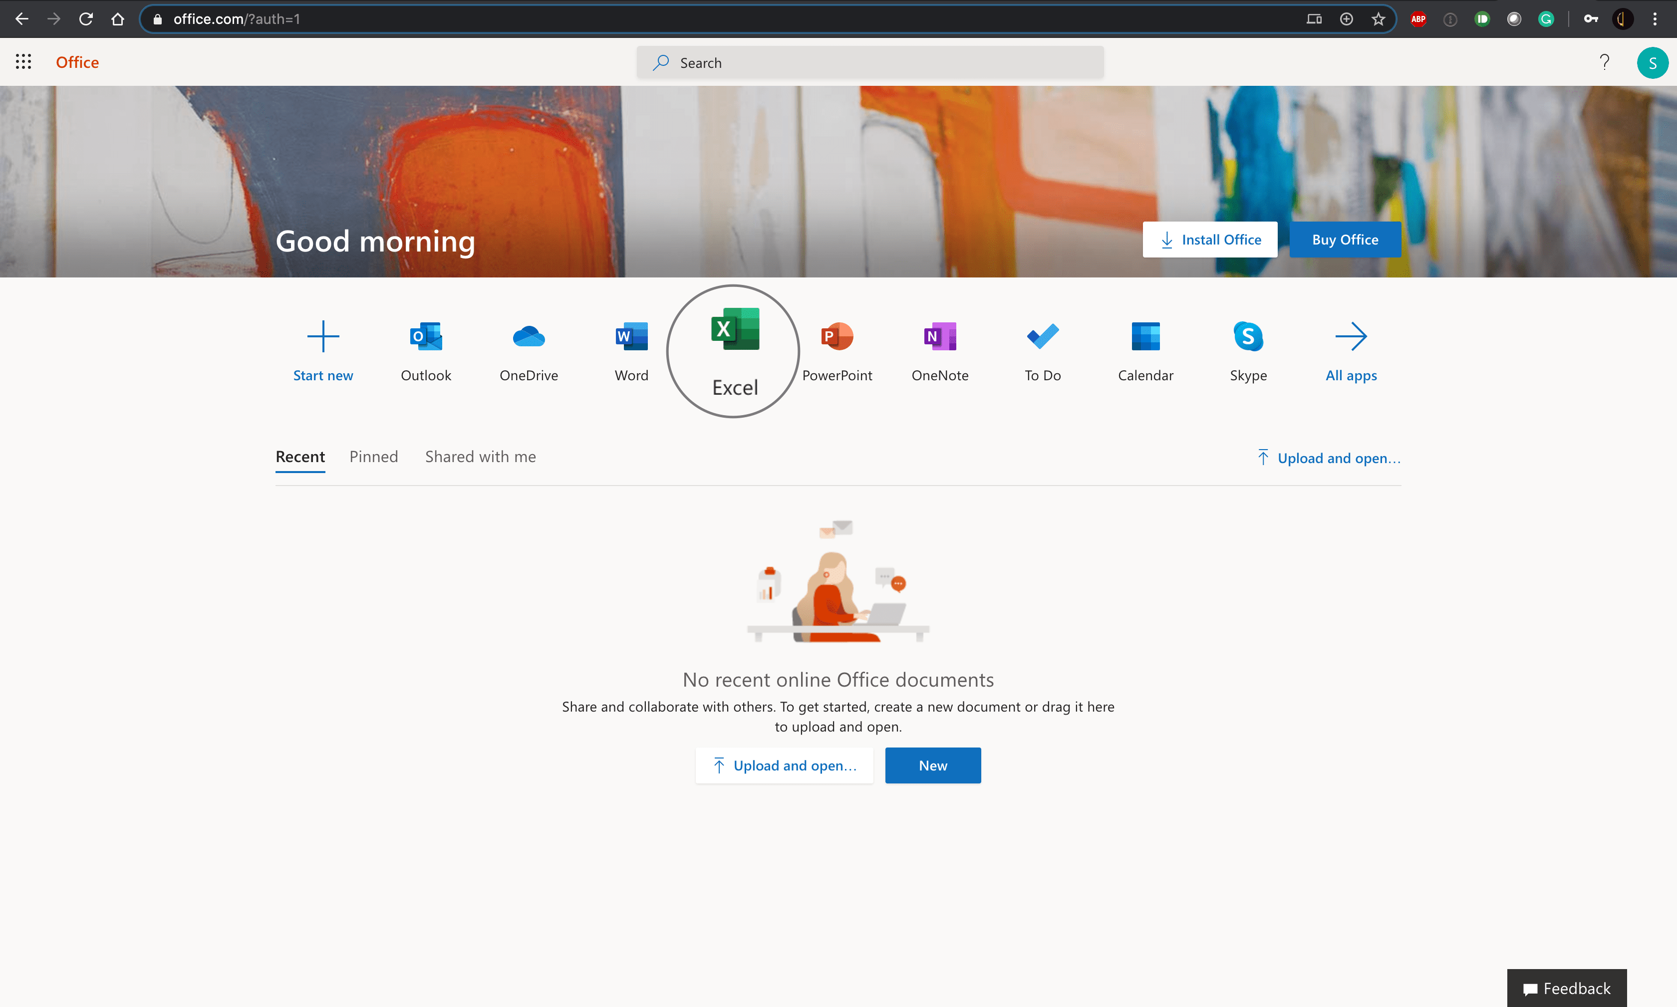

# Exercise 2: Sign-in, Upload and Open a Workbook in Excel for the web

In this exercise, you will sign in to Excel for the web, open a new workbook and then upload and open a workbook.

## **Task A: Sign in to Excel for the web**

1. Go to [www.office.com](https://www.office.com/?utm_medium=Exinfluencer&utm_source=Exinfluencer&utm_content=000026UJ&utm_term=10006555&utm_id=NA-SkillsNetwork-Channel-SkillsNetworkCoursesIBMDeveloperSkillsNetworkDA0130ENSkillsNetwork20531059-2022-01-01). Click **Sign in**.



1. Enter your sign in email.

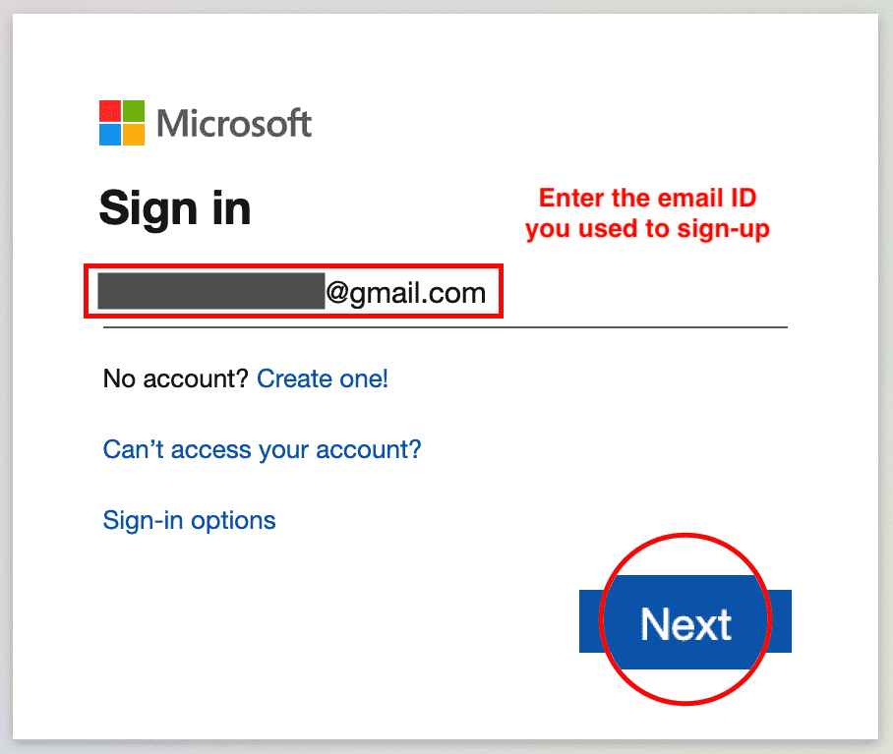

1. Enter your password.

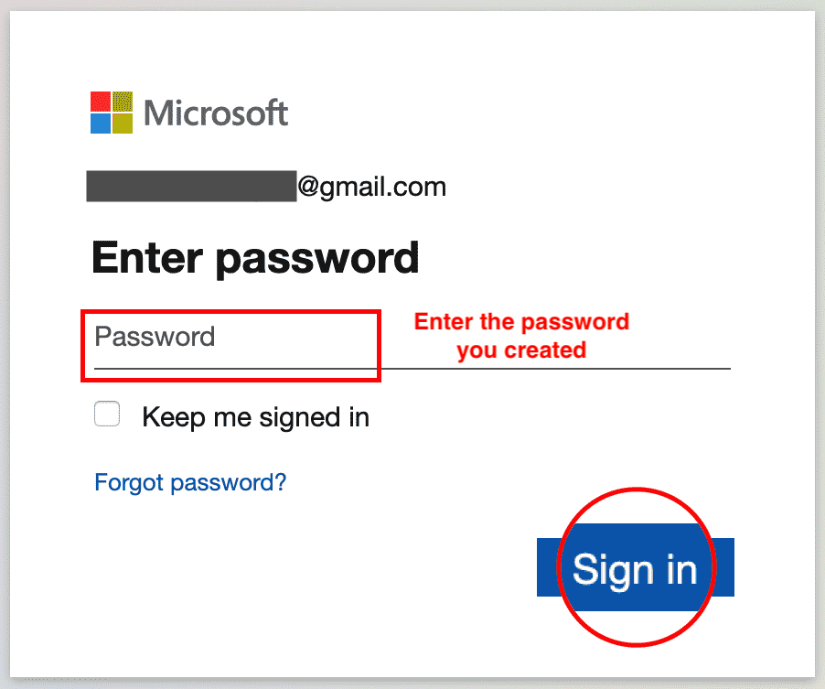

1. You are now signed in.



## **Task B: Open a new workbook in Excel for the web**

1. Click on the **Excel** icon.



1. Click **New blank workbook**.

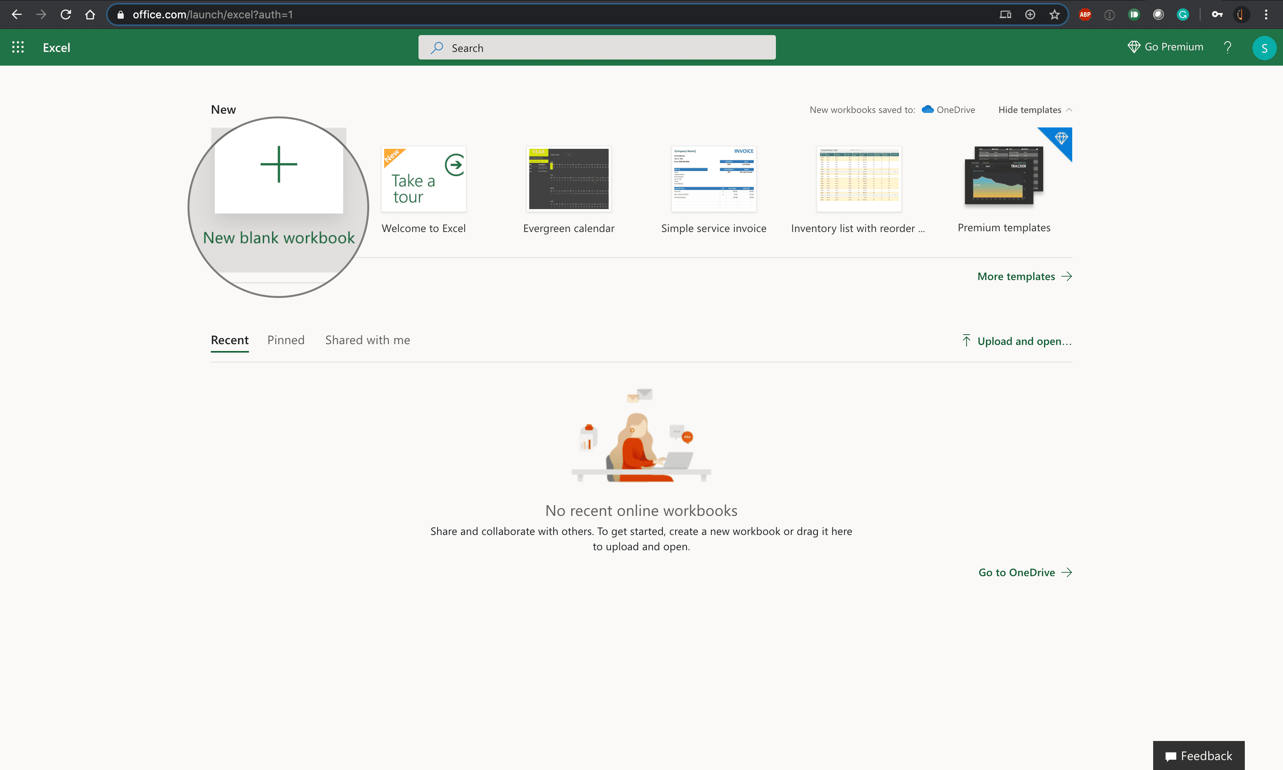

1. You have successfully opened a new workbook in Excel for the web.

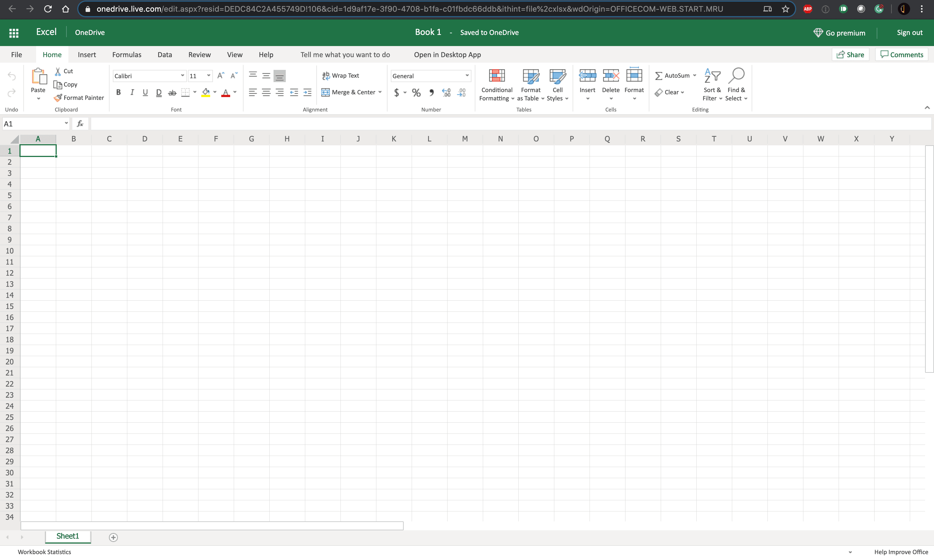

## **Task C: Upload and Open a workbook in Excel for the web**

1. Download the file [**indian_startup_funding_Lab1.xlsx**](https://cf-courses-data.s3.us.cloud-object-storage.appdomain.cloud/IBMDeveloperSkillsNetwork-DA0130EN-SkillsNetwork/Hands-on%20Labs/Lab%201%20-%20Access%20to%20the%20environment%20-%20Excel%20for%20the%20web/indian_startup_funding_Lab1.xlsx).
2. To upload and open a workbook in Excel for the web, click the **App Launcher** (cube of dots) in the top left corner. Click **Excel** icon. Then click **Upload and open...** and select the **indian_startup_funding_Lab1.xlsx** file.

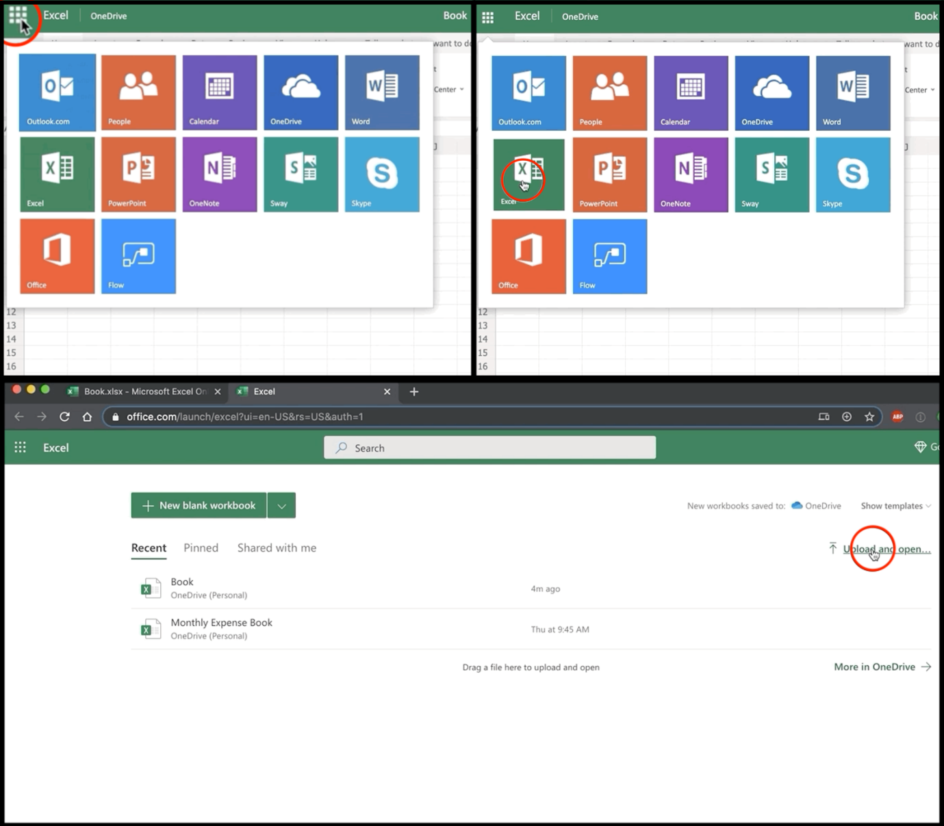

1. The file will be uploaded to your OneDrive of the Microsoft Account you signed up and used to open Excel for the web.

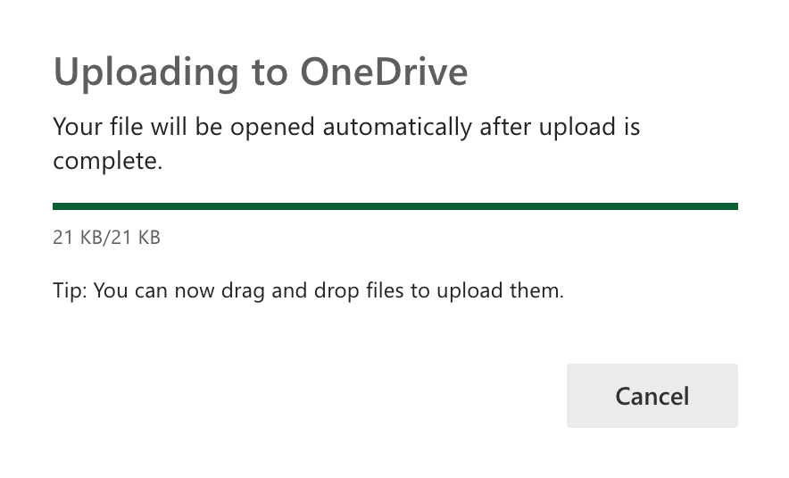

1. You have successfully uploaded and opened a workbook in Excel for the web.

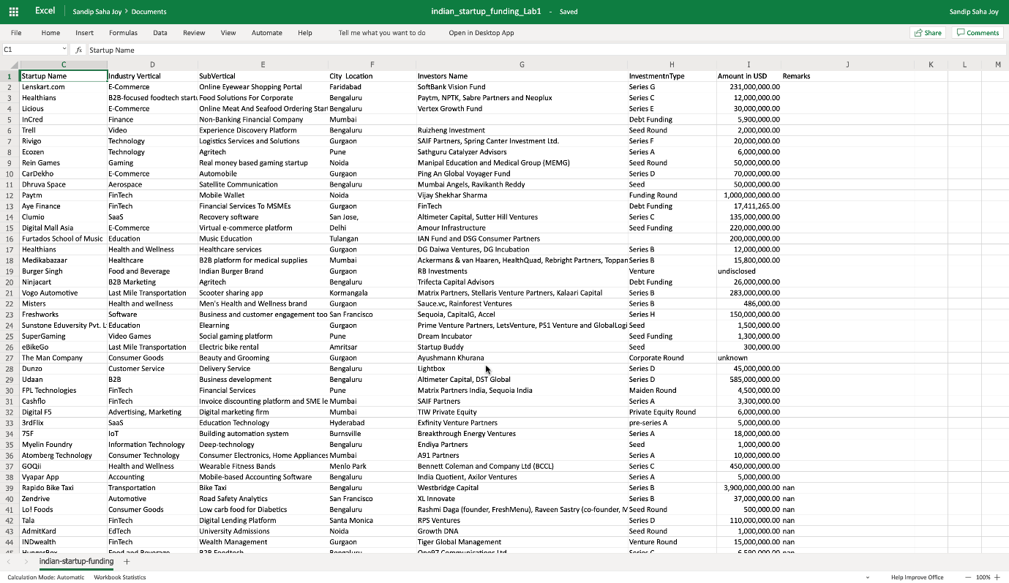

### **Congratulations! You have completed Lab 1, and you are ready for the next topic.**

# Exercise 1: Introduction to Basic Spreadsheet Elements

In this exercise, you will learn about some common spreadsheet elements.

1. Open **Excel for the web**. Click on **New blank workbook**.

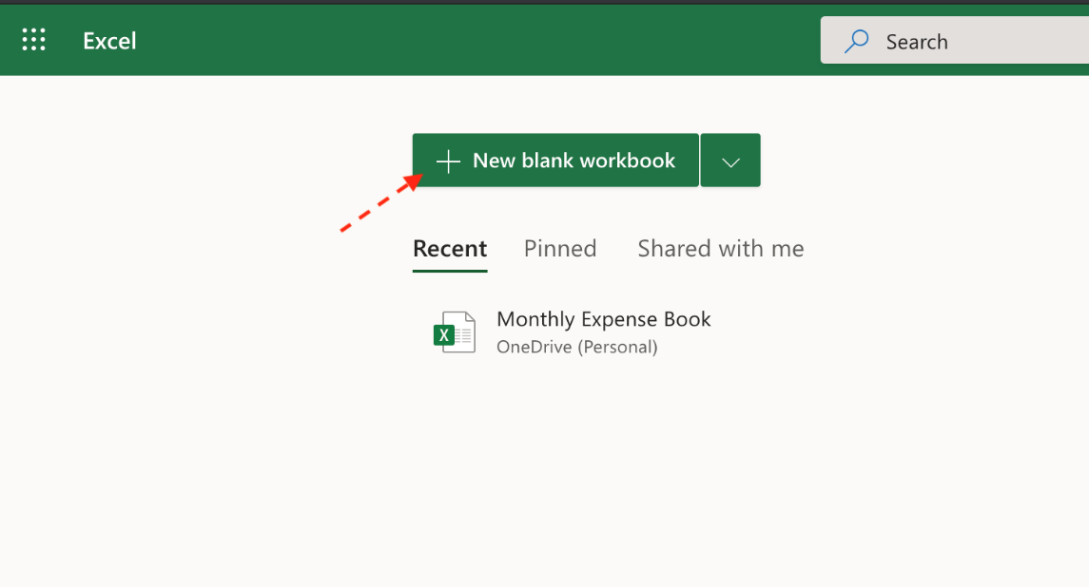

1. The new blank workbook will automatically be saved in Excel for the web as **Book**. To rename the workbook to something more meaningful, click **File**, **Save As**, then choose **Rename**.

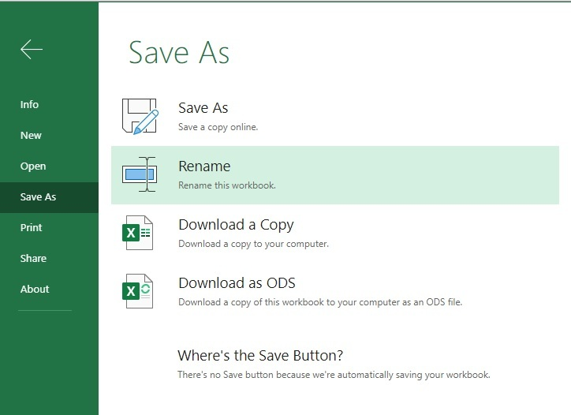

1. In the file name box, type **Personal_Monthly_Expenditure_Lab2** and click **OK**.

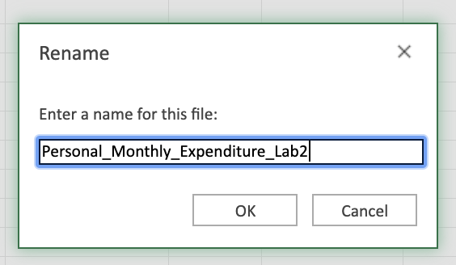

1. In the saved workbook, you will have one worksheet opened, named Sheet1. Click **+** once to add another worksheet. Then, double-click the sheet name tab for **Sheet1** and rename it to **Expense - 2019**. Similarly, rename **Sheet2** as **Expense - 2018**.

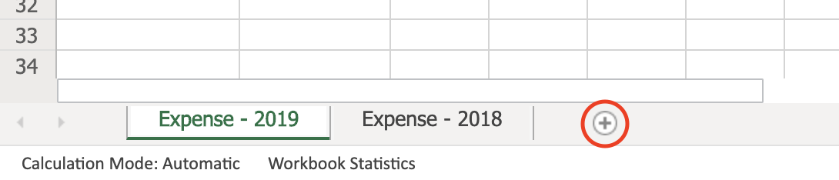

1. To maintain an appropriate worksheet tab sequence, click on the worksheet tab **Expense - 2018**, then drag and drop it before the **Expense - 2019** tab.



1. Click on the **Expense - 2018** tab. Select an entire column by clicking on **B** in the top of the worksheet, then select an entire row by clicking on the number **5** in the left of the worksheet. Click cell **B5**, and a green outline will appear around the cell. Now check if you have clicked the correct cell by looking at the cell name box in the top left corner, circled in red below.

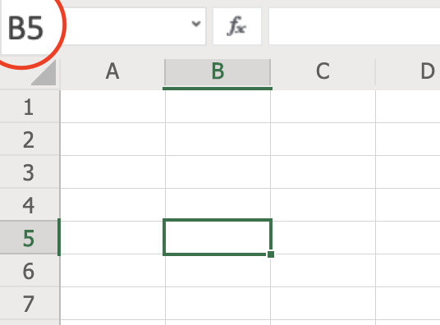

1. Select several cells in the same row, such as A1:D1 by clicking cell **A1** and then drag the cursor across to **D1**. Similarly, select a cell range in the same column, such as A1:A5 by clicking **A1** and dragging the cursor down to **A5**.



1. Now select a cell range which includes several rows and columns together, such as A1:C5 by clicking **A1** and then dragging the cursor across and down to cell **C5**.



# Exercise 2: Explore the Ribbon, Navigate around a Worksheet, and Select Data

In this exercise, you will explore the ribbon, then navigate around a worksheet, and select data.

## **Task A: Explore the ribbon**

1. Download the file [**indian_startup_funding_Lab2.xlsx**](https://cf-courses-data.s3.us.cloud-object-storage.appdomain.cloud/IBMDeveloperSkillsNetwork-DA0130EN-SkillsNetwork/Hands-on%20Labs/Lab%202%20-%20Spreadsheet%20basics/indian_startup_funding_Lab2.xlsx).
2. To open a sample file in Excel for the web, click the **App Launcher** (cube of dots) in the top left corner. Click **Excel**, and then click **Upload and open...** and select the **indian_startup_funding_Lab2.xlsx** file.



1. Click each of the following tabs in the ribbon; **File, Home, Insert, Formulas, Data, Review, View** to explore each of them and get acquainted with the ribbon. Double-click any of the tabs to hide the ribbon, then do the same again to unhide it.

## **Task B: Navigate around a worksheet**

1. Click on **any cell** and move around the worksheet using the arrow keys; **Up, Down, Left, Right**.



1. Click **Page Down** twice, and then **Page Up** twice to move around a bit faster, which is useful if you have lots of rows of data.
2. Click and drag the **horizontal scroll bar** and then the **vertical scroll bar** to move even quicker up, down, and across a large datasheet.
3. Try out these useful shortcuts in your worksheet:
   * Press **CTRL+End** to take you to the cell at the end of your data in the worksheet.
   * Press **CTRL+Home** to take you back to the start of the data in the worksheet (i.e. cell A2).
   * Press **CTRL+Down Arrow** to take you to the end of the column you’re in
   * Press **CTRL+Up Arrow** to take you back to the top of the column.

## **Task C: Select data**

Perform the following steps to learn how to select different parts of your data (you can use the mouse to select cells if you prefer):

* + To select cells in a single row: Select cell **A1**, then select cells **A1 to D1** by using **SHIFT+right arrow**.
  + To select cells in a single column: Select cell **A1**, then select cells **A1 to A10** by using **SHIFT+down arrow**.



1. To select multiple contiguous cols/rows: Select column **A**, and use **SHIFT+ right arrow** to reach column **E**.
2. To select multiple non-contiguous cols/rows: Select column **A**, then hold **CTRL** and select column **E**.
   * To select the entire worksheet: Click the **corner button** (small grey triangle in top left corner of the worksheet).
   * To select all your data: Select any cell in the data, then press **CTRL+A**.

**Note:** The first time you press CTRL+A, it selects the current region if the worksheet contains data, the second time it selects the current data region and its header row, and the third time it selects the entire worksheet.



### **Congratulations! You have completed Lab 2, and you are ready for the next topic.**

Reading: Excel Keyboard Shortcuts

**Estimated time needed:** n/a

The table below lists keyboard shortcuts for some of the most common Excel tasks.

| **Task** | **Shortcut** |
| --- | --- |
| Close a workbook | Ctrl+W |
| Open a workbook | Ctrl+O |
| Save a workbook | Ctrl+S |
| Copy | Ctrl+C |
| Cut | Ctrl+X |
| Paste | Ctrl+V |
| Undo | Ctrl+Z |
| Remove cell contents | Delete |
| Bold | Ctrl+B |
| Open context menu | Shift+F10 |
| Expand or collapse the ribbon | Ctrl+F1 |
| Move up one cell in the worksheet | Up arrow key |
| Move down one cell in the worksheet | Down arrow key |
| Move one cell left in the worksheet | Left arrow key |
| Move one cell right in the worksheet | Right arrow key |
| Move to the edge of the current data region in the worksheet (e.g. end of column) | Ctrl+Arrow key (e.g. Ctrl+Down arrow) |
| Move to the last cell on a worksheet | Ctrl+End |
| Move to the beginning of a worksheet | Ctrl+Home |
| Extend the selection of cells to the last used cell on a worksheet (lower right corner) | Ctrl+Shift+End |
| Move to the cell in the upper-left corner of the window (when Scroll Lock is On) | Home+Scroll Lock |
| Move one screen down in a worksheet | Page Down |
| Move one screen up in a worksheet | Page Up |
| Move one screen to the right in a worksheet | Alt+Page Down |
| Move one screen to the left in a worksheet | Alt+Page Up |
| Move to the next sheet in a workbook | Ctrl+Page Down |
| Move to the previous sheet in a workbook | Ctrl+Page Up |
| Edit the active cell and put the cursor at the end of the cell's contents | F2 |
| Enter the current time | Ctrl+Shift+colon (:) |
| Enter the current date | Ctrl+semi-colon (;) |

# Introduction to Charts

In this video, we'll give an overview of several different types of charts and visualizations and discuss how they can be used to tell a story. Let's begin by looking at a line chart when comparing different but related datasets. A line chart is a great way to display the information. They are able to display trends and show how a data value is changing in relation to a continuous variable. For example, if time is a continuous variable, how has the sale of a product or multiple products changed? Next, we have pie charts. This type of chart can show the breakdown of an entity into its sub-parts and the proportion of the subparts in relation to one another. Each portion of the pie represents a static value or category, and the sum of all categories is equal to a 100 percent. In this example, we have a Marketing Campaign with four distinct categories. Social Sites, Native Advertising, Paid Influencers, and Live Events. With this type of data representation, we can easily see the total number of leads generated per category. We now look at one of the most commonly used charts, the Bar Chart. This type of chart is the most common as they are easy to create and are great for comparing related data sets or parts of a whole. For example, in this bar chart, we can see the population numbers of 10 different countries and how they compare to one another. We can also use stacked bars in which each bar is divided into sub bars that are stacked end to end. In this stacked bar, we can see the population of each country split into four age ranges. Would you like the graph to appear vertical and not horizontal? Then column charts would be a great pick. This type of chart can be used quite effectively to show change over time and to compare values side-by-side. For example, showing page views versus user's session time on a website as it changes on a month-to-month basis. While this type of chart looks similar to a bar chart, they cannot always be used interchangeably. For example, a column chart may be better suited for showing negative and positive values. Next, we have treemaps, which are useful for displaying complex hierarchies using nested rectangles. In this example, the treemap depicts statewide employment rates within the population of a country over the last year. The size of the rectangle represents the population and the color represents the employment rate. We can click on any region to see the employment data of the sub-regions within the selected region. Trying to display a pipeline or different stages of a continuous process, then funnel charts are the way to go. In this example, the funnel chart is showing the conversion rate at each stage of the sales process from lead generation to the final sale. Another exceptional chart is the scatter chart. In this type of chart, the circle colors represent the categories of data and the circle sizes are indicative of the volume of data. For example, in this scatter chart, we can see each product line by the number of units sold and the revenue it brings. A scatter chart can be great for revealing trends, clusters, patterns, and correlations between data points. Next we look at bubble charts. This is a variant of scatter charts, and they are useful for comparing a handful of categories to one another in terms of relative significance. For example, understanding areas of significant expenditure in an organization's sales budgets. Lastly, we have sparklines. Sparklines do not include an axis or coordinates, yet they display trends simply and effectively. These are great for showing the general trend of a variation. For example, stock market price fluctuations from the opening to the closing of a trading day. In this video, we learned about the importance of charts and how they are able to shape our data to provide meaningful information. In the next video, we will dive into more details about how to create and configure different types of charts in Excel.

Creating Basic Charts in Excel (Line, Pie, and Bar Charts)

First let’s start with line charts. A line chart is a type of graph, used to show information as a series of data points connected by straight lines. In a line chart, the horizontal axis typically represents time or a similar category, and the vertical axis typically represents numerical values. Because line charts can display continuous data over a given time period, they're perfect for showing trends in data at equal time intervals, such as days, months, quarters, or years. Line charts are ideal for scenarios where you have data that’s arranged in columns or rows, or where your data contains multiple data series. On the car_sales worksheet of the Car Sales workbook, let’s first filter the data to display only Ford car models.

Play video starting at :1:14 and follow transcript1:14

Now let’s create a line chart with this data. We’ll select the data from 2 non-adjacent columns, in this case “Model” and “Price”. Then we select Line chart from the 2-D Line category of the Charts group.

Play video starting at :1:30 and follow transcript1:30

Let’s change the chart title to “Price of Ford Cars”, which we can do by simply double-clicking the chart title textbox, and editing the text. We now see a floating chart area containing our line chart, which displays the price trend of Ford cars across its models. Let’s move this line chart to the left side of the worksheet below our data.

Play video starting at :1:53 and follow transcript1:53

OK, now let’s move on to pie charts. A pie chart is a type of circular graph, used to show the relative contribution of different categories (which we see as slices), to make an overall total (which we see as a pie). Data points on a pie chart, that is, the slices, are represented as percentages of the complete pie. Pie charts provide a very simple visualization of differing data results, which we humans find very easy to comprehend. Pie charts are best used when you only have one data series, and when your data contains no more than maybe a dozen categories, otherwise the pie chart can start to look too busy and become difficult to read. For the pie chart, we’ll use the model names manufactured by Ford along with their unit sales.

Play video starting at :2:45 and follow transcript2:45

To create our pie chart, we’ll select the data from 2 non-adjacent columns; in this case, “Model” and “Unit Sales”. Then we select Pie chart from 2-D Pie category of the Charts group. The new floating chart area contains our pie chart, which displays the relative contribution of unit sales from individual Ford car models, which are the ‘slices’ of the pie, and they combine together to make an overall total of unit sales of Ford cars, which is the whole ‘pie’. Let’s change the chart style to customize the look of the pie chart. There are numerous styles to choose from in the gallery and you can even make combinations of multiple styles; for example, here we’ve chosen style 3 and style 7, which gives us the percentage values displayed in each slice, and a nice dark contrasting background color. Let’s again move the chart, this time to the center of the worksheet below our data.

Play video starting at :3:44 and follow transcript3:44

Lastly, let’s have a look at bar charts. A bar chart is a type of graph used to compare values across categories either using horizontal bars, or vertical bars in the case of column charts, which are a variety of bar charts. In a bar chart, the categories are usually arranged on the vertical axis, and the values are on the horizontal axis. Whereas, in a column chart, the categories are typically arranged on the horizontal axis, and the values are displayed on the vertical axis. To create our bar chart, we’ll select the data from 2 non-adjacent columns; in this case “Model” and “Retention %”. Then we select a style of bar chart from the 2-D Bar category of Bar Charts.

Play video starting at :4:34 and follow transcript4:34

The new floating chart area contains our bar chart, which displays comparative values for the retention percentage of the different Ford models using horizontal bars. Again, we can change the chart color to customize the look of the bar chart. If you just want to choose a color scheme based on a palette of colors, rather than a style, you can click the Change Colors button and then select a color palette from the list.

Play video starting at :4:59 and follow transcript4:59

Let’s also move this chart; this time to the right side of the worksheet below our data.

Play video starting at :5:7 and follow transcript5:07

In this video, we learned how to create, line, pie, and bar charts in Excel. In the next video, we’ll look at how to use the PivotChart feature in Excel.

Using the Excel PivotChart Feature

A pivot chart is used to show the data series, categories, and chart axes the same way a basic chart is used, but connecting a pivot table with it. Simply put, a pivot chart is nothing more than a graphical representation of a pivot table in Excel. It’s useful when we have a pivot table containing complicated data. A pivot chart can help us make sense of such data. Let’s start with area charts. An area chart is a type of graph, used to show information as a series of data points connected using straight lines with a filled area below it. Area charts can handle both positive and negative values like line charts. First let’s create a copy of the Pivot1 worksheet of the car sales workbook. In this copied worksheet of the car sales workbook, let’s first filter the data of the pivot table to display only Toyota car models. If we expand the field “Toyota”, we can see the details of different models from Toyota, such as the average price of each model, and the average year resale value.

Play video starting at :1:45 and follow transcript1:45

Now let’s create an area chart using the PivotChart feature with this data. Here, let’s select the Area chart type, and choose the 3-D Area chart.

Play video starting at :1:56 and follow transcript1:56

Here we see a floating chart containing our area chart, which displays the trend of average price as well as average year resale value of Toyota cars across its models.

Play video starting at :2:9 and follow transcript2:09

Note, that we can also filter the data in the pivot chart itself, rather than in the pivot table; this is one of the key differences between a standard chart and a pivot chart. So, in our pivot chart, let’s filter the data to display only Chevrolet car models.

Play video starting at :2:26 and follow transcript2:26

When we expand the field, the pivot chart displays our data. Here we can see that it seems that the higher priced models don’t retain their value after one year compared to the lower priced models.

Play video starting at :2:39 and follow transcript2:39

We can also use the Model filter drop-down in our pivot chart to filter on models too. Now we are only displaying 7 of the 9 Chevrolet models in our pivot chart and its associated pivot table. So, we can see that when we make a change, such as adding a filter, directly in our pivot chart, those changes are immediately reflected in our pivot table data. And the reverse is obviously also true; if we make a change in our pivot table, that change is immediately viewable in our pivot chart. Next, let’s have a look at column charts. A column chart is a type of graph used to compare values across categories using vertical bars. In a column chart, the categories are typically arranged on the horizontal axis, and the values are displayed on the vertical axis. To create our column chart, let’s first create another copy of the Pivot1 worksheet of the car sales workbook.

Play video starting at :3:40 and follow transcript3:40

In this copied worksheet of the car sales workbook, let’s again filter the data of the pivot table; but this time to display only BMW, Cadillac and Hyundai car models.

Play video starting at :3:53 and follow transcript3:53

Now let’s create a column chart using the PivotChart feature with this data. Here, let’s select the Column chart type, and choose the 3-D Clustered Column chart. The new floating chart area contains our column chart, which displays comparative values for the average price as well as the average year resale value for BMW, Cadillac and Hyundai cars using vertical bars. From this chart data, we can see that it seems that both the Hyundai and BMW ranges, retain their one-year resale value better than the Cadillac models do. Now let’s view all the BMW models in the table and chart by expanding the cell in the pivot table. But note that we can also use the plus and minus buttons in the chart to expand and collapse the data view too. These buttons can drill-down and drill-up through multiple category levels if you have multiple fields in the Axis (or ‘Categories’) section of the PivotChart fields pane; for example if we had the models further categorized into model variants, and then into engine capacities, and then into colors, and so on. Now we can see all the models for all three manufacturers displayed in our column chart. Note, however that these buttons can only be used to expand or collapse all fields. If you want to expand or collapse just one field then you need to do it in the pivot table rather than the chart, as we did in the previous step.

Play video starting at :5:23 and follow transcript5:23

Let’s change the chart style to customize the look of the column chart. There are numerous styles to choose from in the gallery; for example, here we’ve chosen style 9, which gives us a nice dark contrasting background color.

Play video starting at :5:37 and follow transcript5:37

In this video, we learned how to create area and column charts using the PivotChart feature from a pivot table in Excel. We also learned how to filter data using either the pivot table or the pivot chart, and we learned how to expand and collapse data levels using both the pivot table and pivot chart. In the next video, we’ll look at some advanced charts available in Excel.

# Exercise 1 : Creating Column Charts and Area Charts in Excel

In this exercise, you will learn how to create basic charts, such as column and area charts, in Excel.

## **Task A : Create a Column Chart**

1. Download the file [**Car_Sales_Kaggle_DV0130EN_Lab1_Start.xlsx**](https://cf-courses-data.s3.us.cloud-object-storage.appdomain.cloud/IBMDeveloperSkillsNetwork-DV0130EN-SkillsNetwork/Hands-on%20Labs/Lab%201%20-%20Creating%20Basic%20Charts/Car_Sales_Kaggle_DV0130EN_Lab1_Start.xlsx). Upload and open it using Excel for the web.
2. Switch to the worksheet named **Column Chart**.
3. Click the **filter drop-down** in column **A (Manufacturer)**, and select **Filter...**.
4. In the list, only select **Toyota** and click **OK**.

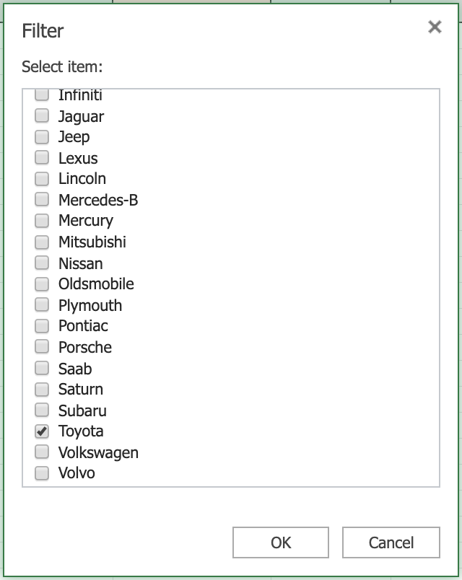

1. Select column **B**, then hold **SHIFT** and select column **C**.

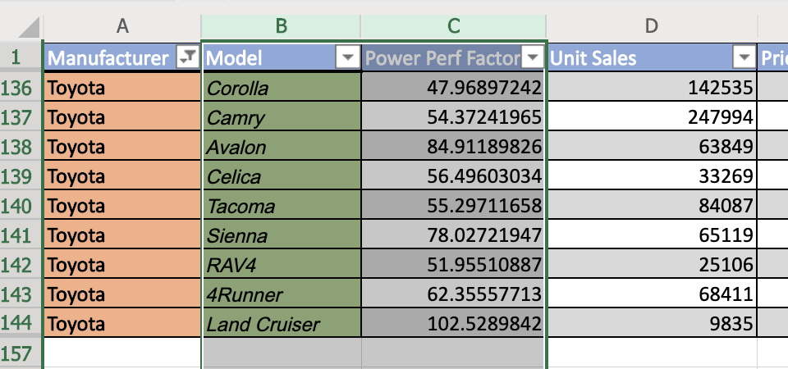

1. On the **Charts** group of the **Insert** tab, click **Column** Chart and choose **Clustered Column** from the **2-D Column** category.

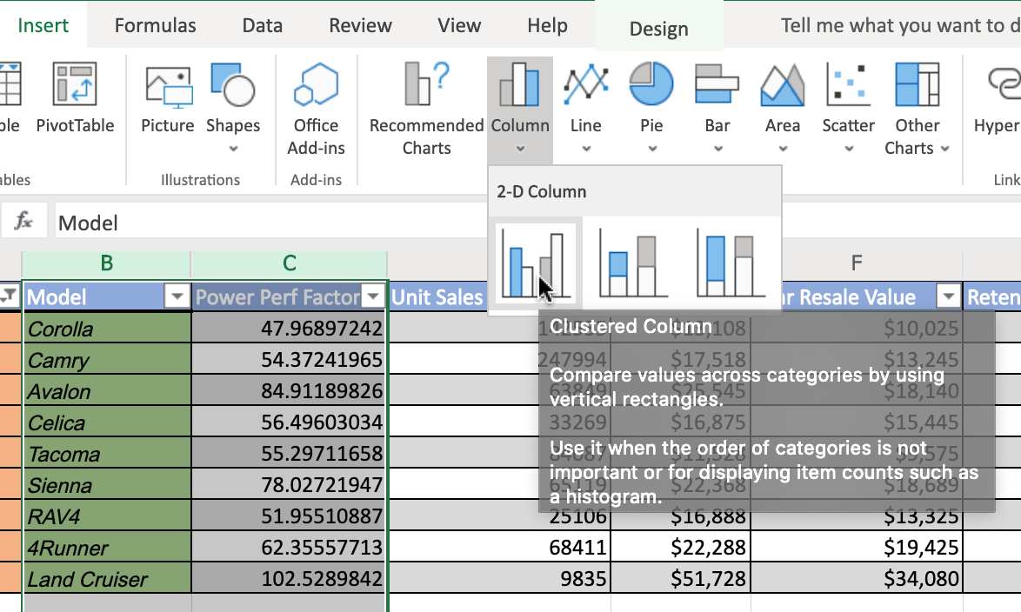

1. Click on the floating chart area to access the **Chart** tab in the ribbon.
2. On the **Labels** group of the **Chart** tab, click **Chart Title** and select **Edit Chart Title...**.

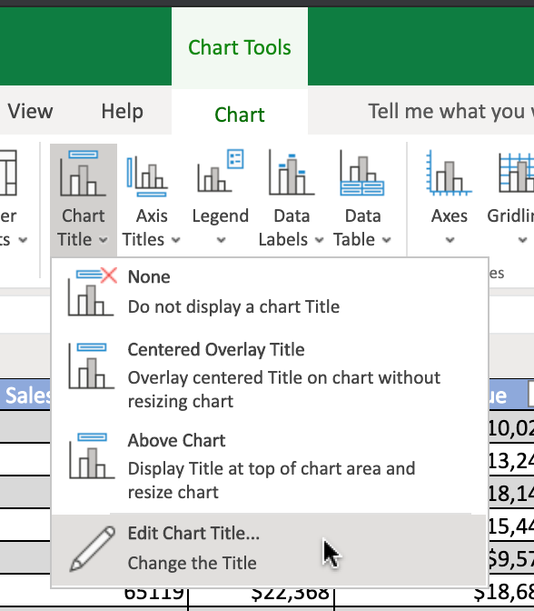

1. In the text input area of the dialog box **Edit Title**, write **"Power Perf Factor of Toyota Cars"** and click **OK**.
2. Your chart should look something like the one below:

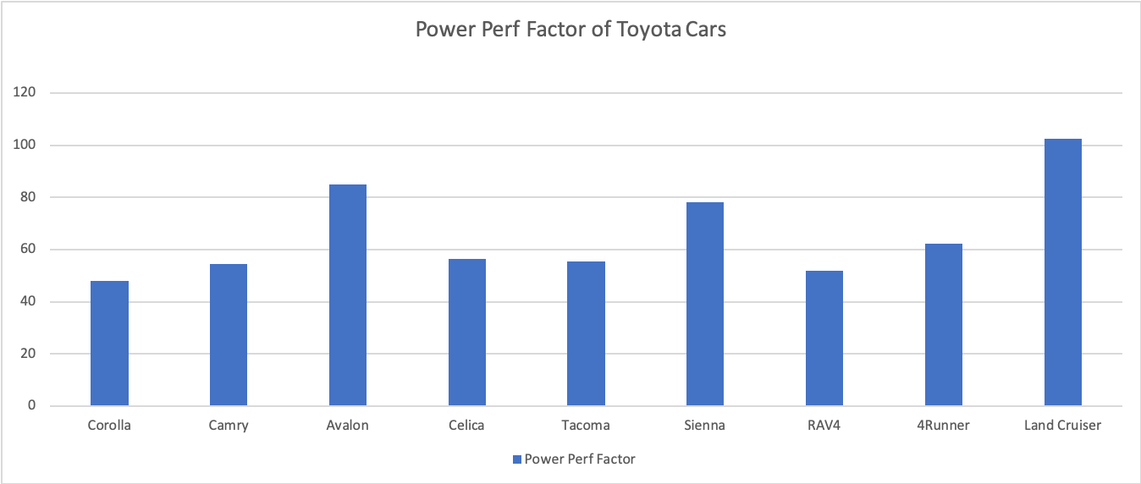

## **Task B : Create an Area Chart**

1. Switch to the worksheet named **Area Chart**.
2. Click the **filter drop-down** in column **A (Manufacturer)**, and select **Filter...**.
3. In the list, only select **Toyota** and click **OK**.
4. Select column **B**, then hold **SHIFT** and select column **C**.
5. On the **Charts** group of the **Insert** tab, click **Area** Chart and choose **Area** from the **2-D Area** category.

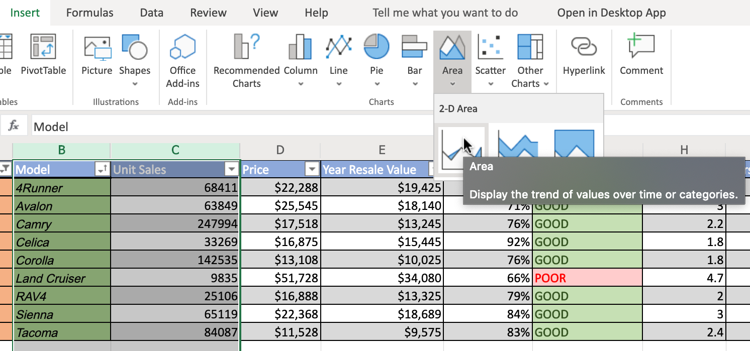

1. Click on the floating chart area to access the **Chart** tab in the ribbon.
2. On the **Labels** group of the **Chart** tab, click **Data Labels** and select **Show**.
3. On the **Format** group of the **Chart** tab, click **Format**.
4. On the right side menu bar **Format**, select **Series "Unit Sales" > Fill > Gold, Accent 4**.

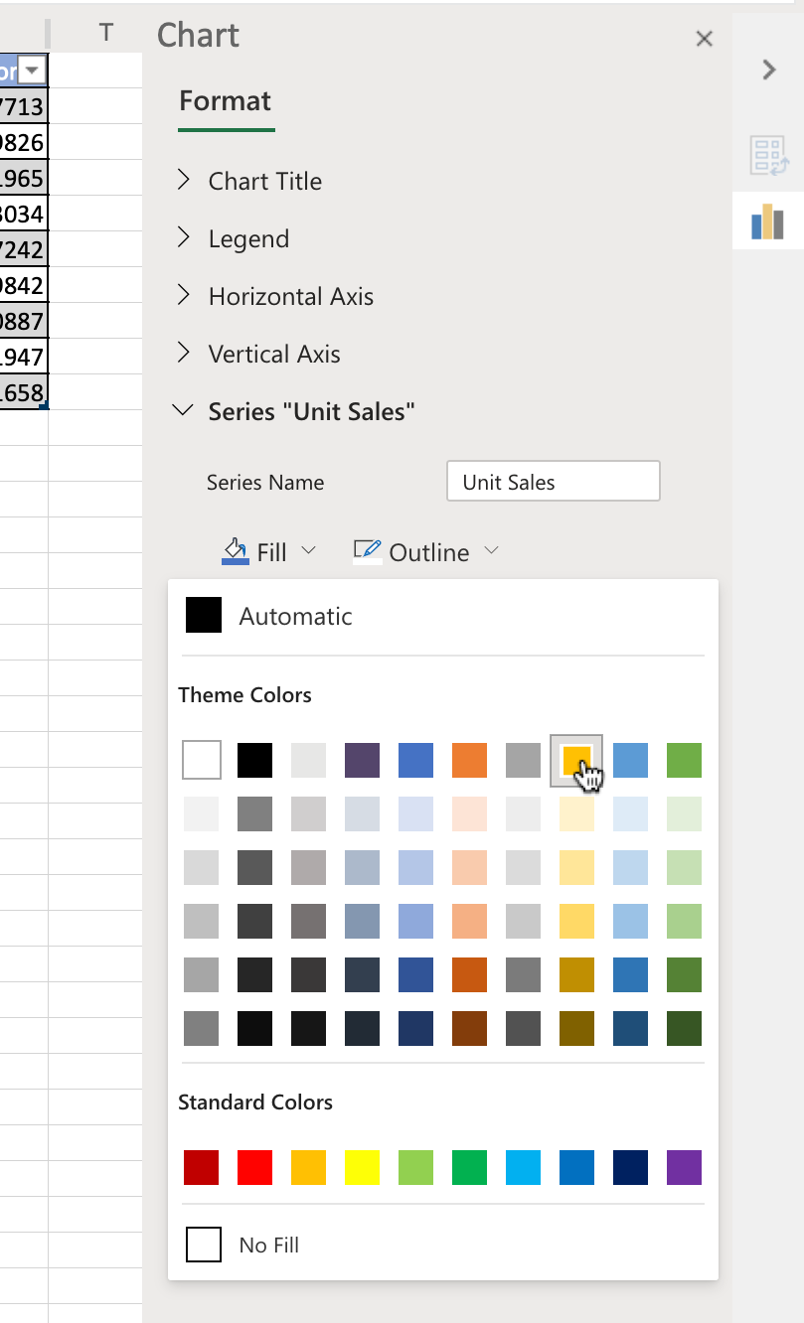

1. Your chart should look something like the one below:

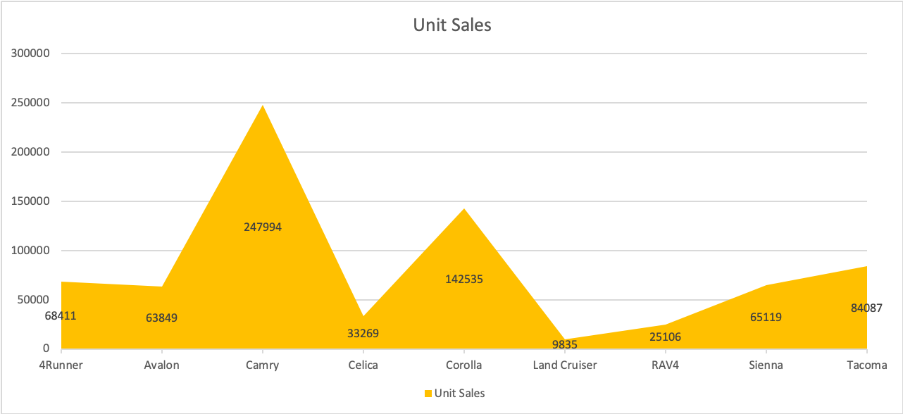

# Exercise 2 : Create Bar Charts and Line Charts from a Pivot Table in Excel

In this exercise, you will learn how to create basic charts, such as bar and line charts, using a pivot table in Excel.

## **Task A : Create a Bar Chart from a Pivot Table**

1. Switch to the worksheet named **Bar Chart**.
2. Click the **filter drop-down** in column **A**, and select **Manufacturer > Filter...**.

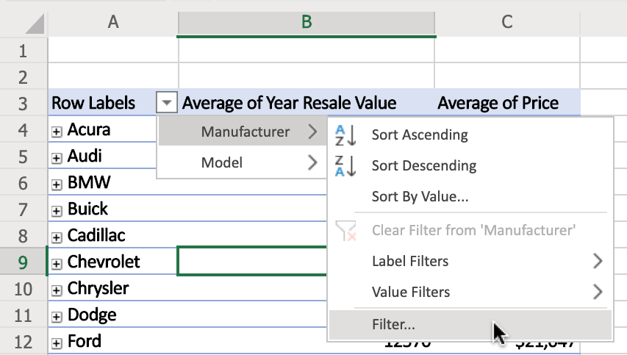

1. In the list, only select **Toyota** and click **OK**.
2. Double-click cell **A4** to expand entire field.
3. On the **Charts** group of the **Insert** tab, click **Bar Chart** and choose **Clustered Bar** from the **2-D Bar** category.
4. Click on the floating chart area to access the **Chart** tab in the ribbon.
5. On the **Labels** group of the **Chart** tab, click **Data Labels** and select **Inside End**.
6. Your chart should look something like the one below:

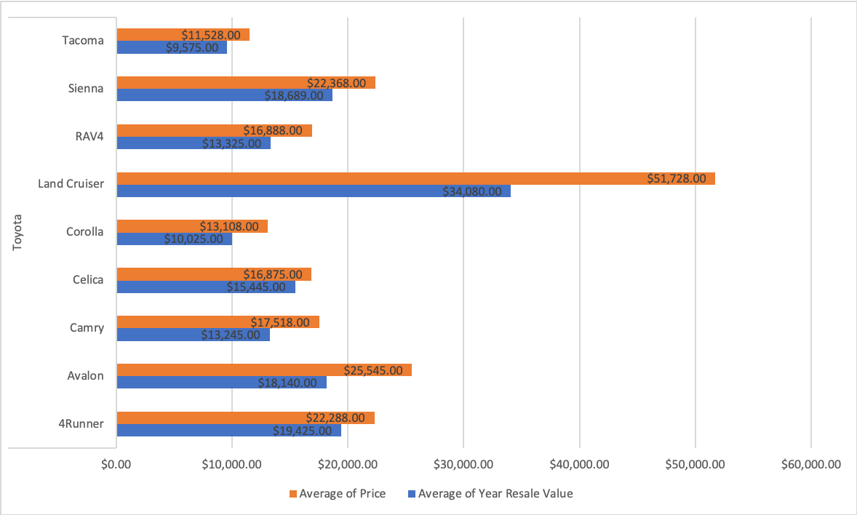

## **Task B : Create a Line Chart from a Pivot Table**

1. Switch to the worksheet named **Line Chart**.
2. Click the **filter drop-down** in column **A**, and select **Manufacturer > Filter...**.
3. In the list, only select **Acura, Honda, Infiniti, Lexus, Mitsubishi, Nissan, Subaru, Toyota** and click **OK**.
4. Click any cell of the pivot table.
5. On the **Charts** group of the **Insert** tab, click **Line** Chart and choose **Line with Markers** from the **2-D Line** category.
6. Click on the floating chart area to access the **Chart** tab in the ribbon.
7. On the **Labels** group of the **Chart** tab, click **Chart Title** and select **Edit Chart Title...**.
8. In the text input area of the dialog box **Edit Title**, write **"Average Retention % of Japanese Auto Manufacturers"** and click **OK**.
9. On the **Labels** group of the **Chart** tab, click **Data Labels** and select **Below**.
10. On the **Labels** group of the **Chart** tab, click **Legend** and select **None**.
11. Your chart should look something like the one below:

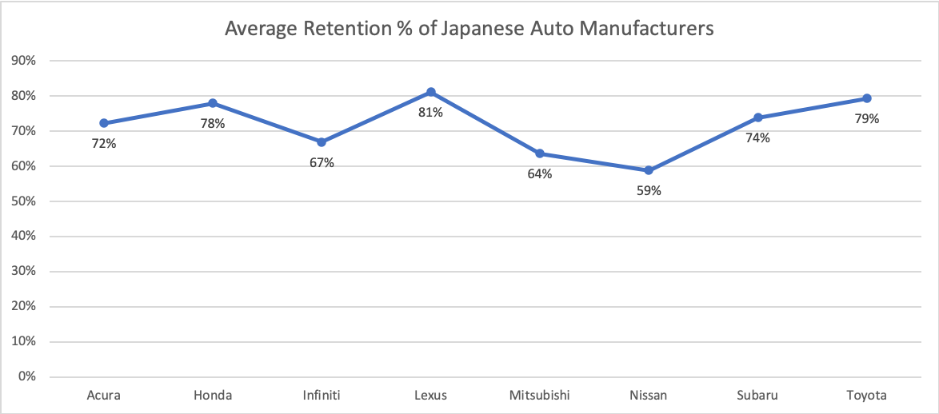

### **Congratulations! You have completed Lab 1, and you are ready for the next topic.**